

Who is Who?

My Top Secret Diary

Name: ……………………..



The 39 Clues

1. Getting started: A million Dollars… or a Clue
What would happen if you discovered that your family was one of the most powerful and important ones in human history? What if you were told that your family’s secret was hidden around the world in the form of 39 Clues?
What would you do if you had the choice between
- taking a million dollars and walking away …
- or getting the first CLUE … that might lead you to the second CLUE… and the third….?
Let’s discuss this in class.
2. Read the intro to book 1 and find out how it all started
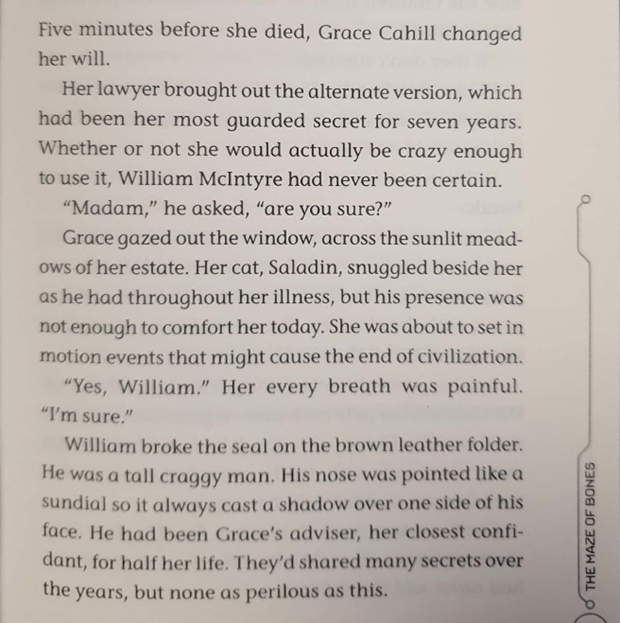
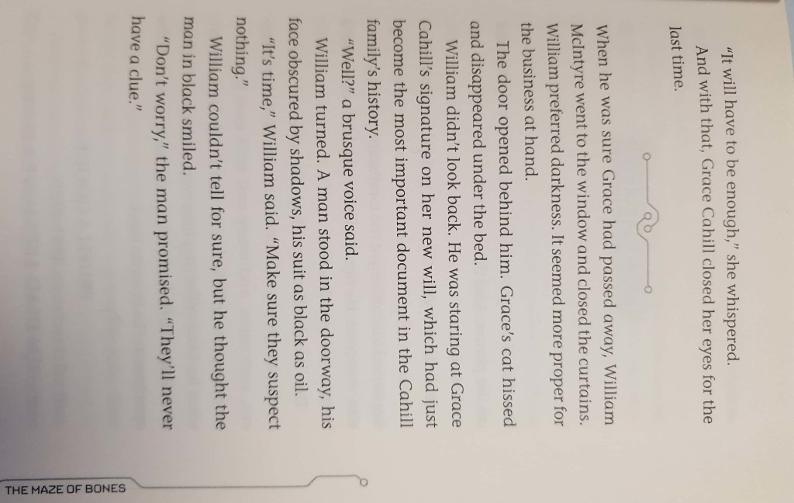

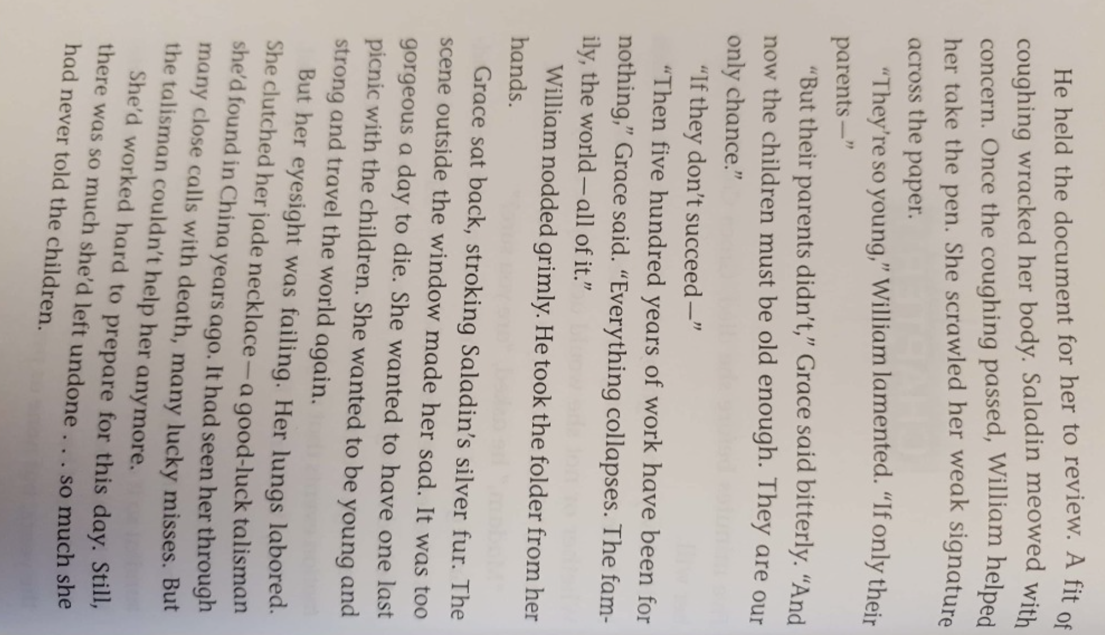


3. The Cahill family
The Cahill family is the most powerful family in human history. Unfortunately, they do not all get along very well. In the 16th century, the family started to fight and broke into five groups, called branches. Their fighting started when Gideon Cahill invented a serum (a medicine) that could cure the Black Plague. He drank the serum and became really strong. His children wanted to have the serum too, but he gave only parts of the serum to each of his children. Therefore, they started to fight and tried to steal the missing parts from each other. This is how the whole problem started.
Grandmother Grace is the only one who seems to know a bit more … but she has just died.
The siblings Dan and Amy have accepted the challenge and want to find the 39 CLUES that will lead to the serum. If they find all the clues, they can save the world. But will they manage? … or will they be killed trying to find the clues?
Lucian   | Ekaterina   | Tomas   | Janus   | Madrigal  
The members of the Lucian branch are leaders and spies. Many of them are mean and ruthless and often use poison to kill their enemies. Everybody is afraid of them.  Their mascot is a red two-headed snake. | The members of the Ekaterina branch are also called EKATS. They are often scientists and inventors. Be careful, some Cahills just claim that they belong to the Ekats but actually belong to a more dangerous branch.  Their mascot is the yellow dragon. | The members of the Tomas branch are often athletes, explorers and warriors. They are strong and work hard to be successful.  Their mascot is the polar bear. | The members of the Janus Branch love the arts. They are creative artists (painters, writers, singers, actors…).  Their mascot is a green wolf. | The Madrigals want to reunite the Cahill family. If one branch of the family becomes too powerful, they will destroy their work and if necessary, kill them. The Madrigals are very intelligent and special. They keep lots of secrets. Many famous people belong to this branch.
4. Starting to read:
Find the students who have received the same book and start to read. (30min)
Who are the main characters that you meet in your book?
Add their names into the table below and collect information about them.
Name | What branch does this character belong to? | What else do you find out about this character?  Age, interests, personality traits, job, …


5. The Clue Hunters’ Travel Diary

Slip into the mind of either Dan or Amy and write 3 detailed diary entries of “your” adventures. Choose the most interesting places and events that they have encountered.
In your diary
  - explain why you went there and what you were trying to find
  - describe the places you have visited
  - say what happened there
  - make sure you include “your” thoughts and feelings, worries, hopes …
Diaries are usually full of such personal reflections. People do not write diary entries on boring days. 
Look at the next page to learn more about “How to write a diary entry”.

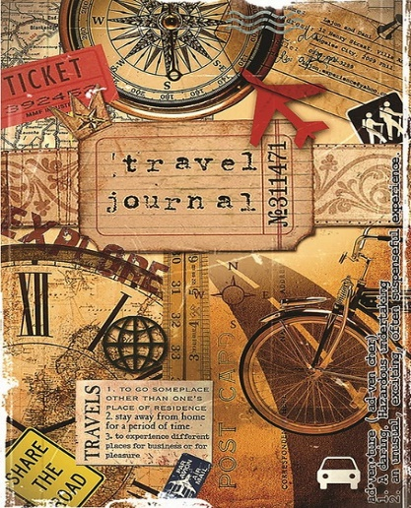
Diary entry 1 Date:……………………………..


continue diary entry 1

6. Talk to a friend


Imagine this: After a dramatic day, you (Amy or Dan) are calling a friend on Whatsapp.
Tell your friend about the dramatic events of the day.
Your friend will listen carefully and ask several questions to find out more details about your dramatic day.
Step 1: Letˋs do 1-2 such conversations in the plenary.

Step 2: Work in pairs and tell each other about "your" dramatic days. Listen carefully to your partner’s story and ask at least 5 questions to find out more details.

Step 3: In the plenary, you will have to report what you have found out about your friend's dramatic experiences. Be prepared to tell us lots of details.

Then keep reading your book and write a second diary entry for Amy or Dan by Friday.

7. Diary entry 2 Date:
Diary entry 2


8. Grammar Challenge 1
Why has the writer used these tense forms?
In this scene Amy is being chased by the Kabras. Amy has climbed on top of an old chuch steeple (tower)
Work with a partner. Read the text and explain why the writer has used these tenses, rather than other ones.
Why past simple, why past progressive (-ing form)?
Tip: Use your grammar book, part 1 and check if you find a helpful explanation for these tense forms there.
Finally, Amy was at the peak (=top of the church). An old iron lightning rod pointed into the sky. At its base was a metal ring like a tiny basketball hoop, and below that a grounding wire, just like Franklin had recommended in his early experiments. Amy lashed (wound, tied) the wire around her wrist, then took out the vial (= glass container) . It was so slippery she almost lost it. Carefully, she slipped it into the iron ring — a perfect fit. She inched back down the roof (=she climbed back down). “Please,” she thought, holding on tight to the rungs. She didn’t have to wait long. The hair stood up on the back of her neck. She smelled something like burning aluminum foil, and then, CRACCCCK! The sky exploded. Sparks rained down all around her, hissing on the wet tiles.
Dazed, she lost her balance and skittered down the roof. She grabbed frantically and caught a rung so hard pain shot up her wrist. But she held on and began to climb back to the top. The glass vial was glowing. The green liquid inside was no longer murky and slimy. It seemed to be made of pure green light, trapped in glass. Carefully, Amy touched it. There was no shock. It wasn’t even warm. She slipped the vial (=glass container) out of its brace and put it back in her pocket. As thou charge this, so I charge thee. The hardest part was still to come. She had to get away safely and figure out what she’d just created.
“Dan! I did it!” She climbed back into the bell tower, but her smile melted. Dan was lying on the floor, bound and gagged. Standing over him, in black combat fatigues, was Ian Kabra. “Hello, cousin.” Ian held out a plastic syringe. “I’ll trade you.” “MMMM!” Dan struggled and tried to say something. “MMMM! MMMM!” “Let—let him go!” Amy stammered. She was sure her face was bright red. She hated that she was stuttering again. Why did Ian Kabra turn her tongue to lead? The bronze bell shuddered. The Holts were still pounding away (=they were hitting the door) below, trying to get through the trapdoor.
The 39 Clues Book 1: The Maze of Bones (pp. 204-205). Scholastic Inc.. Kindle Edition.

9. Grammar challenge 2 (for pros)
Look at the underlined phrases. Why has the writer used the past perfect tense here?
had finished… had found…had met…had stayed…
January 2nd, 2021
Dear Diary,

Today I got into a really tricky situation again. A few minutes ago, I was hanging upside down in a mine, copying and memorizing a text. This was one of the scariest things I have ever done. It was totally dark, and I was scared of falling down even deeper into the hole below me.
I was hanging in there, head down because I was copying a text that was carved into the stone wall. I knew it was an important message for the next clue in South Africa.
When I had finished copying the text, Nellie pulled me up and Amy and Nelly wanted to know what I had found out down there and why I had stayed down there so long. But there was a problem: we were not alone. Court, the strange boy that we had met earlier was also there. I did not trust him at all, he might be following us in order to get to the clue first. Therefore, I said that there was nothing special down there, just bats and rats.
When we were finally alone, I told Amy and Nelly what I had found. I am soooo excited – I am sure this will lead us to the next clue. I hope Court won’t follow us tomorrow. We have to get away from here as fast as possible…
Tip: In what order did these things happen? Draw the events on the timeline:
Example:
When I had finished copying the text, Nellie pulled me up.

The strange boy that we had met earlier was also there.

Nelly wanted to know what I had found out.

Wish me luck!

Nellie pulled me up
I finished copying the text

Now find 5 examples of the past perfect tense in your book.
Write the sentences on this page, and draw similar timelines.



Read another book from the 39 Clues series

Swap books with your classmates and read another one of the 39 Clues adventures.
Have a look at the next task before you start reading.
10. Famous historical figures
We know that the Cahill family is related to many famous historical characters. Therefore, these characters play an important role in the clue hunt.
In each of the 39 Clues books, Amy and Dan find out interesting facts about a famous character from history. Some are very old -- others more recent, but all of them are world-famous and have contributed important things to our society.

Step 1: While reading your second book, collect bits and pieces of information about the historic character that plays a role in the book. Print out the "who-was" fact sheet and collect your notes there.


Famous Cahill Characters from History
Who was………………………………… (name)?
Collect your notes here.

11. More Research
After reading the book, go to SIMPLE WIKIPEDIA and do some research on your character. Add more notes here.
ATTENTION: write keywords or short phrases – not whole sentences. Do NOT plagiarize – (copy other people’s texts). Just take notes notes here.

12: Write an info page about the famous character for your classmates.
Write a first draft and upload it to Moodle. Then correct your text and write your second draft on this page.
Famous Cahill Characters from History
Who was…………………………………(name)?

13. A Diary entry from another point of view
Read at least 50 pages of the new book. Choose an interesting character (not Amy or Dan) and an interesting scene form the book.
Write a diary entry from this person's point of view. Upload your first draft to Moodle. Then copy your revised diary on this page.
Remember: In a good diary entry the character describes
- the events of the day
- how they felt about these events
- their plans for the next steps
Write a long and detailed diary --not just a few lines.

14. Speaking Activity: Teaming up against Amy and Dan
We now know that all the other branches of the Cahills are also hunting the clues. Some of them are building teams and alliances in order to fight against Amy and Dan. In this task choose one character from your book who is from another branch of the family. Meet with a partner and act out a (telephone-)conversation where you ask each other what you know about Amy and Dan and how you could pair up in order to get to the next clue before them.
- Discuss what Amy and Dan have recently done ...
- what clues or parts of clues they have found...
- where you have met them...
- what you and your own branch have recently done to find the next clue ...
- what you are planning to do next in order to get to the next clue before Amy and Dan can find it
Practice your conversation, then act it out for your teacher.

