- Read the text.
Mobile phones at school
Nowadays more and more students bring their mobile phones to school. Many teachers think that this is a bad idea. While I believe that students should carry mobile phones in case of an emergency, I am strongly opposed to phones being used in the classroom.
First of all, many students need their phones because they travel to and from school without their parents. Therefore, it is important for them to have a mobile phone in case they need help or have an accident on the way to school or home.
In addition, parents who work may need to contact their children. For example, if a parent has to work late, the student has to be told that they need to go to a neighbour or a relative after school.
On the other hand, teachers say that phones distract the students from work. There is no doubt that a ringing phone or an incoming message will make a student look at their phone rather than focus on the teacher. That’s why I think the phones should be turned off and stay in the students’ lockers or schoolbags.
To sum up, I feel that students should be allowed to take mobile phones to school for use in an emergency. However, all phones should certainly be turned off during lessons.
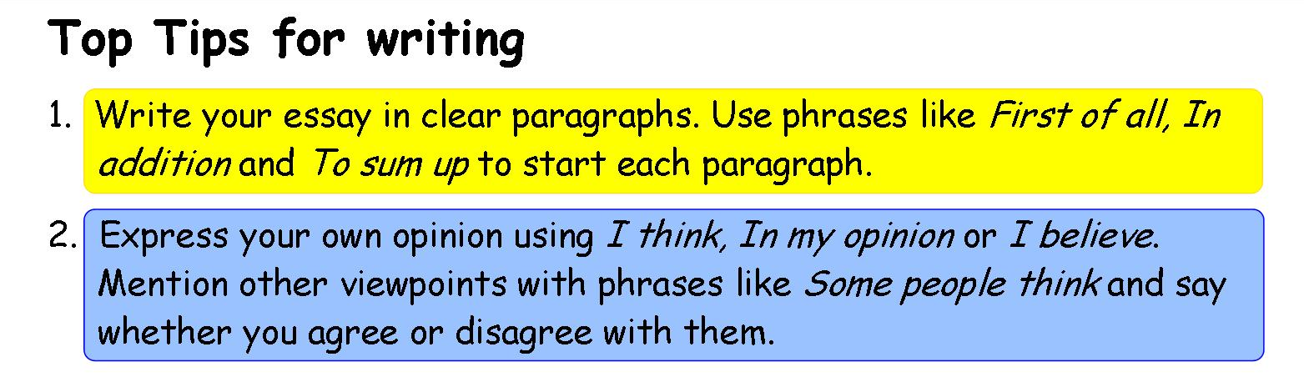
http://learnenglishteens.britishcouncil.org/skills/writing-skills-practice/opinion-essay
Find the two arguments the author gives How does he back his arguments
in favour of mobile phones: (reasons/examples)
argument 1: reason:

____________________________ _____________________________________
argument 2: reason

_______________________________ _________________________________________
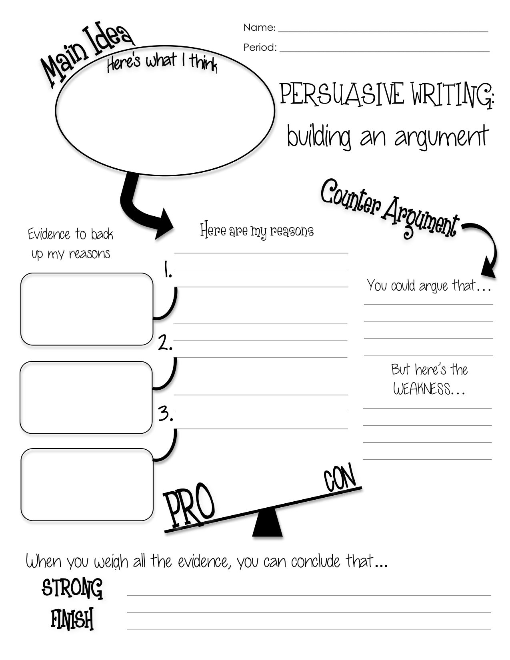
Reasons
arguments

https://www.dbayna.com/uploads/4/2/0/9/4209638/argu

https://www.dbayna.com/uploads/4/2/0/9/4209638/argumentative_writing_-_graphic_organizer_copy.jpg

Phrases for writing good arguments
Deutsch | Englisch
Meinung äußern (allgemein)
Mir scheint, dass ... | It seems to me that ...
Meiner Meinung nach ... | In my opinion, ...
Meiner Erfahrung nach ... | In my experience ...
Ich persönlich denke/glaube/nehme an ... | Personally, I think/believe/suppose ...
Ich bin mir (nicht) sicher, dass ... | I am (not) sure/certain that ...
Tatsachen herausstellen
Es gibt keinen Zweifel daran, dass ... | There is no doubt that ...
Es gibt viele Gründe für ... | There are many reasons for ...
Teilweise zustimmen
Unter gewissen Umständen ... | Under certain circumstances ...
Es stimmt nur bedingt, dass ... | It is only partly true that ...
Es ist nicht so einfach wie es scheint. | It is not as simple as it seems.

Widersprechen
Das Problem ist, dass ... | The problem is that ...
Was sogar noch schlimmer ist, ... | What is even worse, ...
Argumente verknüpfen
Erstens ... | First, ... / Firstly, .../ First of all,…
Zweitens ... | Second, ... / Secondly, .../ The second point is…
Außerdem ... | Moreover, ... / Furthermore, ... / In addition, ...
Schließlich ... | Finally, .../ Lastly,…
Einerseits ... Andererseits ... | On the one hand, ... on the other hand, ...
Wegen ... | Because of ...
Deshalb ... | That is why ...
Schließlich / Immerhin ... | After all, ...
Der Grund dafür ist, dass ... | The reason is that ...
Beispiele anführen
Zum Beispiel ... | For instance ... / For example ...
Ergänzungen und Schlussfolgerungen
Alles in allem glaube ich, dass ... | So all in all I believe that...
To sum up... | Um es zusammenzufassen,…

Debate prompt:
- Read the text. Decide if you are for or against giving up certain luxuries to save the environment.
- Collect arguments for your opinion. Think of reasons / evidence to make your arguments stronger.
- When you are ready, find a partner to discuss the topic. Use your discussion competition sheet.

Would you give up certain luxuries to save the environment?

Climate change is threatening the world. Cars and air conditioners cause pollution. Some people say that we should give them up. Others feel that we shouldn’t. What do you think?

You parents are driving you crazy. They don’t seem to care about the environment at all. They drive everywhere in their car, the turn on the air conditioning in summer and heat up the flat in winter. They use chemicals in the garden.
What’s worse, when you try to talk to them about climate change they don’t listen.
Then, one day, they tell you that they want to take you on holiday – to Florida. Sunny beaches, surfing – the holidays of your dreams.
BUT – Flying is very bad for the environment. It’s much worse than everything your parents do all year long. What will you do? Will you stay at home in order to save the environment? Or will you spend an amazing summer in Florida?

Everybody struggles with these decisions. What is the solution? Should we give up things that we want or is our life and comfort more important? You only live once – but on the other hand – there’s only one planet….

This Evidence /These Reasons support my arguments
These are my arguments

Debate prompt:
- Read the text. Decide if you are for or against a school dress code.
- Collect arguments for your opinion. Think of reasons / evidence to make your arguments stronger.
- When you are ready, find a partner to discuss the topic. Use your discussion competition sheet.

Should schools have a dress code?

Some people say that uniforms help to reduce bullying in school. Others say that they destroy creativity. What do you think is right?

Imagine you come to school and everybody is wearing the same outfit. How would you feel? For some kids this is normal school life – they go to schools where uniforms are mandatory (=the rule – you have to wear them).

Many people say that school uniforms “level the playing field”. They mean that it doesn’t matter whether you are poor or rich, everybody looks the same and nobody can be bullied because of their clothes. What’s more, students can concentrate on school rather than on their fashion problems.

Other people claim that choosing (and maybe even creating) your own clothes offers teenagers a healthy way to be creative. The clothes you wear are also an important part of your identity. If students feel uncomfortable in their school uniforms they cannot concentrate well on school and so it’s hard for them to study.

These are my arguments
This Evidence /These Reasons support my arguments

Debate prompt:
- Read the text. Decide if you are for or against year-round school
- Collect arguments for your opinion. Think of reasons / evidence to make your arguments stronger.
- When you are ready, find a partner to discuss the topic. Use your discussion competition sheet.

Should we have school all year round?

It’s a known fact that students forget a lot in the long summer holidays. Some people think that you should not have long summer holidays. Others feel that having school all year long would be too much work for kids. What do you think?

About 10% of the students in America do not have a long summer break. Instead they have shorter breaks every six to eight weeks. That way they do not have long weeks of summer holidays where students often get bored and forget most of what they’ve learnt. The teachers do not need to spend that much time revising things that the students have forgotten and as a consequence students learn more in the same amount of time.
What’s more, families can decide when to go on holiday. They are not limited to the summer when hotels and flights are most expensive.
While these advantages sound great it is important to keep in mind that most of our school building don’t have air conditioning and it is almost impossible to concentrate in the hot classrooms in summer. Another argument against year-round school is that older students cannot have summer jobs if they do not have long summer holidays. These work experiences are important and even compulsory in many school types.

This Evidence /These Reasons support my arguments
These are my arguments

Debate prompt:
- Read the text. Decide if you believe you can keep money that you found.
- Collect arguments for your opinion. Think of reasons / evidence to make your arguments stronger.
- When you are ready, find a partner to discuss the topic. Use your discussion competition sheet.

If you find 100 Euros, can you keep them?

You are in a park and when you sit down on a bench you see something lying on the ground. You pick it up and you cannot believe it – it’s a 100 Euro bill. You look left and right but you cannot see anybody.
Think of all the things you could do with 100 Euros! But is the money yours to keep? Or should you go to the next police station and hand it over?

While some people say that you are very lucky and should keep the money, others argue that it would be unfair and someone might be looking for that money. It is not yours and you should give it to the police so that the person who lost it can get it back.

On the one hand, the money might never get back to the person who lost it, even if you hand it over to the police. He or she might not know where they lost the money and even if they did, they might search for it but might not go to the police station to ask if it had been found. Then the money would go to the state – and the state definitely has more money than you do.
On the other hand the person who lost the money might be a teenager like you or a poor person who really needs the money and is desperately looking for it. Imagine how happy they would be, if they got it back.

This Evidence /These Reasons support my arguments
These are my arguments

