- Listen and answer the questions
https://www.youtube.com/watch?v=oHaozAhonnw
How many books have been challenged in this Utah school district? ___________________________(1)
What was the most recent book that has been challenged in this Utah district? ___________________(1)

Who can ask for a book to be banned from school? Name at least 3 (3)

How many of the challenged books have actually been taken off the shelves? ____________________(1)

Choose whether these statements are TRUE or FALSE:
Parents can write an e-mail to the school and ask that a certain book should be removed from the library.
True --- False (1)
The school decides quickly not to ban a book if they think the request is silly.
True --- False (1)
Parents can find a list of the banned books on the school’s website.
True --- False (1)
Parents can use the school website to report books that should be banned. (1)
True --- False
Parents have to explain in detail why a certain book should be banned.
True --- False (1)

What do parents have to do if they want a book to be banned in this school? (2)
Explain:

What three facts does the speake give about banning committees in the Utah district (3)
Explain:
True or False: The schoolboard has decided that the Bible will be removed from all schools in this Utah school district. (1)
True or False: Parents can also ask the school not to give a specific book to their child. (1)
___________/18 P
- Writing
Opinion Writing:
Write a letter to the editor of one of these newspapers.
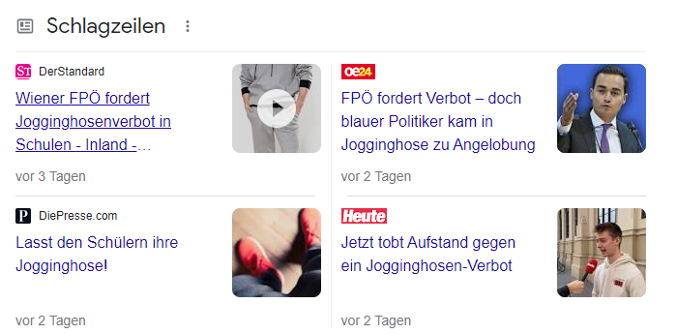
Remember: Your text must be well structured. (Use the hamburger structure) and state your opinion very clearly and convincingly.
Assessment:
Listening |  |  | Writing
Listening | /20 P  % |  | Writing | %
Schularbeitennote Einstufung  ¨ AHS  ¨ STANDARD |  | ____________%

Notenschlüssel
100 – 90% | Sehr gut AHS
89 – 80% | Gut AHS
79 – 70% | Befriedigend AHS | Sehr gut Standard
69 – 60% | Genügend AHS | Gut Standard
59 – 50% | Nicht genügend AHS | Befriedigend Standard
49 – 40% |  | Genügend Standard
39 – 00% |  | Nicht genügend Standard

KEY
https://www.youtube.com/watch?v=oHaozAhonnw
How many books have been challenged in this Utah school district? _81_more than 80)_______ (1)
What was the most recent book that has been challenged in this Utah district?
__________________________ (1)
Who can ask for a book to be banned from school? (3)
Explain: you need to have “Standing” – that means you must be
a student, a parent of a student, an employee ( teacher.) or a member of the school board.

How many of the challenged books have actually been taken off the shelves? _____33____________(1)

Choose whether these statements are TRUE or FALSE:
To get a book banned from the library, parents only have to write an e-mail to the school.
True --- False (1)
The school decides quickly not to ban a book if they think the request is silly.
True --- False (1)
Parents can find a list of the banned books on the school’s website.
True --- False
Parents can use the school website to report books that should be banned. (1)
True --- False
Parents have to explain in detail why a certain book should be banned.
True --- False (1)

What do parents have to do if they want a book to be banned in this school? (2)
Explain:
Make a request on the website
Include a lot of evidence

Give three facts about committees (3)
Explain:
7 people / there are 15 committees / they have 60 days to review the book
True or False: The Bible will be removed from all schools in this Utah school district. (1)
True or False: Parents can also ask the school not to give a specific book to their child. (1

