Back from the holidays!
Task 1: Find out how many of your classmates…..

 | Question | Names and notes
…went abroad  (Find out details: where to? Why? How long did they stay there?) | Did you go abroad?
travelled in Austria  (Find out details: where to? Why? How long did they stay there?) | Did you travel around in Austria?
…visited their families?  (Find out details: Who? Where?) | Did you visit your family?
…worked for school?  (What did they do?) | Did you work for school?
…attended summer school  (Find out details!) | Did you….
…went swimming  (Find out details!) | Did you….
…learnt something new  (e.g. doing a handstand) Find out details!) | Did you….
…read more than three books.  (Find out details!) | Did you….
…discovered a new tv series or a new game (which one? what is it about?)
…had Corona

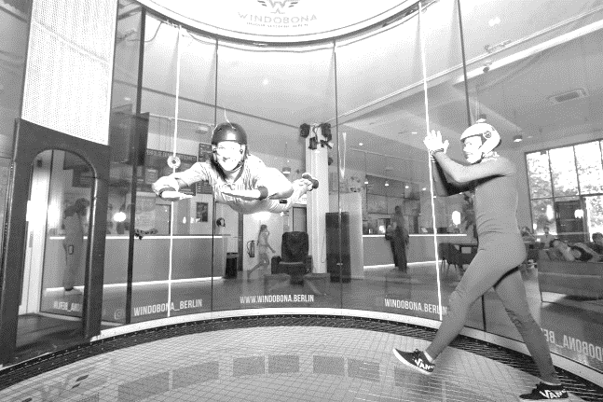
That was really cool! Have you ever tried that??
This summer I did something really cool. I went flying in a wind tunnel.
It was very exciting. I flew twice, for one minute each time.
Unfortunately it was quite expensive.
Have you ever flown
in a wind tunnel?

Now write 3 sentences about something exciting that you did this summer.

Guess: How many of your classmates have done that (in their lives)? Write down the number:

Write down the Question:

Ask you classmates. Were you right?

