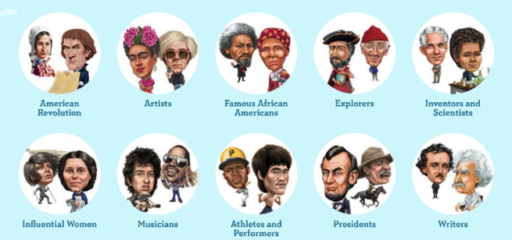
Extraordinary People

Writing task
Letter to our friends in the ERASMUS GOAL project
You have recently read a book about an extraordinary person and you have listened to your classmates’ presentation of other extraordinary persons from different times and backgrounds. Which three persons do you admire most?
Write a letter to our Erasmus partners in Greece, Cyprus, Italy and Romania. Tell them about this reading project and explain what you have learned from all these extraordinary persons.
- Tell our partner students which three persons you admire most and explain why?
- What makes them extraordinary in your eyes?
- Give examples of these persons’ achievements in life and
- show how these persons have overcome obstacles and challenges that were in their way.
Don’t forget that you are writing a letter. Letters need an opening and a closing phrase.

It’s presentation time: Let’s find out more about these extraordinary people
While visiting your classmates’ presentation tables take lots of notes on this sheet. You will need all the information for your final writing task.
Write the persons’ names into the stars. Then collect all the achievements in the top row of the table ---
and write all the obstacles and challenges that the person had to overcome into the bottom row. Look at the example:
J.K. Rowling | 
She has written all the Harry Potter books.
She has written several crime books for adults under the name Robert Galbraith.
She has become a millionaire.
In October 2010 she was named the “Most Influential Woman in Britain”.
She was a single mother and did not have a job. She did not have any money. The publishers rejected her books.

The weights, challenges and obstacles that have pulled them down.

The weights, challenges and obstacles that have pulled them down.

