Fake News: Unbelievable things that someone said

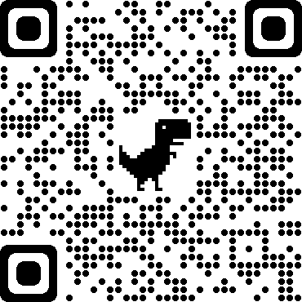

Flying penguins? Watch the BBC video. Watch the video
This is what the explorer said in the video: This is what your

teacher reported in the
next lesson:
The explorer said that the recently discovered colony of penguins was unlike any other.

“This recently discovered colony of penguins is unlike any other.”

“They don’t need to huddle together every winter for protection against the bitter cold.”
They didn’t need to huddle together every winter for protection against the bitter cold.

“These little fellas can do something no other penguins can.”

He reported that they didn’t need to huddle together every winter for protection against the bitter cold.

He claimed that those little fellas could do something no other penguins could do.”

“They fly thousands of miles to the rainforests of South America where they spend the winter basking in the tropical sun.”
He said that they flew thousands of miles to the rainforests of South America where they spent the winter basking in the tropical sun.”



Now it’s your turn:
Report what people told you in the past.

Write down what the person really said in the speech bubble on the left and report it in the speech bubble on the right.
Last Thursday, my teacher told me that she had visitors from England the day before.
…………………………………………………………………….
……………………..……………………………………………
……………………..……………………………………….…
………………………..…………………………………………

I had visitors from England yesterday.


Yesterday, Belinda said that she liked my pink t-shirt, but I don’t believe her. She always says that she hates pink!
MONDAY: I like your pink t-shirt.
I really like your pink t-shirt.

ALWAYS: I hate pink.
……………………..…………………………………
……………………..…………………………………

…………………………………………………………………..
.…………………………………………………………………
……………………..……………………………………………
……………………..……………………………………….…
………………………..…………………………………………

……………………..…………………………………
……………………..…………………………………
………………………..…………………………………………

…………………………………………………………………..
.…………………………………………………………………

………………………..……………………………………………….
………………………..………………………………………………
…………………………………………………………………..
.…………………………………………………………………
……………………..……………………………………………
……………………..……………………………………….…
………………………..…………………………………………

Find your own examples of things people said but you did not quite believe. What did you friends, your parents, your brother, your sister say last week, last month, last year…?
LAST WEEK:
……………………..…………………………………
……………………..…………………………………

Last week, ………………………………………………..
.…………………………………………………………………

……………………..…………………………………
……………………..…………………………………

Last _______, ………………………………………………..
.…………………………………………………………………

……………………..…………………………………
……………………..…………………………………

Last _____________,………………………………..
.…………………………………………………………………

……………………..…………………………………
……………………..…………………………………

Last _______, ………………………………………..
.…………………………………………………………………

My rule:
When we report what someone said that happened in the past …
When we report what someone said that we don’t quite believe …

