
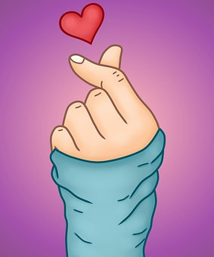
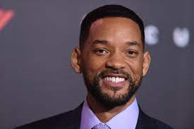

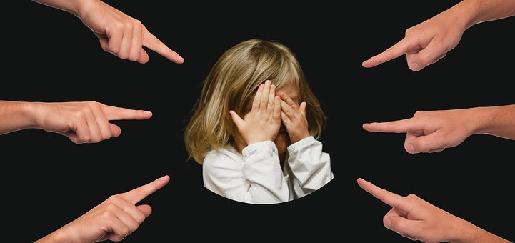
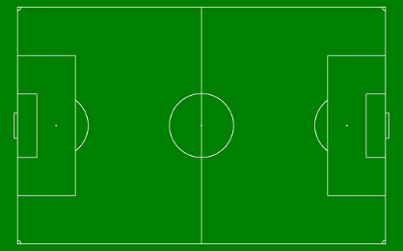

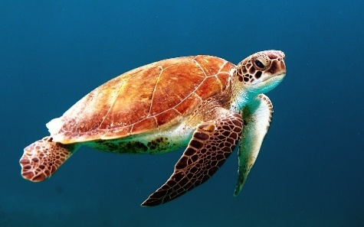
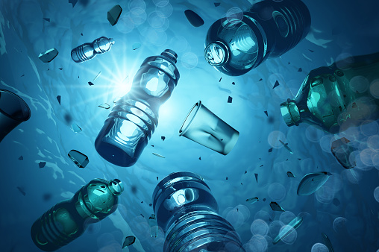

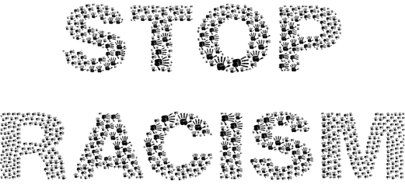

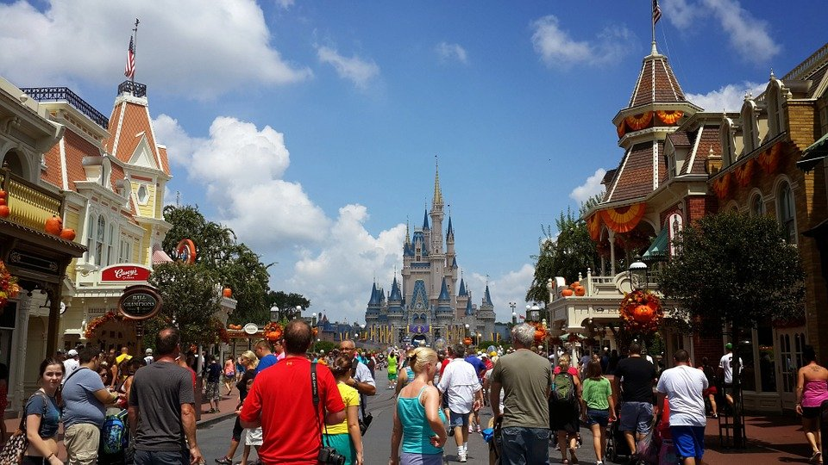

Mixed

Table of contentents

Page: 1 = The big problem bulling
Page: 2 = Racism has gotten worst
Page: 3 = Fridays for Future
Page: 4 = The problem with palm oil
Page: 5 = Living without plastic
Page: 6 = How the sea becomes extinct
Page: 7 = Food waste impact climate change
Page: 8 = How you can start with sport
Page: 9 = Movie recommendations
Page: 10 = Will Smith’s sad childhood
Page: 11 = Why Disney isn’t that good
Page: 12 = Why videogames aren’t that bad
Page: 13 = Videogame recommendations
Page: 14 = Fast cupcakes, recipe

The big problem Bullying
Everyone can stop Bullying
By Selina Prettenhofer

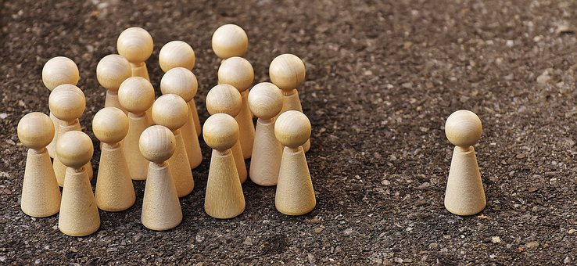
What would you do?
Imagine the following situation. You are walking through the school hallway during recess and you notice a child who is badly bullied by others. You have the choice to look away and just keep walking, but you also have the choice to help the child. What and would you do? How do you act? Be honest. Everyone here knows the situation of being outcast and badly treated. But we have a choice to do something about.
Does Bullying leaves damages?
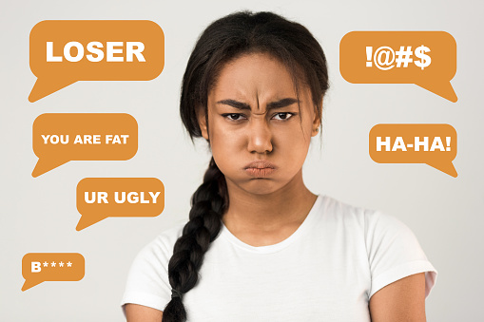
Bullying often leaves damage on the person being bullied. Lots of children are afraid of being hurt and scared of being singled or going to school. Many of the students must live with these fears. Often you do not see what is going on in that person. You feel this pain the day before, just when you think about getting up the next day. Bullying can make your life difficult.
Why don`t people help?
Why do so many people look away when they see someone being bullied? Why do so few people help when someone is hit? Often people do not feel able to help on their own. The whole thing can be changed, and we can choose to help the next time instead of looking the other way.
What could you do?
At first you can do lots of little things to help someone who is being bulled. When you see someone, who is treat badly you should go there and help the person. Don’t help the people who are common to the person. On good Tip is to talk to the person and do something with her after school, so the person see that he or she isn’t alone. When bulling happens in school you can go to a teacher and talk to them. Mabey they could help you or that person. When you are affected at yourself talk to your parents or do a good friend. Often that helps to feel better.
Don’t forget that everyone has the right to belong and to be treated with respect. We have the choice!

Pictures from Pixabay

Racism has gotten worse
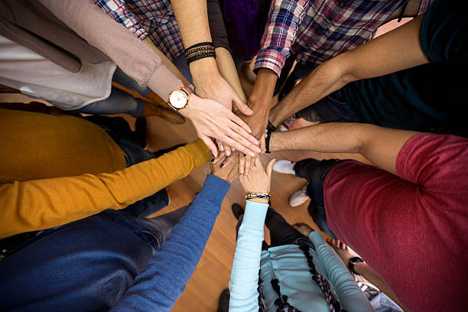
Organisation against Racism
Still bad things are happening that show that racism is still a big topic in the 21st century. There are many organizations that try to stop racist behaviour. One movement that is especially often talked about in the media is now the "Black Lives Matter” many Organization take a part.

A tragic event from the past
Racism is a big topic. You have probably all heard that Gorge Floyd was murdered by a policeman in the USA, when he had no chance to help himself. Like me, you’re probably thinking how something like this could happen, because police officers are supposed to be protectors of all people. This is a very bad example of racism, but discrimination starts on a small level.

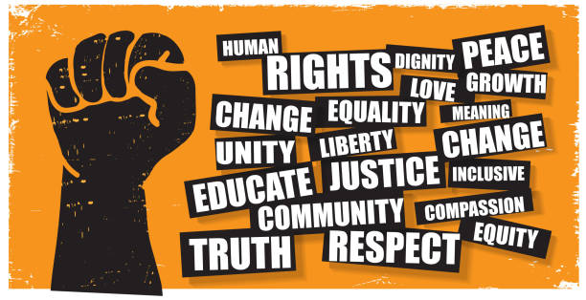

What could we do?
Often, we say things we don't really mean, which can make other people feel sad, because of that. I would ask you to take it this seriously and maybe you are going to think next time and spell it out after.
Especially in difficult times it is important not to forget the equality of all people, no matter what gender, characteristics, age, origin, sexuality etc. Each of you can help make the world a better place for everyone.
Racism is still a big topic. Racism exists all over the world in some countries less in some more everywhere should be the same rules for everybody but often this will be forgotten, that's why I would like to give you attention with this article
By Elisabeth
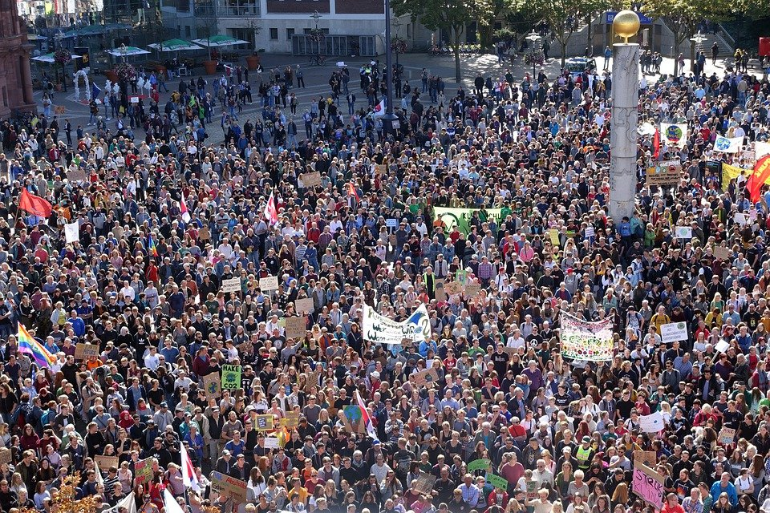
Friday for Future
Friday for future (FFF) is a global movement. Many teenager, children and students take a part. In these times it is hard to organize protests and stay connected.
Pictures from pixaby and free google.
By Elisabeth

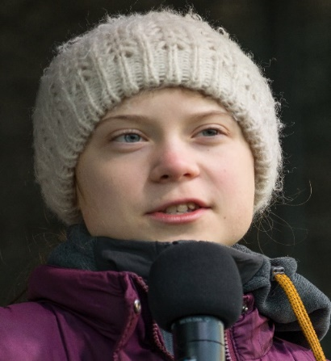
What do they want?
The Friday for Future movement about stopping climate change. If everything continues as it is now, a global climate catastrophe is imminent. Fridays for Future wants to change this through protest. The goal is to stop climate change. The 1.5-degree limit is important here. this limit was set to show that global warming must not exceed this limit. It must not go one degree higher than that. This was set in 2015 in the Paris climate agreement.
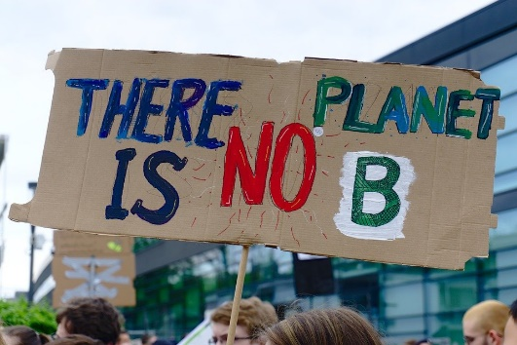
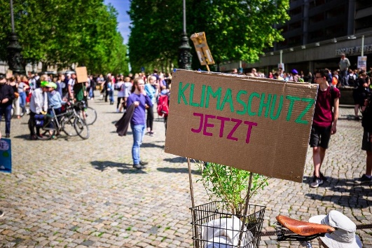
Who is Greta Thunberg?
Greta is a swedish climate archivist. At the age of 17, she started a global protest by children.
20 August 2018 is the day it all started. Instead of going to school, Greta Thunberg demonstrates for more climate protection in front of the Swedish government. With the slogan
"We strike until you act!”

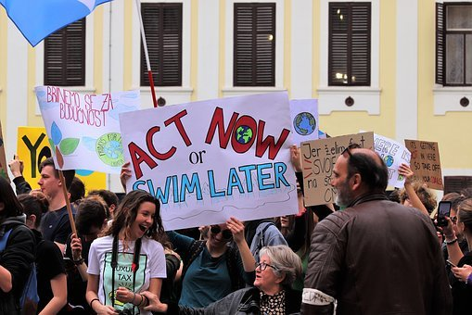

This is how it works with Covid 19
In times of Corona, FFF movement is also struggling. Besides empty streets, the Corona pandemic brings with it many feelings of insecurity, worry. Some people just have had other things to worry about since Corona than the climate, it seems.
As soon as events are allowed again, planed friday for future events with a limited number of people and wearing masks will take place. All FFF members hope that demonstrations can take place again soon.
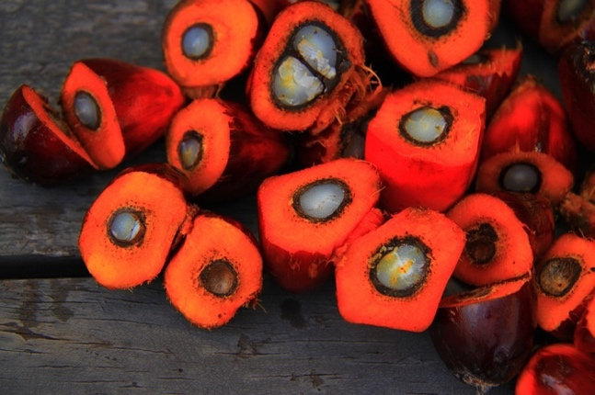
The Problem with Palm Oil
After this article you will know, why using palm oil is a big problem for the environment and how you can help the environment.
by: Tim K.
Palm oil is an important product for the food and cosmetics industries because the production is really cheap and you get more oil from less farmland than compared to other
Form this Plant we get Palm oil
oil crops. In addition, these palms grow quickly and are very long-lived.
But what is the problem with palm oil?
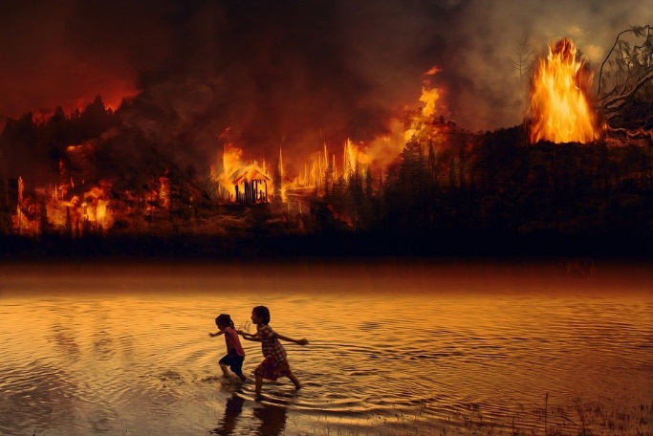
We need more and more of this oil, so more and more plantations have to be
built. But these palms can only grow in tropical areas, and this is the problem, because the rainforest has to be cut down in order to use the fertile soil for palm plantations. If this is done, the CO₂ from burning the woods and the dirt come into the air and this is bad for the environment. In addition to that, also all the exotic animals lose their homes and die.

How can we fight for it?
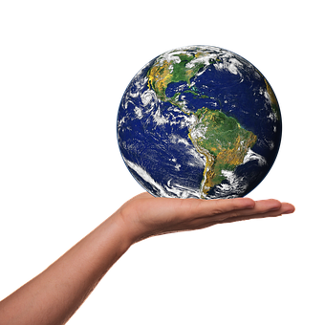
First of all you can only buy palm oil which have a label that says that these are made with CO₂ neutral palm oil. However, you can´t be 100% sure that’s that right. Therefore, the best way is to reduce its consumption and to buy fresh and natural products, like carrots ore tomatoes, in these products are no palm oil like in all other vegetables and fruits. This is not only healthier but also protects the environment.

I hope, that this article can motivate you to help saving the planet. You don’t have to stop using everything. It is already good if you do little things.

Living without plastic
What is it like to dispense with things?

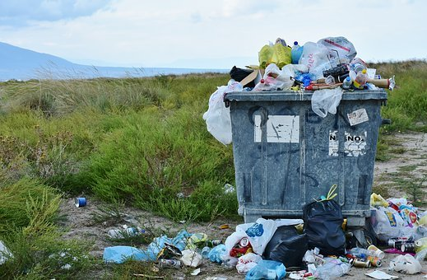
What’s the problem with plastic?
You find plastic in most products you buy. This is a big problem because the microplastic but also the normal one ends up in the seas and lakes but also in the forests and on the streets. Our climate is under attack because, our climate gets hotter and hotter. In Plastic are fabrics like methane or ethylene. These fabrics are very bad for our health but also for the earth and the climate change.
When we want to stop the Climate Change, we must get rid of some products especially some with plastic.
What is the alternative for plastic products?
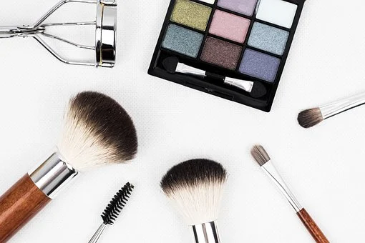
Because the plastic is such a big problem some people decided to live without it and buy only things that made of naturally materials. For some products there are some alternatives. For example, straws. The EU had forbidden them because of the Climate Change but if you don`t want to dispense with plastic straws you can buy some made of glass. Also, in cosmetic is a lot of plastic that you can’t see because it’s microplastic. This plastic is very bad for your health and for the world. If you want to get rid of that you can buy nature cosmetic. If you want to live without plastic, you have to be creative and always look for new alternatives.

Sandra Krautwaschl:
Sandra Krautwaschl and her family lived without plastic for a while now. She had that idea when they were on Holidays in Croatia and saw the plastic on the beach and in the sea. Before that she had watched a film about plastic called “Plastic Planet”. This movie was and is a big motivation for her and the family. They tried to find alternatives for the products do sell less plastic. At first it was very hard for them because they had to go without a lot of things. After a time, she said that life has become easier with less plastic and less products.
I think everybody should do something against the climate change. So maybe you, want to get rid of plastic for a few weeks. Probably you like the live without these products.

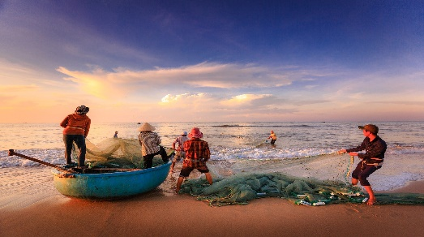
How the the seas become extinct

Find out how our sea gets destroyed and animals get killed brutally, why animal death is also a big problem for the climate change and how the plastic problem in the sea related to fishing.
by, Clemens

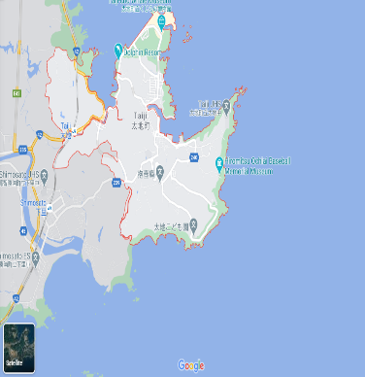
Whale’s and dolphin’s deaths in Japan:
Most countries in the word forbid whale and dolphin hunting. But some countries do not forbid it, for example Japan more accurately, Taiji. On the picture you can see that Taiji is a city on the sea. In Taiji live many fishermen and they help to kill the whale and dolphins because they eat their fish, which they want to sell, but that is not the most disgusting thing. There where yearly killed over 700 whales and dolphins to sell them. There also sharks get killed only for their fins. The fins are sliced of and the halfdead sharks get throw back into the sea, but the government does not do anything about it.
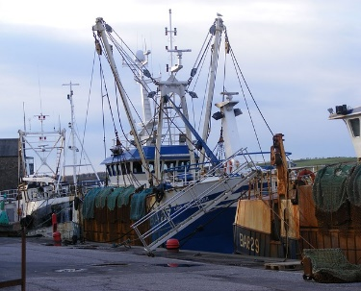
Illegal fishing:
Illegal fishing is also a big problem because the fisherman with big boats fish in places where there are many fish, for example, in Africa. Some villages there live from fishing, but the big fishing boats catch most of the fish before they could come near the beach where it is easier.to catch them. So, the poor fishermen and their families starve, because the people thy only have small boats for fishing and cannot go out that far. So, they cannot catch any fish. The FAO estimates that 30% or more from the fish all over the world are caught illegally.

Plastic in the sea:
We all know that plastic in the sea is a problem. But did you known that every minute 1 truckload of plastic is thrown into the sea? Or that 500 times more microplastic particles are in the sea than stars in the Milky Way? And that’s not science fiction that is the truth. Many animals die in the sea because they swallow plastic. They do not swallow only the normal plastic bottles or other small pieces of plastic. They swallow fishing nets, planes, or other fishing equipment. Most of plastic in the sea is old or broken fishing equipment and turtles or whales force into these nets.

But there are many organizations who fight against these things. For example, OcenCare, Sea Shepherd and some more. It is very important that the sea gets saved, because when the sea dies, we all die.

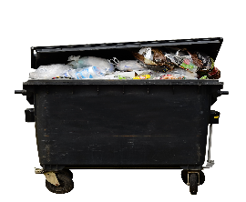
How food waste impact climate change
Many people around the world have problems to get something to eat, but new findings from a new United Nations report, say that every sixth piece of food get thrown away.
By, Clemens

690 million people go hungry each year. More than 3 billion people can’t afford a healthy diet. At the same time, the food waste produce 8-10% of global Greenhouse gas emissions. Reducing food waste could ease world hunger and help prevent climate change.

World hunger:
Everyone knows that world hunger is a big problem. The world hunger index 2020 says 18,2. Too many people around the world are still hungry: 690 million people are malnourished, 144 million children suffer from emaciation, a sign of acute malnutrition, 47 million children suffer from stunted growth, a sign of chronic malnutrition. In the year 2018 5,3 million children died of hunger.

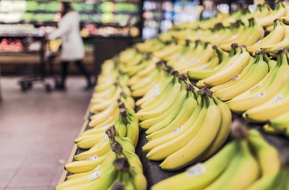
Now you know that food waste is a big problem. Think about it when you are buying food next time, because when you focus on what you eat you will notice that you are wasting a lot of food as well. For example: hard bread, because you didn’t eat the whole bread, etc... When you don’t waste food, you will help the environment.

Some tips against food waste are, freezing left foods you can eat it later or don’t buy too much food. Or only go to the supermarket with a shopping list, because then you know what exactly you need and don’t buy things again and there are many more ways to reduce food waste.

How you can start a sportier life
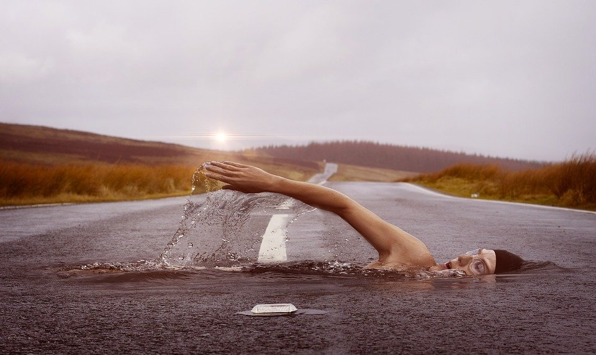
Today a lot of adults and also children are sitting in front of the computer all day. But that is not good for their health and that’s why I want to give you tips, how you can cange your life.
By: Tim K
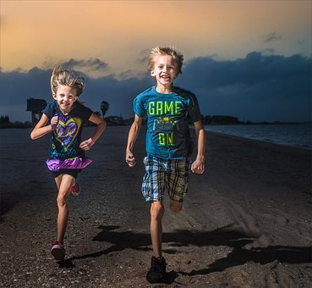
Meet your Friends!

You can meet your friends to go with them on a walk or a run. If you do that with your friend, he can motivate you and you can motivate him. So, with this trick you can get better results.
Your friend can also remind you of your sports meetings so you can’t forget it and come in a routine to stay active.

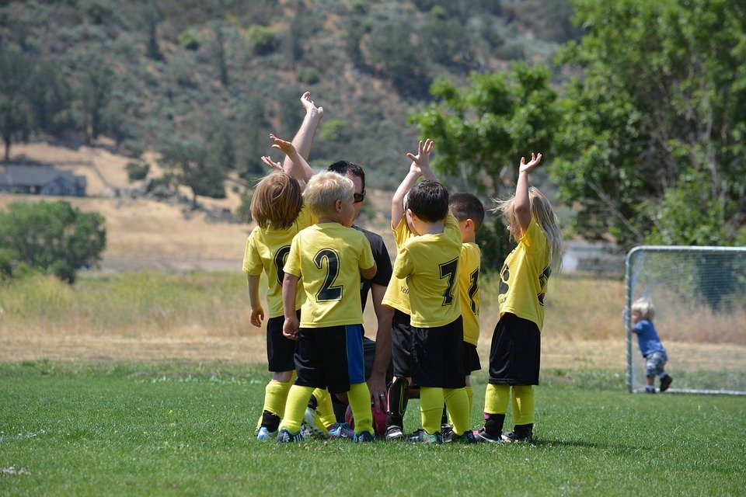
Join a Club!
There are many clubs in Graz. You only have to choose a sport you are interested in. For example swimming or soccer. When you are in a club you will get a trainer who can correct you if you do something wrong. That is the advantage of a club. The disadvantage is, in a club you can’t change the time of your trainings. So, if you have school longer you maybe cannot go to the training and this could be a big problem.
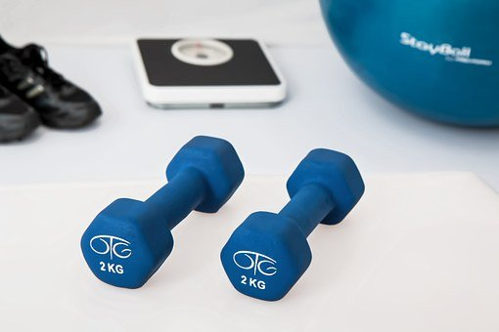
YouTube can also help you!
Everybody should know YouTube and there you can find also creators who are showing sports content. These youtubers can give you tips and also motivate you with their videos. The workouts form these people are free end easy to understand, so everyone can do them at home. But the biggest advantage at YouTube are the rebate codes from the youtubers. With those you get for example 10% discount on equipment that you need for the training at home.
I hope that this article could help you with the start of your sporty lifestyle.
Nice Movies you should wait for


Are you bored during the lockdown? Do you want to have nice experiences? Then this Article can really help you. We will show you the three best movies that will probably be published soon.

By: Tim K.

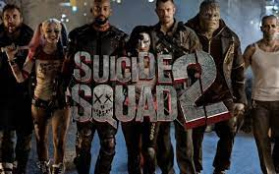
- The Suicide Squad 2
The release of this movie is planned for 6th of August 2021. The film is about the anti- hero team “Suicide Squad” from the comic publisher DC. It’s the 11th movie of the DC Extended Universe. I would recommend it for people who like the first part and are interested in. In general, for all DC fans.

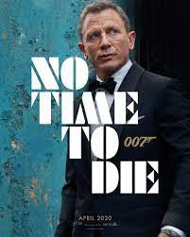
- James Bond “No time to die”
Do you like action and spectacular stunts? And you like the character 007 then “No time to die” is the right movie for you. James Bond has retired and enjoys his free time in Jamaica, but a friend asks him for help, that means a new mission for 007. That’s what we know about the content and we have been able to watch the trailer for more than a year. Initially the movie should have been released in April 2020. Now you can mark October 8th in your calendar.
Fun Fact: It will be the last James Bond in which Daniel Craig acts 007.

- Mission Impossible 7 and 8
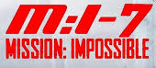
In these parts of Mission impossible, which will probably be released in the middle of the year 2022 and 2023, Tom Cruise will get back in his role as the IMF-Agent Ethan Hunt. Part 7 and 8 will be released shortly after one another because they were filmed together. What is very fascinating with the mission impossible series is that Tome Cruise does most of the stunts himself, that’s very special because normally a stuntman does that. If you are a fan of agent movies and you can’t watch a movie without stunts than Mission Impossible is a must see for you.
I hope that all the dates are correct and the cinemas will open soon.
Will Smith’s sad childhood
You all know him he is one of the most famous actors in the world. Have you always wanted to know more about him'? Yes? Well here you can find more.
By Elisabeth
Who is Will Smith?
Willard Carroll "Will" Smith Jr. is an American actor, film producer and rapper.

He got his biggest success in the 90s with his serie "Prince of Bel air". Now 25 years later Will Smith is a multi-millionaire and one of the famous actors in the world.

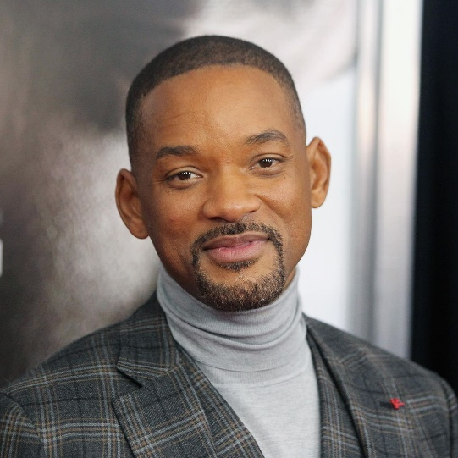
Will Smith’s love life
Will Smith is now married for the second time, since 1997 he was married to Jade Pinkett Smith, before that he was married to Shereen Zampino. They were divorced in 1995 but there are still good friends.
Will Smith is a father of three kids "Trey Smith" is the shared child with Shereen. "Jaden and Willow" Smith are from Jade's marriage.


The deep truth
One of will smith's characteristics is his big smile with his good humour and the matching charm. He was able to make every person, who watched his films laughing. But this smile has a very deep background. Will smith this developed smile as a protection against his aggressive father. Even as a small child, he tried to stop his father from beating his mother or his three siblings with his smile. In an interview he said that he wanted to make his children be like that, too. He wants that they become later to persons who care about themselves and others and lovely people.
That the story of will smith's childhood is all over the media that doesn't seem to bother him. He wants to show everyone who is fighting with the same problem that there is a way out and everybody has the right to a non-violent childhood.

Why Disney isn’t that good
What happens behind the scenes
By Selina
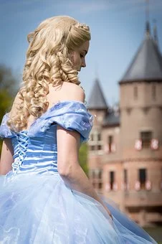
We know Disney as a world where children’s dreams come true. Every child loves Disney. But there have been some serious allegations. So, is everything right in the Disney world?
Is there rases and sexism’s in Disney movies?
Everybody knows Disney as a company from America but there are many scandals. In the Disney movies you will find lots of prejudices against people with other skin color. For example, in the movie Dumbo. These prejudices are not acceptable in our century. Lots of peoples fight against racism and questioning the was people were portrait in the movies. The Disney company of course, rejects the allegations. Another allegation against the company is sexism’s in the films. Mainly in the princess’s films for example Cinderella. Children think that they also must look like that. Good News are that Disney works on the movies and product new movies without any of these prejudices.
The Disney Land:

The Disney Land is a Theme Land where people can go when they want to have lots of fun but there were also lots of scandals. Of course, is there a safe place where you can spend your free time with your family. In the media you can often read about scandals that go as far as rape. In how far all this is true no one can say.
A detective could arrest a worker because he saw him rape a child. These things do not always work like that. There are claims that some teenager and children were raped by workers but also by visitors.
But all in all you can go there and have fun with you family and friends.

Why videogames aren’t bad at all for children
Many People say that videogames are bad for children but, there are also many good things about videogames. For example, in times of corona you can interact which your friends. This text is about other good things about videogames.
by, Clemens

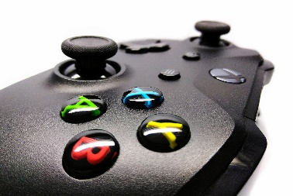
First, its normal that parents don’t like it when their child only plays videogames in their free time and don’t do their homework because of the videogames. Many people say that videogames are bad for your mental health, but many studies say the opposite.
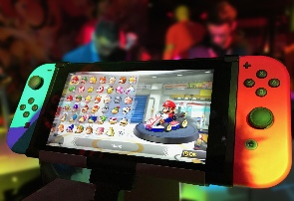
There are many different types of games (Shooter, Adventure-games, Strategy-games) and many people say that shooters are bad, but that mean that all games are bad, because there are many different types of games and every different type is about something different. For example, Minecraft is different to “Call of Duty”.
A famous brain scientist called Daphne Bavelier said in a lecture videogame are like drinking wine: There are bad uses for wine, but when you don’t drink too much of it can be very healthy.
Let us have a look at some of her studies:
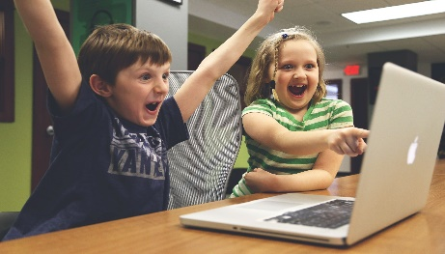
Are computer games bad for attention?
In this study Daphne Bavelier found out that gamers can switch better from one task to another one and the brain region for attention is better developed than in people who don’t play videogames.
Are Video games bad for your eyes?
No, people who play videogames have better eyes. The people who play videogames can see details better.
Another study said that videogames are positive is from National Literacy Trusts and said that videogames are good for creativity, empathy and reading skills.
Of course, it’s important what the game is about for example are many people who say that shooters make you aggressive. The verdict on this is still out: there are studies that say that that’s not true but there are also studies that say that is true. Now you know something about the positive sides in videogames, but in the end everyone had to decide what he/she want to do in their freetime.

Videogame recommendations
When you are interested in games and are bored from all games you have, you can read my recommended games. For sure there are many other good games, but there are some of them.
By, Clemens
Shell Shock:

Shell Shock is a tank game, where you can play alone or as a team to 4 people in one team. There are many different game modes and weapons. You can level up your tank with shields, better wheels, more fuel and much more. With level ups you can get better weapons and new items. You can win the game when you destroy all other tanks from the enemies. The game costs only 6,99€, and its available on Steam. The best thing about the game is that it is not P2W (Pay to win).

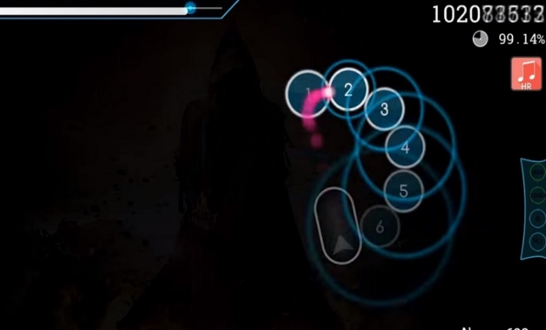
Osu!:
Osu is a completely free to play music game and its available on the website of Osu (https://osu.ppy.sh). You can also download beat maps, skins and much more on this website. In this game you must click the circles and use sliders on the beat. There are different game modes and a ranked system. On this picture the game looks very easy but there are also very hard beat maps. The important things you will learn in the tutorial. The game is for every age.

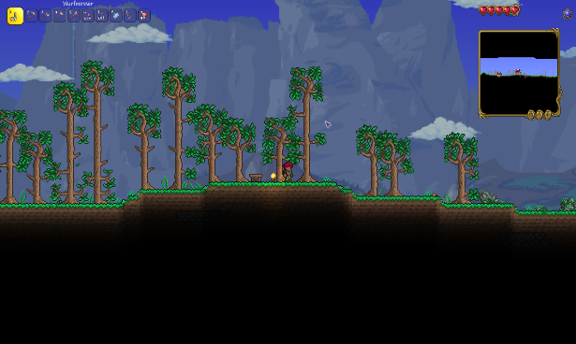
Terraria:
Terraria is like Minecraft, because it has the same rules, but its only in 2D. In this game you can play with your friends on a server ore alone in a single player world. You must slay many different Bosses to win the game. You can buy the game on Steam for 9,99€. The game has an age limit of 6 years. I think it’s a must have for every game fan.

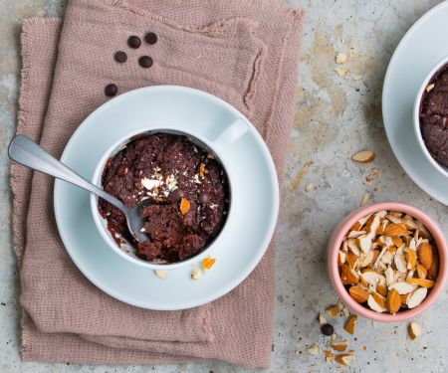
Fast Cupcakes

75g wheat flour
1 tbsp almonds (roasted and ground)
15g cocoa powder
25g raw cane sugar
¼TL baking powder
2sp. ground tonka bean
25g butter
6EL milk
2 tsp. chocolate drops
1 tsp almonds



By Elisabeth & Selina
Kitchen utensils
1 microwave, 2 cups, 1 kitchen scale

- Melt the butter in the microwave at 600 watts for 1 minute. Add the melted butter, milk and chocolate drops to the flour mixture. Put the dough into cubs and smooth the top.

- Place the flour, almonds, cocoa, sugar, baking powder and tonka bean in a small bowl and mix it for 3 minutes.

3.
Put the cupcakes into the microwave for 1 minute and 30 seconds at 800 watts. You can also take the oven. If the cup cakes are still too soft, put them in the microwave for another 30 seconds. Finely chop the almonds, sprinkle over the cup cakes and enjoy.

