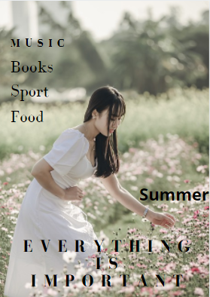
https://pixabay.com/de/photos/frau-blumen-feld-wiese-kleid-5948094/

Content:

I. Mountains, beach, or nature? Error! Bookmark not defined.
II. The most popular sport in summer 5
III. S, S and S 6
IV. Body and Appearance………………………………………………………………………………………………………………….8
V. Caprese Sandwich………………………………………………………………………………………………………………………12
VI. Salt dough………………………………………………………………………………………………………………………………….14
VII. Summer Vibes……………………………………………………………………………………………………………………………15
VIII. The Voice KIDS…………………………………………………………………………………………………………………………16
IX. Movies coming out in 2021……………………………………………………………………………………………………… 17
X. One of the best books…………………………………………………………………………………………….…………………18
XI. Book………………………………………………………………………………………………………………………………………… 20

mountains, beach, or nature?

Free time is vacation time. There are many types of vacation and travel. Where do you like to go in the summer holidays?
Do you prefer to be in the forest, on the beach or on a mountain? Not sure where you are going? Then you should read this page.

When you think of a beach holiday, you immediately think of Croatia or Italy, Brazil also has a lot of beaches and beautiful places. One of my favourite beaches is Dolphins Bay, Praia da Pipa.
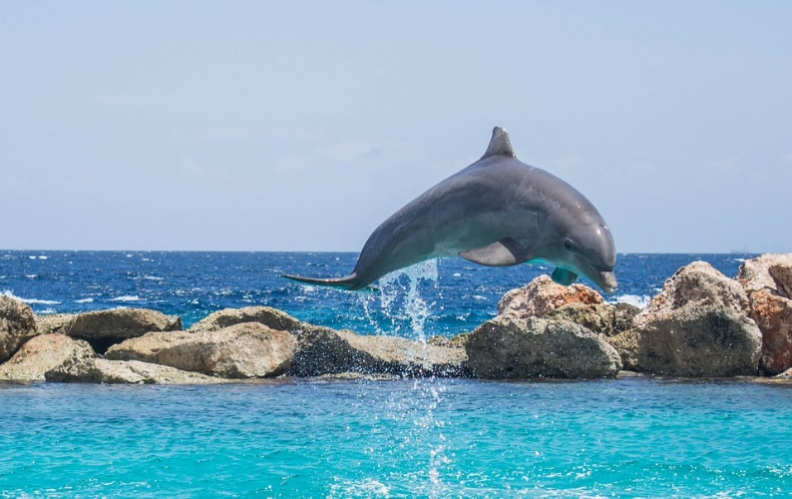
Beach
Baía dos Golfinhos is a small village in Tibau do sol it is in the near Natal.
This is my favourite beach because you can swim there with dolphins and lots of other animals. There are also a lot of excellent places to eat, drink and enjoy. And near the Beach there are also other beaches like the "Praia do Amor" (or so Love Beach). Another beautiful beach in this area is "Baía dos Golfinhos" (Dolphin Bay) and "Praia do Madeiro" (Madeiro Beach). At night, the street is closed to cars and full of people drinking and listening to music at the bars.
- #delfins # music # good food # good weather
Source: https://cdn.pixabay.com/photo/2015/08/25/04/35/dolphin-906182_960_720.jpg

Source: Pixabay
https://cdn.pixabay.com/photo/2016/07/28/16/38/dolphin-1548405_960_720.jpg

By: Sidra Khalef
Many people cannot travel that far or do not have the time or enough money to fly to Brazil. If you have a lot in a beautiful place, there are other options. Austria is maybe not the first aim that comes into you mind if you are going on a beach holiday.
But in Austria there are also a lot of wonderful Beach and it is not that far away, and it is very beautiful there.
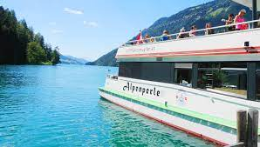
Source: https://commons.wikimedia.org/wiki/File:Weissensee_Schiffahrt_%22Alpenperle%22_im_Naturpark_Weissensee,_K%C3%A4rnten.jpg
Beach
The Weissensee is beautifully situated in a valley in the southwest of Carinthia and is one of the cleanest lakes in Austria. At the west end you will also find villages and hotels. In the eastern part it is steep and there are no villages or roads, and it is very quiet there. Most of the places along the coast of the lake can be reached by ferry. You can also rent sailing, rowing, and electric boats to cruise the lake. And there are also a lot of Hotels.

#good weather #fresh air #fun #see #sun

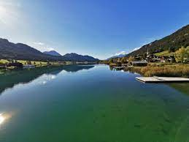

Source: https://www.google.com/url?sa=i&url=https%3A%2F%2Fcommons.wikimedia.org%2Fwiki%2FFile%3AWeissensee-ort_mw.jpg&psig=AOvVaw0TWhQbAiR95Jasw9sEYGB1&ust=1618641184405000&source=images&cd=vfe&ved=0CAIQjRxqFwoTCJionrySgvACFQAAAAAdAAAAABAT

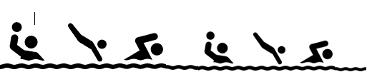

By: Sidra Khalef
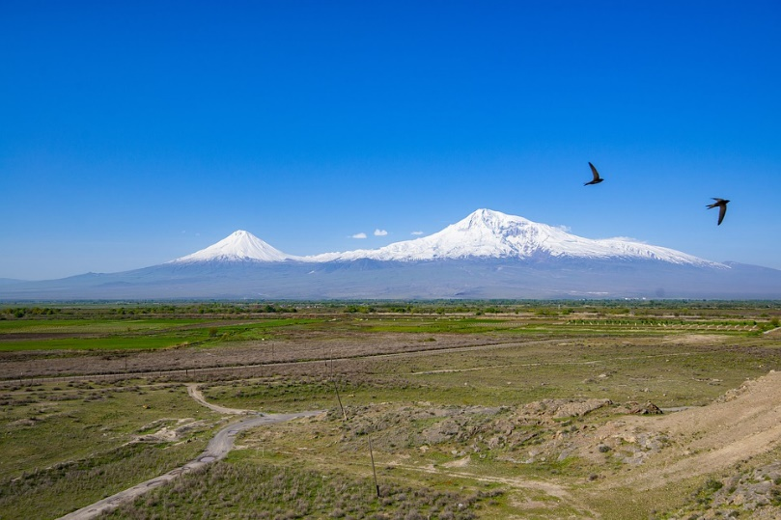
When you think of mountains, you probably think of Grossglockner or Mount Everest. But there is also a very beautiful mountain in Turkey.
Source: Pixabay.com
Mountain
Büyük Ağrı Dağı is the highest mountain in Turkey. The Ararat is in the Eastern Anatolia region of Turkey between Doğubayazıt and Iğdır, close to Iran. It has 2 peaks, the small Ararat with 3,896 meters and the large Ararat with 5,165 meters.
I like the mountain very much because it is in Turkey and it is very beautiful and in Turkey, there are also other beautiful places in the city.
- #fresh air #mountains # cool weather #hiking

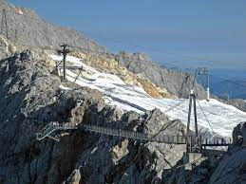
If you do not want to go far, there are other beautiful mountains that you can climb. There are also a lot of mountains in Austria that are very beautiful and very popular.
Mountain
The Dachstein is 2995m high and it is very beautiful there. There is a skywalk there and a suspension bridge. The view there is beautiful, and it is not so strenuous to hike there. And there is also an inn where you can eat a lot of good food when you are hungry and need a break.
- #Mountains #fun #sport #good weather #fresh air # good food
Source: https://commons.wikimedia.org/wiki/File:Dachstein-Plattform.jpg

By: Sidra Khalef




When you think of nature, you usually think of a forest with lots of trees. But there is also wonderful place with cacti and a lot of nature.

Source:
NATURE
Saguaro National Park, one of the most beautiful regions in the desert, is in the Sorona Desert in Arizona. It is in the USA. The National Park is full of columnar cacti that can be 15 meters high and up to 70 centimetres wide. I think it is very nice because it is something special and you cannot find something like that in other countries.
- #Colorful nature #cacti #plants #good weather
https://cdn.pixabay.com/photo/2014/07/20/12/01/arizona-397746_960_720.jpg

By: Sidra Khalef
The most popular sport in summer
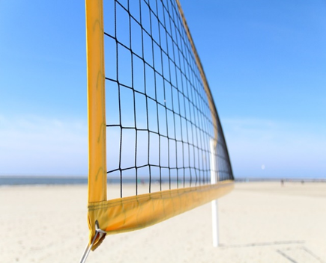
In summer everyone likes to play volleyball. Everyone loves cooling off after playing.
It is a team sport and one of the setback games. The playing field consists of two halves with a net in the middle. The ball must hit the ground on the opposite side of the game. In this game there are six players on each side. You get a point when the ball hits the ground on the other side or the other team makes a mistake.
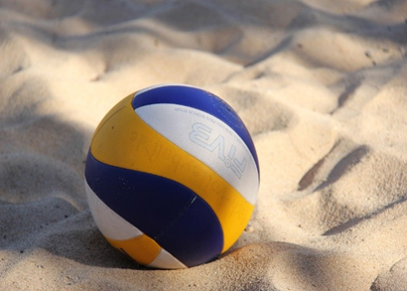
There is the possibility to play volleyball in every swimming pool. Volleyball is a perfect sport to do something with friends and have fun with friends.

https://pixabay.com/de/photos/volleyball-sport-teamsport-2639700/
https://pixabay.com/de/photos/volleyball-strand-beachvolleyball-1890209/
By: Selina. D
are moving, they can cut your skin and bones. Never put your fingers or hands into
any blender!
3) Add some juice (For example: Orange Juice to take fruits.
4) Mix until smooth. Later fill the Smoothie into the glass.
NOW you can drink and enjoy the smoothie!

You can do this anytime for your family and friends. You can even keep the drink in
the freezer. A tip for you: do not put anything out of glass in the freezer. 😊

By: Azra Kisa
Body and Appearance

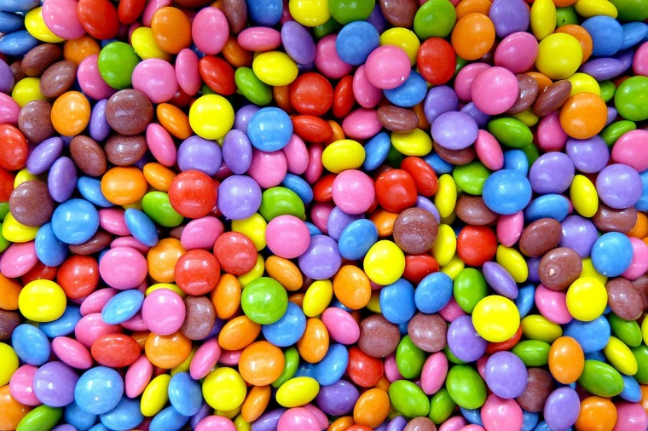
I know many of you want to have perfect bodies by summer. Will diets help? Is it healthy to eat very little? Does this diet work at all? Should you Give up chocolate? Are you doing everything right? Do you even have to weigh less?

https://pixabay.com/de/photos/s%C3%BC%C3%9Figkeiten-konditorei-s%C3%BC%C3%9F-smarties-50838/

The internet is full of pictures of perfect people. For many people it is important to have a good body. This summer it is supposed to be different, everyone must be perfect. Many are already trying to lose wight for the summer. I was going to go on a diet myself. But it is a bad idea to just do what other people want. We are at a stage where we need a lot of food because we need to grow. Why do you want to lose weight if you do not weigh much? Be yourself and do not listen to others. You can make sure you eat lots of healthy things and fewer sweets. You should do a workout, drink a lot of water, because our body needs fluid. Be yourself and get healthy, if you do, you do not need a diet. Our health is much more important than our look. Even though most people only pay attention to the appearance, you should not try to be perfect. Nobody is perfect. It’s important to stay fit, that’s why you will find here on this page a list of suggestions you can make, that is good for your body. And that is not for you to lose wight, that is for you to stay fit. I have a healthy recipe for you, too. It has a lot of what our body needs.

By: Sidra Khalef
How can I stay fit?
Even more important than the appearance, however, is that you remain physically fit. That does not mean you have to train hard. It is enough to go hiking once a week or something of this kind. You do not have to be in fitness to exercise. Here you can find 5 tips.

1. Take a long walk
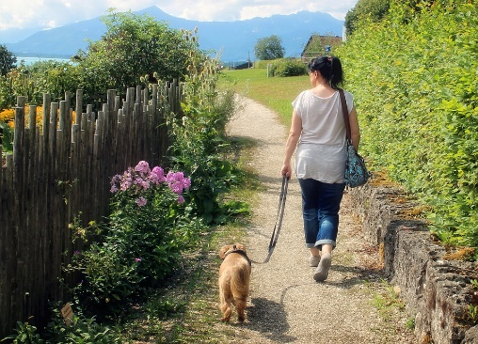
Walking a lot and long is one of the best possibilities. And of course, you do not need to push yourself Walking is not the same as jogging, which means you should walk a bit more. 30 minutes a day is enough. If you have a pet, you can take it for a walk, and you have done something good for your body for 30 minutes.
https://pixabay.com/de/photos/frau-person-hund-mensch-tier-892309/

2. Healthy eating
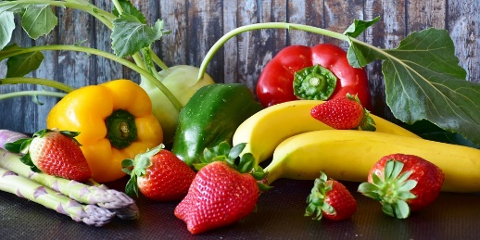
Healthy eating is very important for the immune system and protects the body from diseases. When you think about healthy food, fruits and vegetables are the first thing that comes to mind.
A healthy diet includes not only fruits and vegetables, but also low-fat such as dairy products and cereals. That means you must eat a lot of healthy food.
https://pixabay.com/de/photos/frucht-gem%C3%BCse-obst-paprika-3304977/

3. Ride a bike
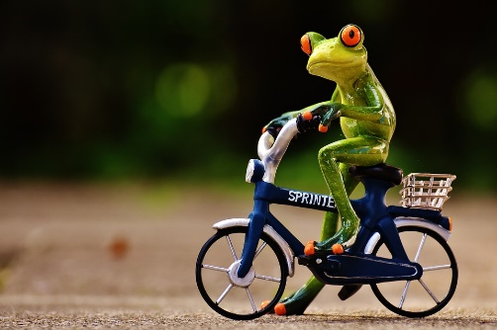
Cycling is also important. You can ride a bike with your friend for a long ride. Or if you are near the school, you can ride your bicycle to school on some days. Or if you must go shopping, you can also ride your bicycle.
Cycling reduces the risk of heart disease instead. If you ride a bike regularly, not only your legs but also your heart is well trained.
https://pixabay.com/de/photos/frosch-fahrrad-lustig-niedlich-s%C3%BC%C3%9F-1701075/
This is important because the heart muscle needs training.

By:Sidra Khalef
4. Take a break

It is important to know that you should take a break and that you should not overwork.
Recovery protects your muscles, tendons, and joints from injury. Your body needs a break to work better. Rest days are therefore just as important as training days. Your body should not become too over-strenuous, which means that you should not do too much exercise.
https://pixabay.com/de/photos/kermit-tasse-kaffee-trinken-pause-3657139/
Especially when it comes to sports, it is important to make a break. Intensive training of one to two hours is not good. Overexertion may occur, for example, microscopically small cracks in the heart muscle. Normally, they only disappear then if you take a whole week off.

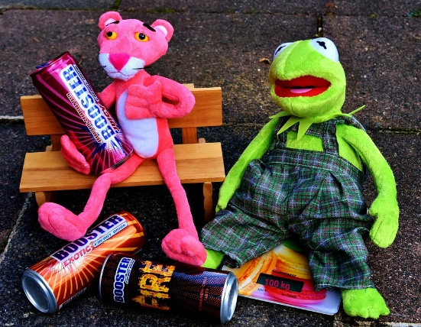
5. Don’t drink so much coffee and energy drinks
Nearly 70 percent of all young people drink energy drinks. A study from Canada now shows how dangerous the drinks can be. Every second teenager has health problems.
Energy drinks contain lots of caffeine, sugar, taurine and other substances. In 25-litre can alone contain up to 35 grams of sugar, that's 12 sugar cubes.
https://pixabay.com/de/photos/kermit-der-rosarote-panther-2875346/
Too much sugar is bad for our body, so make sure you drink drinks without too much sugar. For example, organic orange juice or water.


Also coffee you should not drink so much the coffee contains caffeine and too much of it’s not good for a child or an adult.
Insomnia, restlessness, stomach problems, impotence and headaches may be the consequences.

By: Sidra Khalef
https://pixabay.com/de/photos/kaffeem%C3%BChle-kaffeebohnen-kermit-3054007/
Social Media
what are these apps we use every day?

Everybody has social media these days and its okay that way. You can chat and call your friends and also make new friends. The most used app from 2020 is Tiktok, but there are a few other apps that are very popular. For example Instagram, snapchat, WhatsApp, zoom or Netflix..


On Tiktok you can post short videos about 15 seconds. Charli D’Amelio got more than a 100 million followers with her 17 years, she’s has the most followed account on tiktok. But she also gets hate from some of these people on the internet. You can get popular by filming how you dance to a sound or sing. The more followers you get the more money you earn from tiktok.

Instagram is something different, because you can post stories or pictures of

yourself and your friends. You can also chat and facetime your friends and make group chats so you all can text. Be careful when you write to strange people, they perhaps send you a spam message or a virus. Instagram also
hears what you are talking the whole time, so they can give you personalized adds.


Snapchat is a completely other thing, you know. Yes, you can also post stories, but you can make them private, so just people you want to see them can see it. The new thing is, you can see your friends. If you add them and they allow you to, you can see them on the snap map it’s like google maps but just with your friends in it, so you know where their location is. When you want to send them a picture you send them a snap they can open it one time and then its gone and if you want to make an screenshot from the chat the other person gets a notification that you made one the same thing with the snaps if you screenshot one.

So be careful with what you show on the internet or what you post. The chance to get hacked or to get a virus on your phone is not very low, you have to know. And please read the privacy policy of an app carefully.

A good Breakfast
But it’s also important to eat enough. That means breakfast, lunch, and dinner.
Here you will find a healthy recipe for a good, healthy Breakfast.

Breakfast:
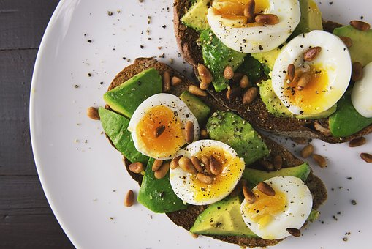
A healthy breakfast is important because you need a lot of strength for the day.
Avocado bread with egg:
- 1⁄2 TL peeled sesame
- 1 onion
- 1⁄2 Lime
- 1 Avocado
- Salt and pepper
- 1 grain bread
- 1 egg

https://pixabay.com/de/photos/lebensmittel-ei-eier-toast-2673724/
1) Fry the sesame seeds in a pan, then take them out and let them cool.
2) Wash the onions and cut them into small pieces.
3) Cut the avocado in the middle and remove the core.
(With a spoon you can easily get the avocado out)
5) Add a few drops of lemon to the avocado.
6) Boil an egg in a pan with oil.
7) Spread the avocado on bread and put the egg on the top.
8) Put the onions and sesame on the egg outside.
Enjoy! By: Sidra Khalef

CS

Caprese Sandwich
Summer is coming, that means picnic season. Your blankets are ready, your drinks are ready, but not your sandwich? Yes? I'm going to show you how to prepare a great sandwich. Don’t worry! it's simple and tasty. Good picnic food does not have to be hard. This sandwich is here to prove it.
Caprese Sandwich Recipe Ingredients
Here is what you will need to make this sandwich recipe:
- Mozzarella cheese
- Tomatoes
- Basil leaves
- Olive oil
- Salt
- Pepper

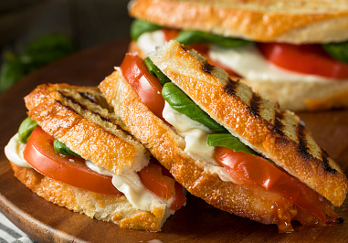
https://media.istockphoto.com/photos/healthy-grilled-basil-mozzarella-caprese-panini-picture-id930271208?b=1&k=6&m=930271208&s=170667a&w=0&h=l20WIucho4A8oq5MqSzMM7Wt3d-S9uGePdHmVFF9RPw=

Instructions
- First wash the tomatoes and cut them into pieces. Wash the basil too.
- Then cut the mozzarella into small pieces.
- Cover two slices of sandwich with tomatoes and basil and drizzle with an olive oil.
- Then you should put all these ingredients on top.
- After that season with salt and pepper.
- Finish each with another sandwich slice.
If you want, you can put the sandwich slices in the toaster for a few minutes so that it is crispy
This sandwich is perfect for a picnic because the tomatoes have so much water. So it would be better if you do a few hours ago this sandwich. If you do that early, it will get wet. And then it won't taste so good.

PICNIC PLACES
Everything is now ready, but you, your family and your friends don't know where you guys can have picnic because all the restaurants are closed because of corona and you don't have a garden at home? How about a picnic in town? Yes, you have read that correctly, Graz have many great chances for an enjoyable picnic. I will show you some places in Graz where you can have picnic.

First of all, you can have picnic in Thalersee:
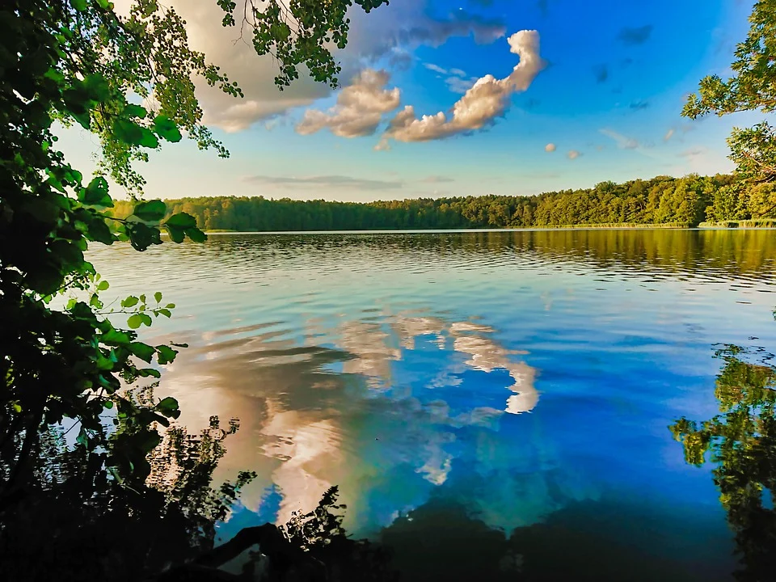
There you can have a picnic, swim, ice skate in winter and hike. There are also golf courses near Thalersee. So if you like to play golf you can play golf there. It’s a beautiful place!!
https://cdn.pixabay.com/photo/2021/04/06/11/18/lake-6156112__340.jpg
The next place where you can have picnic is Hilmteich:
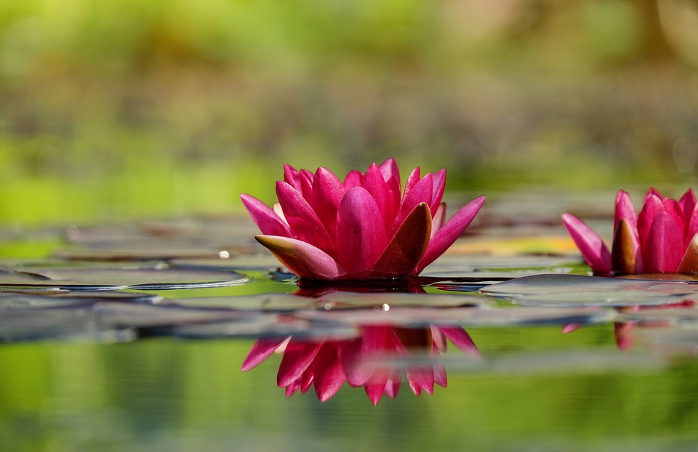
https://cdn.pixabay.com/photo/2016/06/07/20/20/water-lilies-1442497_960_720.jpg
This is a small but lovely pond at the foot of Leech Forest. It’s a nice place to relax as well as to be active in sports. You can go for a walk, run, ice-skate, etc.
Hopefully you now have an idea where you can have a picnic

By: Azra Kisa

Salt dough

Children's recipe - make clay yourself
Make clay yourself quickly and easily with step by step instructions especially for children to do it yourself.
Recipe from Little Stories

6 ingredients
ingredients
3 cups of flour
1/2 cup of salt
1 cup of water
2 tbsp lemon juice concentrate
2 tablespoons oil
Food coloring

By: Selina. D

Summer Vibes


Music is very important for our society because music is not just any melody or text. when you are sad you hear your favorite music and you feel better again, when you are stressed, you listen to music to relax. Musicians show their feelings and emotions in music, so when they write a songs text.

Music often makes you feel better, because for example in this corona time, when you can't celebrate with your friends on the beach or at home. Here is a playlist with summer songs in the quarantine time, because we also can’t go to concerts or party’s.

Here is the summer playlist to chill:

- Right round (Mark Brown Remix) by Flo Rida
This song is more like a party song and it makes good vibes
- Peaches by Justin Bieber ft. Daniel Caesar
This one makes good vibes but it’s not that party song more to
chill with friend
- Tongue by GroupLove
- Backyard boy by Claire Rosinkranz
- My Head & My Heart by Ava Max
- Seven Nation Army by The White Stripes

I have chosen these songs and put them into a playlist because I think they are good summer songs to have a nice day with. This is more my taste so if you don’t like this song very much you don’t have to listen to them and listen to your favorite music..

By: Michelle Pregova
https://pixabay.com/de/photos/publikum-konzert-musik-unterhaltung-868074/https://pixabay.com/de/photos/mobil-telefon-samsung-musik-605422/
The Voice Kids

.

There are four coaches, who are all famous in the music industry. During the blind auditions, these coaches will turn around in their chairs when they hear a performer, who is between the age of 8 and 14, they want in their team. If there are more coaches who want a performer, he or she gets to choose who they want as their coach. During the battles there will be two or three contestants from the same team up against each other. The coach then must choose one of them to get through to the live finale. 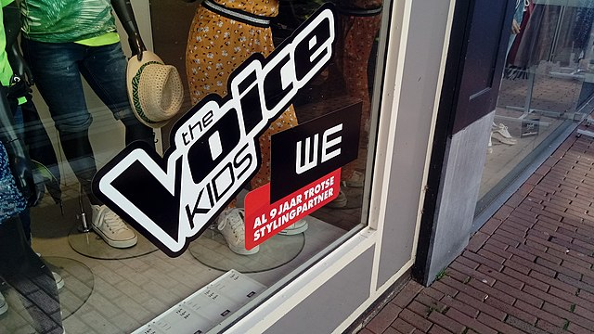Search media - Wikimedia Commons

By: Selina. D


Movies coming out in 2021

You might want to know what movies are coming out this year, so you can watch them with your friends in the cinema or at home on the couch, if it’s a rainy day or you’re just ill.
Here I have a couple of films from the Action Films category. There are about 5 new films that are coming out and I hope you will enjoy them when they are available. You can watch them in the cinema or simply at home in front of the TV or in bed. Of course, they are not all the films coming out this year, just a few action and comedy films.

The first one on this list is:
Godzilla vs. Kong
This movie will come out on May 20th the film is about who will be ,,the king of the monsters’’ that means Godzilla and King Kong fight against each other and one of them will be the king at the end. The film is almost 2 hours long. The actors are Millie bobby brown, Alexander Skarsgard, Rebecca Hall and others.

Black Widow
This movie is coming out on July 8th and it’s a Marvel film, which means superheros called Avengers are saving the world and the universe. Natascha Romanoff aka ,,Black Widow’’ is a Russian spy and also one of the Avengers. The character is played by Scarlett Johannsson. The film is about two hours and 10 minutes long.

Fast & Furious 9
This movie came out on April 1st and is from the fast & furious saga. The characters are played by John Cena, Vin Diesel, Michelle Rodriguez and some other popular actors and actress. The main characters are Dom and Letty with their son Brian, they just want to live a calm life.
__________________________________________________________________________

There are many other films coming out this year. There are some Marvel films but also some horror movies but for them you need to be 18 years old, or some romantic movies also for older people.

By: Michelle Pregova

One of the best books
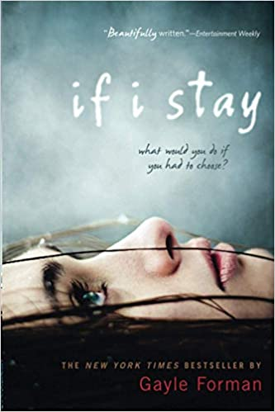
In summer, the weather is almost always nice, but there are days when the weather is not so good and where you do not want to go outside or are not allowed to go out because you are sick. Then you can read a book. One of my favourite books is “If I stay’’. Reading books is very cool and nice when I read books then everything is better, and it is not so boring. Sometimes I also read English books because I want to be better in English. Reading books is for my very important. When you are sick in the summer holidays you should read a book. “If I stay” is a perfect book, because the book is not boring and the 100 first pages are as exciting as the last 288 pages.
.If i stay.
Autor: Gayle Forman
Pages: 288
Age: 14 and up
Language: English

This book is about a girl named Mia, she had everything. Mia had a very friendly family, a boyfriend, a lot of friends and she was a very good musician. But then she lost everything. In a car accident her parents and her brother died, and she had a concussion and an amnesia for a short time. She can not remember a lot and when her friends came to her then she started to remember small things. So, she had to decide whether to stay in this world or to go.
It is very difficult to decide because of her ex-boyfriend.

By: Sidra Khalef
If you want to know what she decides, then you must read the book. I really like the book, because it is a very short story, and it is easy to understand the story and what happened in the book. In my opinion this book is not for kids and not for young teenager. You should read the book when you are 14 and up, because then you also can understand the story.

By: Sidra Khalef
Book
Would you like to read an English book, but you can’t find a book? Because some books you read you dislike and the others are difficult to read right? I'll show you one of my favourite English books. I like to read because I can live a thousand different lives. It's a great feeling when a book makes you laugh or cry.

Book name: Amy
Author: Mary Hooper
Page: 176 pages
https://images-na.ssl-images-amazon.com/images/I/419XGPBEXGL._SX329_BO1,204,203,200_.jpg
She had 3 best friends and they did everything together until one moved away. Now her other two friends have left her. She doesn’t have friends any…...until she meets Zed. Amy meets Zed in an internet chatroom. She wants to meet him but is he really who he says he is? Can you trust Zed?
If you want to know how this book ends then read the book!!!

This book is perfect for naive teenagers and has a very important message. I love this book because it’s a realistic book. Don't trust everyone and be careful first. You don't know anything about this person. The profile picture can be fake and the name also. If something seems strange to you, better break the contact. This book is good for young adults. Even people who don't speak English very well can read and understand the story.

By: Azra Kisa

