The beautiful side of Austria
Ideas for wonderful day summer trips near Graz
by Elias Kitzberger
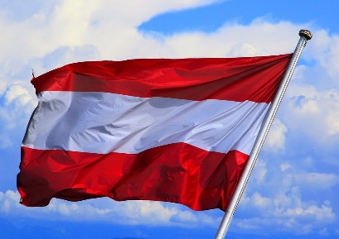
We can’t be sure if we will be allowed to travel again in the summer holidays. Even if it’s possible to travel, most of us wouldn’t like to travel to other countries, because of the Corona pandemic. But that’s not a problem. In Austria we have a lot of beautiful places too. Maybe not buildings as tall as in New York, or a sea like in Italy, but other cool and extraordinary things. In my opinion the two day trips described below are the best. I’ve been to both and really enjoyed it there.
Österreich Flagge Wind - Kostenloses Foto auf Pixabay
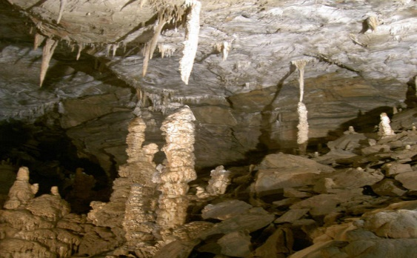
Lurgrotte: Near Graz there is the Lurgrotte cave. It’s a fascinating trip. You can reach it easily from Graz. It’s the largest stalactite cave in Austria. You can go into the Lurgrotte only with a guide. Every hour a guided tour takes place. In summer the tours are for free. In the winter a private guided tour costs 8 € (normally in winter there are no tours, so if you want to go there you have to book a tour). In the cave it is very cold, about 8 to 10 degrees. So, I can recommend wearing a jacket and comfortable walking shoes.
Lurgrotte-2 - Lurgrotte – Wikipedia
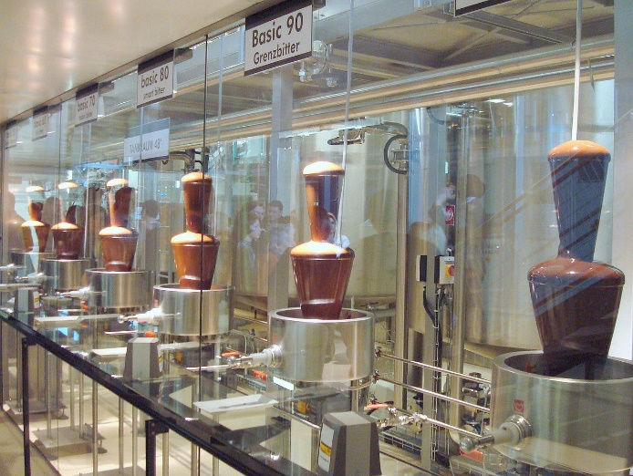
Zotter Chocolate Factory: Maybe you have already been there, I’ve been there more than three times. If you like chocolate the Zotter Chocolate Factory is a must. The tour starts with a short film. After the film an audio guide leads you through the factory. You can see all steps of making chocolate. After each step you can try the chocolate by yourself (not the finished one, but the chocolate after the process you have just seen). Sometimes it is delicious, but sometimes it is a bit too bitter. At the end of the tour you can try as much finished chocolate as you want. You can try chocolate flavours you have never heard before. There are over 400 different flavours. After the tour you can buy Zotter chocolate in a shop. As I see it, the funniest thing is that Zotter also made a kind of chocolate graveyard. Every chocolate flavour that did not succeed “rests in peace” there. Of course, such a big tour costs a lot. You have to pay 17.90 € for each person. Even if this is expensive I can recommend the chocolate factory for everyone. Normally I am not the biggest chocolate fan, but at the factory I liked it quite a lot
Schokoladenmanufaktur Zotter Bergl Riegersburg Schokotankstelle BASIC 50-100 - Zotter Schokolade – Wikipedia
These are only two of many beautiful places near Graz. If you want to do more exciting things in the holidays you can check this list: 25 Best Day Trips from Graz as Recommended by a Local (nomadepicureans.com)

