From angry to charity
Why Ronaldo’s fit of rage also had an advantage
by Elias Kitzberger
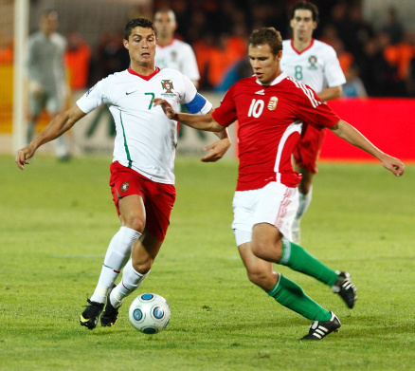
Every four years a WC (World Cup) takes place. The next WC is going to take place in 2022 in Katar (Qatar). France won the last WC. Only 32 teams can take part in this competition and the WM-qualification determines which 13 teams from Europe take part. And this qualification is now in whole Europe. The teams are distributed in groups where each team plays against every team in its group twice. Austria has also a chance to take part in this competition.
Two weeks ago, a scene overshadowed the game Serbia against Portugal. This game ended 2:2, a draw which meant one point for each team. In the overtime Cristiano Ronaldo one of the best soccer players scored a goal. 3:2 for Portugal everyone thought and every player from Serbia was disappointed. But the referee decided that it wasn’t a goal. The ball wasn’t over the goal line, the referee thought. In the WC-qualification there is no VAR* that could check if this really was not a goal. Ronaldo gets very angry because Portugal would have gotten three points, if this goal had counted. He wasn’t that angry in a soccer game for a long time. He raised his captain’s armband* from his arm, through it on the ground and left the game field. If Portugal had won this game, they would have had a real chance to take part in the next WC in Katar.
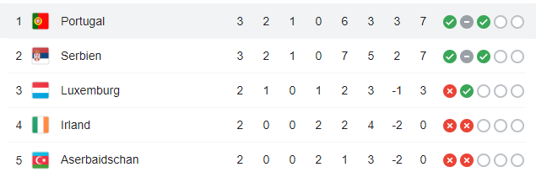
After this game the was auctioned* for 64 000 euros. The money they made was given to a sick child. A very nice gesture, I think / in my opinion / I would argue….
Points
Wins

Draws
Goals for/ against you
Loses

Gameses
auctioned: When something is auctioned everyone can say a prize he would pay for the auctioned thing. The person with the highest bid wins and gets the thing. Of course, he has to pay the price for it.
captain’s armband: Every soccer team needs ads. Captain/skipper He leads the team through all the games. To mark the caption, he gets a loop. He ties it around the arm.
VAR: The Video Assistant Referee can check goals after they are scored. They can watch the situation again in slow motion as often as they want and so they hardly make mistakes. Often the VAR is a decisive game character. But the VAR is also in critic.

