Videogame recommendations

Shell Shock:
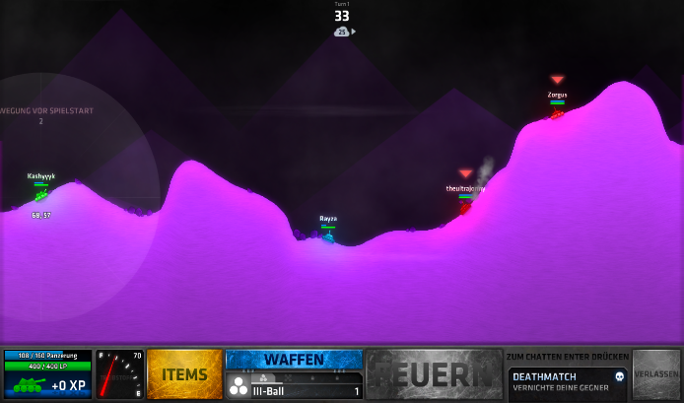
Shell Shock is a tank game, where you can play alone or as a team to 4 people in one team. There are many different game modes and weapons. You can level up your tank with shields, better wheels, more fuel and much more. With level ups you can get better weapons and new items. The game costs only 6,99€, and its available on Steam. The best thing about the game is that it is not P2W (Pay to win).

Osu!:
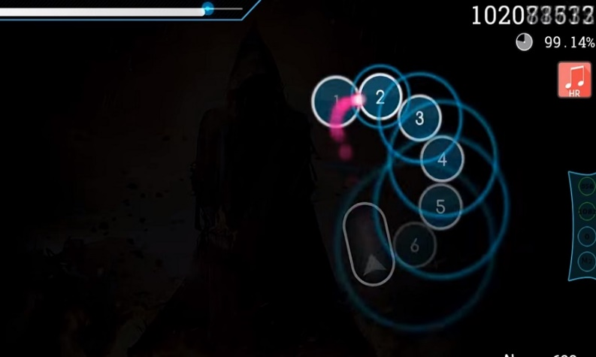
Osu is a completely free to play music game and its available on the website of Osu (https://osu.ppy.sh). You can also download beat maps, skins and much more on this website. In this game you must click the circles and use sliders. There are different game modes and a ranked system. On this picture the game looks very easy but there are also very hard beat maps. The important things you will learn in the tutorial. The game is for every age.

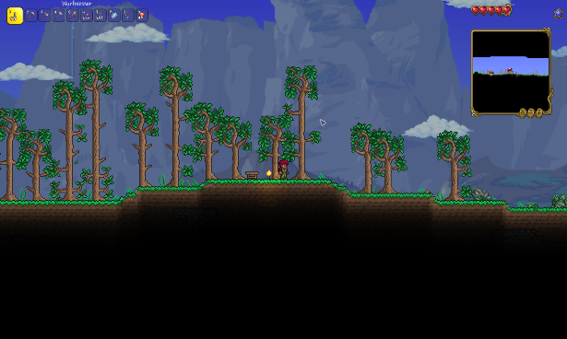
Terraria:
Terraria is like Minecraft, because it has the same rules, but its only in 2D. In this game you can play with your friends on a server ore alone in a single player world. You must slay many different Bosses to win the game. You can buy the game on Steam for 9,99€. The game has an age limit of 6 years. I think it’s a must have for every game fan.

