Why Disney isn’t that good
What happens behind the scenes
By Selina
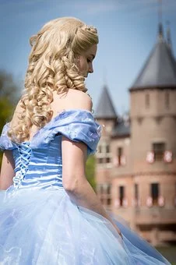
.
Is there rases and sexism’s in Disney movies?
Everybody knows Disney as a company from America but there are many scandals. In the Disney movies you will find lots of prejudices against people with other skin color. These prejudices are not acceptable in our century. Lots of peoples fight against rases and questioning this scandal. The Disney company of course, rejects the allegations. Another allegation against the company is sexism in the films. Mainly in the princess’ films.
The Disney Land:

The Disney Land is a Theme Land where people can go when they want to have lots of fun but there were also lots of scandals. Many people who went to Disney Land are pedophile and rape children. Lots of workers were arrested because of that. A detective could arrest a worker because he saw him rape a child. These things not always went like that. Lot of teenager and children were rape from workers but also from visitors.

Pictures from Pixabay

