Cyberbullying

Cyberbullying is very hard. Most people can’t image a life without a phone. Young people use social media more than one hour a day. Sometimes that can be really bad. On the internet people are often bullied just because of little things. People often send pictures of other people and make jokes about them or spread rumors. Sometimes it can get even worse and other people hit them or they get depressed or even want to kill themselves. People on the internet bully people so much, without even recognizing that this isn’t good. Most victims of bullying want to change something with their body or face. They are no longer happy with their bodies. Getting out of this phase is very difficult because everything on the internet is saved and you can’t delete it easily. Bullying is very hurtful, and I think people shouldn't be bullied because of bad things they have done in their life. They will realize their mistakes on their own, bullying does not help.

A victim of bullying told us: “I was in a such phase and I know how it is and this time was really bad. It took more than one year to get out of this phase. My friends helped me and they were always there for me and have helped me with many things. At this time I was very thankful that there were people who helped me. I hope someday cyber bullying will be stopped and that there will be bad consequences for bullying.”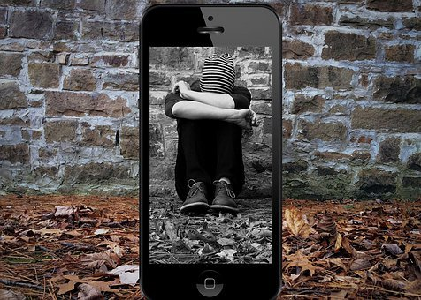

What to do if you or your friends are bullied online

