fresh self-made recipes
easy to make – delicious to eat

Over one-year Corona has controlled our life’s. Even in the summer holidays we cannot choose what to do. To think about something other, we create 2 recipes for the summer holidays to relax and find the summer feeling. The ingredients for both recipes are cheap. The first recipe is for a self-made ice cream. To make ice cream you need an ice cream machine. We decided to put an extra recipe into the magazine. This recipe is for strawberry Tiramisu. Both recipes are delicious.

Ice cream Strawberry Tiramisu
300g raspberry  20ml milk  250ml whipped cream  1 tbsp Lemon juice  100g powdered sugar | 1 kg Strawberry  750g Mascarpone  500g curd  2 EL Lemon Juice  120g powdered Sugar  40 pcs. Ladyfingers
Puree the Raspberry with the mixer | Puree the strawberries with the lemon juice and powdered sugar. Then mix the mascarpone with the curd with 2/3 of the strawberry mixture
Put the raspberries, powdered, lemon juice milk and whipped cream into the container of the ice cream maker | First, place the ladyfingers in a shape and then give some strawberry mixture on top
Freeze the ice cream maker for 40 minutes | Put another layer of ladyfingers on top and so on. Finish with the strawberry mixture
Then you can serve the ice cream | Put the Tiramisu in the fridge for 6 hours
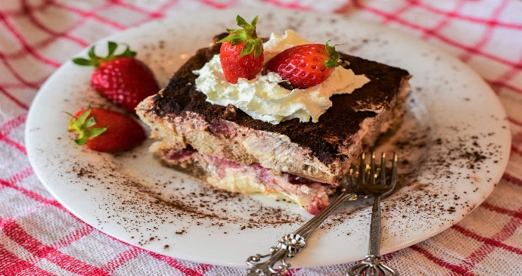
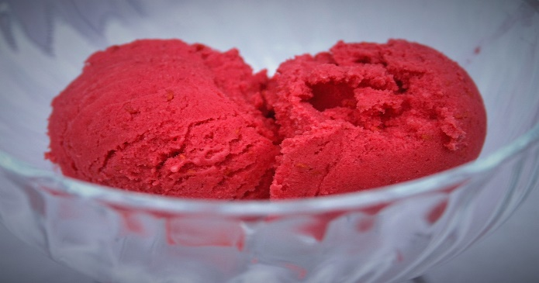

https://pixabay.com/de/photos/eis-himbeere-lebensmittel-creme-1564728/ https://pixabay.com/de/photos/tiramisu-dessert-kuchen-scheibe-6172170/
I hope that you enjoyed reading my article. Maybe you will try one of the recipes in the summer holidays or even in the next few weeks. I can recommend both recipes, because the taste of strawberries and raspberries create the best summer feeling.

