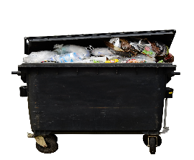
Food waste
many people around the world have problems to get something to eat, but new findings from a new United Nations report, say that every sixth piece of food get thrown away.
.
690 million people go hungry each year. More than 3 billion people can’t afford a healthy diet. At the same time, the food waste produce 8-10% of global Greenhouse gas emissions. Reducing food waste could ease world hunger and help prevent climate change.

World hunger:
Everyone knows that world hunger is a big problem. The world hunger index 2020 says 18,2. Too many people around the world are still hungry: 690 million people are malnourished, 144 million children suffer from emaciation, a sign of acute malnutrition, 47 million children suffer from stunted growth, a sign of chronic malnutrition. In the year 2018 5,3 million children died of hunger.

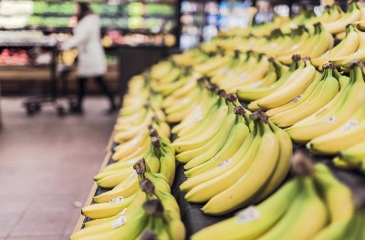
Now you know that food waste is a big problem. Think about it when you are buying food next time, because when you focus on what you eat you will notice that you are wasting a lot of food as well. For example: hard bread, because you didn’t eat the whole bread, etc... When you don’t waste food, you will help the environment.
.

