„Is this the end of a long and successful career” criticism of Sebastian Vettel
by Felix Wieser


Sebastian Vettel doesn’t feel well after the unsuccessful
start into the season. Now Timo Glock and Ralf Schumacher are
also criticizing him.

Timo Glock and Ralf Schumacher were hard on Sebastian Vettel. Vettel finished the first Grand Prix of the season in Bahrain in an Aston Martin on the 15th place* and made many mistakes.
The mistake in qualifying should not have happened to him. For this mistake he got a penalty* and in the race he made a mistake too. Then to say: 'The other made the mistake' - is very disrespectful. He has to try to act cleverly and really concentrate, "Glock told to Sport 1. https://de.wikipedia.org/wiki/Datei:2019_Formula_One_tests_Barcelona,_Vettel_(47200008782).jpg
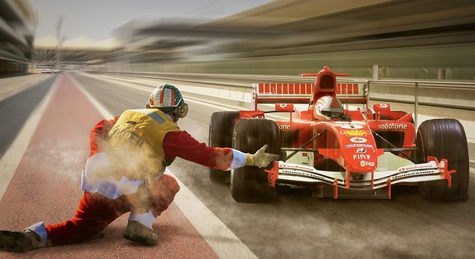
Schumacher went one step further and asked Vettel to "just step on the gas". And Schumacher is also not happy with Vettel’s disrespectful way to communicate.

https://pixabay.com/de/photos/rennsport-formel-1-boxengasse-3415413/
*15th place: Every team, like Mercedes, Red bull etc. have two drivers so totally there are 20 drivers and the 15th place is very bad.

*Penalty: You get a Penalty when you bring another driver into trouble because of your own mistake.

I am sorry, Felix, but this article does not work at all. I do not understand what you are talking about because I do not know what actually happened and what Vettel was criticized for.
I also do not see the relevance – what is going to happen or what might happen. And what does the title refer to?
You will have to work on this article again from scratch.

