Formel 1: „The complaining must stop” criticism of Sebastian Vettel
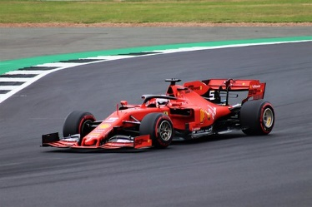

Sebastian Vettel doesn’t feel well after the unsuccessful
start into the season. Now Timo Glock and Ralf Schumacher are
also criticizing him.

Timo Glock and Ralf Schumacher go hard with their compatriot to Sebastian Vettel. Vettel finished the first Grand Prix of the season in Bahrain in an Aston Martin in 15th place* and made many mistakes.
"The mistake in qualifying must not happen to him. There were other cars that had the yellow flag* that did not receive any penalty*. The mistake in the race must not happen to him. Then to say: 'The other made the mistake' - He has to try to act cleverly and really concentrate on the essentials, "Glock told to Sport 1.
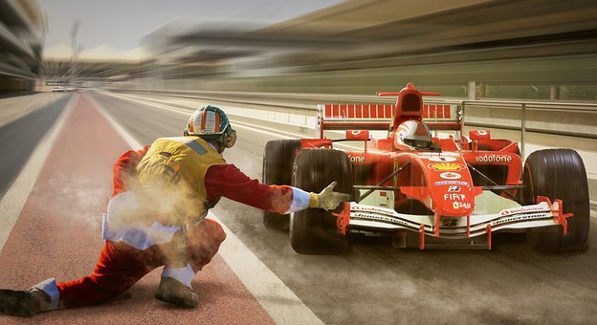
Schumacher went one step further and asked Vettel to "just step on the gas". And Schumacher is also not happy with the way how Vettel communicates: "I'm sorry that he assardet that the car doesn't have to stop."

*15th place: every team, like Mercedes or Red bull etc. have two driver so totally there are 20 drivers and the 15th place is very bad
*yellow flag: A yellow flag means that you cannot overtake because of an accident
*Penalty: Penalty points are so- called "Strafpunkte"

I am sorry, Felix, but this article does not work at all. I do not understand what you are talking about because I do not know what actually happened and what Vettel was criticized for.
I also do not see the relevance – what is going to happen or what might happen. And what does the title refer to?
You will have to work on this article again from scratch.

