How you can start a sportier life



Today a lot of adults and also children are sitting in front of the computer all day. But that is not good for their health and that’s why I want to give you tips, how you can cange your life.

By: Tim K

Meet your Friends!

You can meet your friends to go with them on a walk or a run. If you do that with your friend, he can motivate you and you can motivate him. So, with this trick you can get better results.
Your friend can also remind you of your sports meetings so you can’t forget it and develop a routine to stay active.

Join a Club!
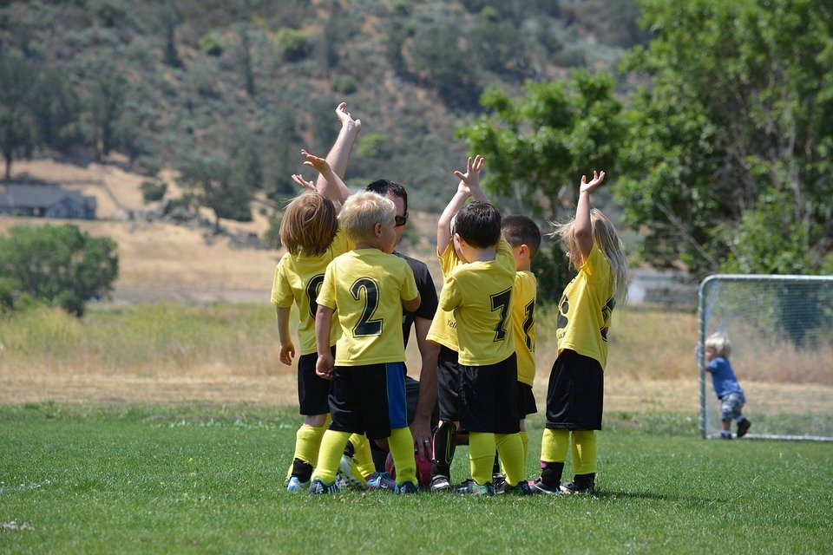
There are many clubs in Graz. You only have to choose a sport you are interested in. For example swimming or soccer. When you are in a club you will get a trainer, who can correct you if you do something wrong. That is the advantage of a club. The disadvantage is, in a club you can’t change the time of your trainings. So, if you have school longer you might not be able go to the training and this could be a big problem.

YouTube can also help you!

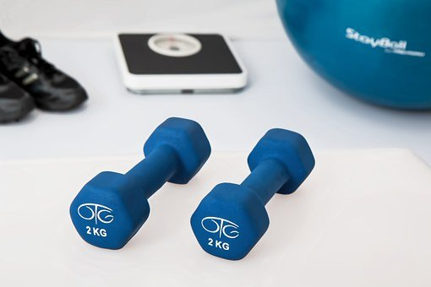
Everybody should know YouTube and there you can find also creators who produce sports content. These youtubers can give you tips and also motivate you with their videos. The workouts from these people are free end easy to understand, so everyone can do them at home. But the biggest advantage of YouTube are the discount codes from the youtubers. With those you get for example 10% discount on equipment that you need for the training at home.

I hope that this article could help you with the start of your sporty
lifestyle.

