The Volcanos of Hawaii
A volcano erupted

Every year there are 50 to 60 volcano breaks. Some volcanos are always active. In the last 10.000 years were 1900 volcanos active. At some inactive volcanos there are tours, where you can look at the volcanos. Of course, for a trip like this you need a guide. The biggest volcano of the world is called Mauna Loa.

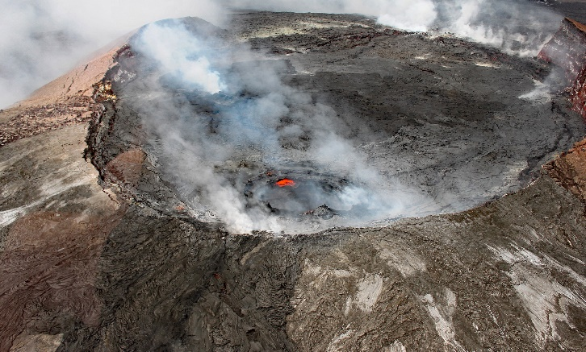
Kilauea
The Kilauea is an active shield Volcano on the big Island of Hawaii. Lava has been flowing there since 1983. The Kilauea is a part of a chain of volcanos. The chain is called Hawaii-Emperor-chain*. The Kilauea is the most active volcano of the world. The volcano erupted 2018. Fountains of Lava rose and there was a 1,1 km lava flow.

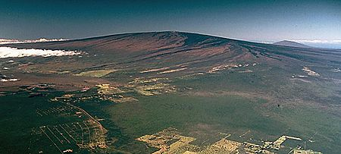
Mauna Loa
The Mauna Loa is the biggest volcano of the world. The name “Mauna Loa” means “long mountain”. The volcano is in the middle of the Pacific Ocean. He is also a part of the Hawaii-Emperor- chain*. Mauna Loa is 4170 m high and the length is 120 km. It covers 5270 km² and he has volume of 80.000 km³. The last outbreak of Mauna Loa was on 15. April 1984.

Hawaii-Emperor-chain*: That is a chain of volcanos in the Pacific Ocean

Maybe you have learned something about this text. I hope that I can visit a volcano in future. That is my biggest dream.

