Friday for Future in times of the pandemic
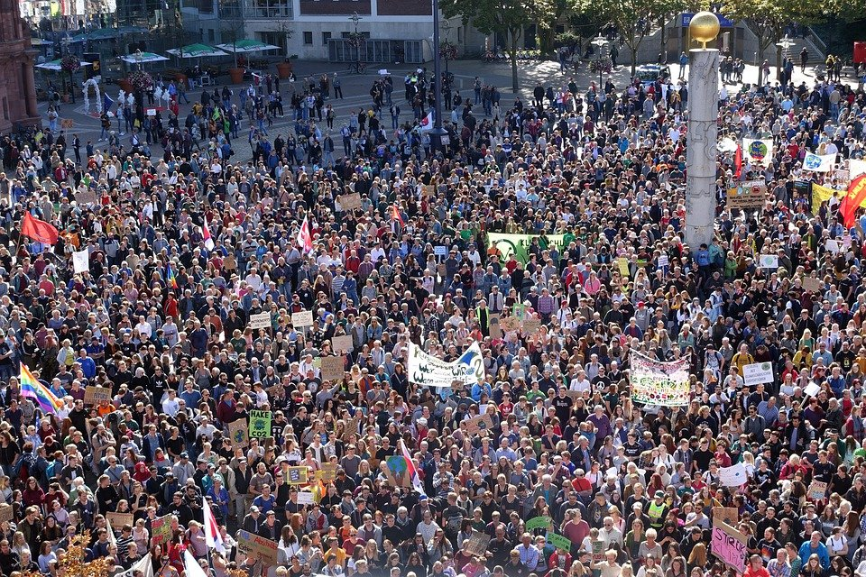
Friday for future (FFF) is a global movement. Many teenager, children and students take part. But in these times where any events are forbidden are hard.
by Elisabeth

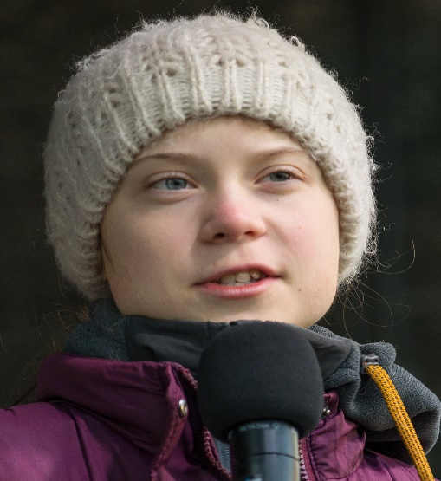
What do they want?
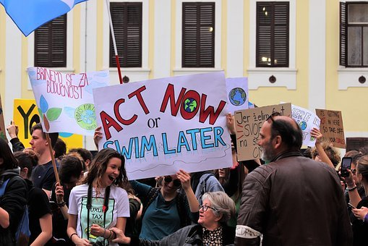
It’s about stopping climate change. If everything continues as it is now, a global climate catastrophe is imminent. Fridays for Future wants to change this through protest. The goal is to stop climate change. The 1.5-degree limit is important here. This was set in 2015 in the Paris climate agreement.
Who is Greta Thunberg?
Greta is a Swedish climate achivist.activist At the age of 17, she started a global protest against climate change. This was taken up by children, teenagers and young adults around the world
20 August 2018 is the day it all started. Instead of going to school, Greta Thunberg demonstrated for more climate protection in front of the Swedish government. With the slogan
"We strike until you act!”

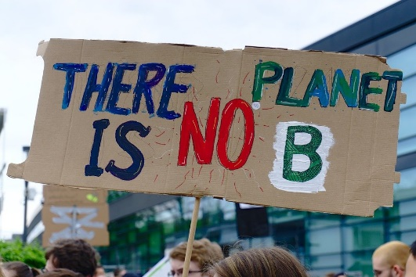
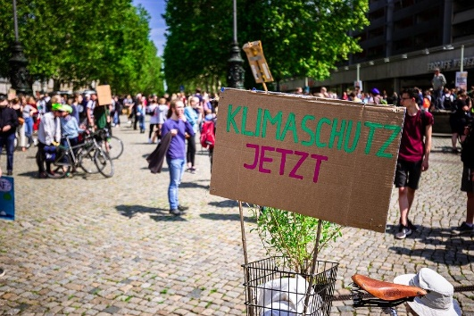

This is how it works with Covid 19
In times of Corona, FFF movement is also struggling. Besides empty streets, the Corona pandemic brings with it many feelings of insecurity and worry. Some people just have other things to worry about since Corona than the climate, it seems.
As soon as events are allowed again, blant Friday for Future events with a limited number of people wearing masks will take place. All FFF members hope that demonstrations can take place again soon.

