Living without plastic
What is it like to dispense things?

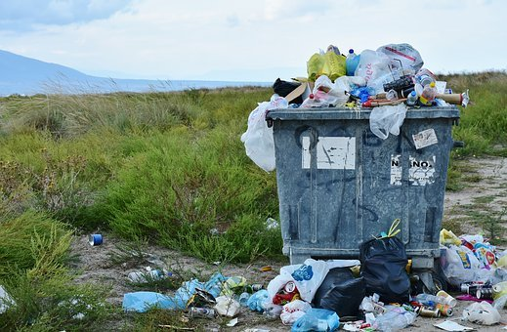
What’s the problem with plastic?
You find plastic in most products you buy. This is a big problem because the microplastic but also the normal one ends up in the seas and lakes but also in the forests and on the streets. Our climate is under attack. When we want to stop the Climate Change, we must dispense some products especially some with plastic.
What is the alternative for plastic products?
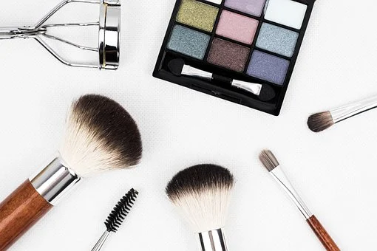
Because the plastic is such a big problem some people decided to live without it and buy only things that made of naturally materials. For some products there are some alternatives. For example, straws. The EU forbidden them because of the Climate Change but if you don`t want to dispense with plastic straws all togehter you can buy some made of glass. Also, in cosmetic there is a lot of plastic that you can’t see because its microplastic. This plastic is very bad for your health and for the world. If you want to dispense on that you can buy nature cosmetic. When you want to live without plastic you have to be creative and always look for new alternatives.
Sandra Krautwaschl

Sandra Krautwaschl and her family live without plastic for a while know. She had that idea when they were on Holidays in Croatia and saw the plastic on the beach and in the sea. Sometimes before she had watched a film about plastic called “Plastic Planet”. This movie was and is a big motivation for her and the family. The tried to find alternatives for the products and gave the plastic products away. At first it was very hard for them because they had to go without a lot of things. After a time, she said that life is easier with less plastic and less products.

