The big problem bullying
Everyone can stop bullying


What would you do?
Imagine the following situation. You are walking through the school hallway during recess and you notice a child who is badly bullied by others. You have the choice to look away and just keep walking, but you also have the choice to help the child. What and would you do? How do you act? Be honest. Everyone here knows the situation of being outcast and badly treated. But we have a choice to do something about it.
Does Bullying leaves damages?
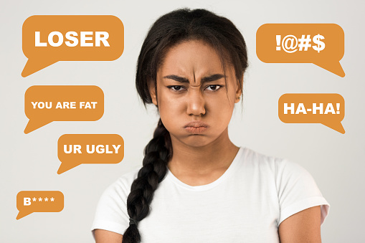
Bullying often leaves damage on the person being bullied. Afraid of being hurt scared of being singled out and scared of going to school. Many of the students must live with these fears. Often you do not see what is going on in that person., you feel This fear the day before, just when you think about getting up the next day. Bullying can make your life difficult.
Why don’t people help?
Why do so many people not take notice when they see someone being bullied? Why do so few people help when someone is hit? Often people do not feel able to help on their own. The whole thing can be changed, and we can choose to help the next time instead of looking the other way.
Everyone has the right to belong and to be treated with respect. We have the choice!

