The Problem with Palm Oil

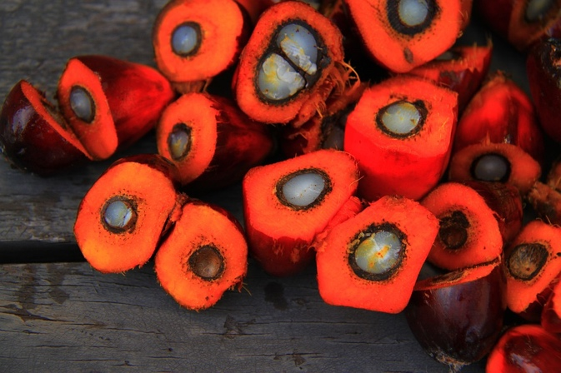
Find out why using palm oil is a big problem for the environment and how you can help the environment.

by: Tim K.

Palm oil is an important product for the food and cosmetics industries because the production is really cheap and you get more oil from less farmland than compared to other
oil crops. In addition, these palms grow quickly and are very long-lived.

But what is the problem with palm oil?

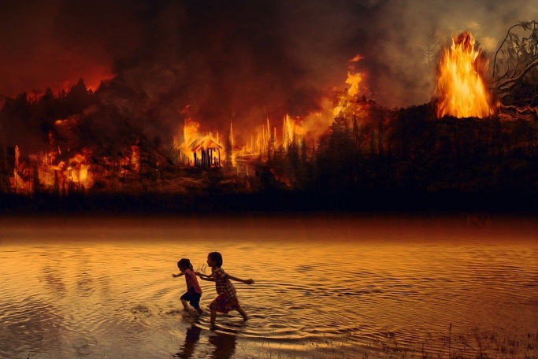
We need more and more of this oil, so more and more plantations have to be
built. But these palms can only grow in tropical areas, and this is the problem, because the rainforest has to be cut down in order to use the fertile soil for palm plantations. If this is done, the CO₂ from burning the woods and the dirt come into the air and this is bad for the environment. In addition to that, also all the exotic animals lose their homes and die..

How can we fight for it?

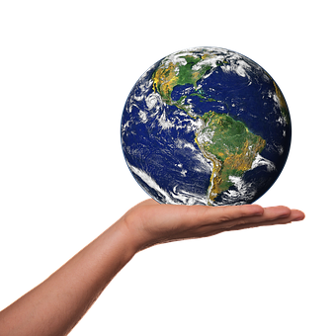
First of all you can only buy palm oil products which have a label that says that these are made wit CO₂ neutral palm oil. However, you can´t be 100% sure that’s that right. Therefore, the best way is to reduce its consumption and to buy fresh and natural products. This is not only healthier but also protects the environment.

I hope, that this article can motivate you to help saving the planet. You don’t have to stop using everything. It is already good if you do little things.

