The FIBA 3x3
Olympic Qualifier 2021
It will be in Graz!
by Franca Harzl

DIVERSITY QUESTIONS Not norma
Q: When will the tournament be? But this tournament isn’t a normal
A: From the 26th till the 30th May one as you know it, because it’s on
2021. The best 3x3 basketball will the street and in gyms all over the world.
match up for the games in Tokio. 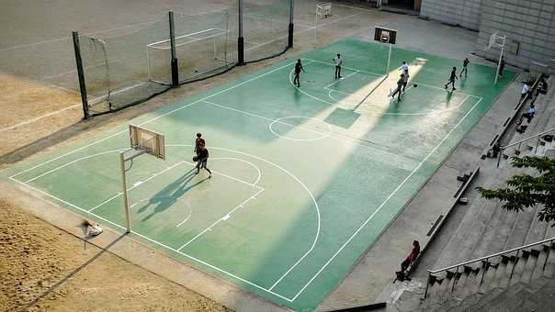
Words of the press
Conference
,,We are overjoyed that we were able to bring this great tournament to Austria,‘‘ says basketball president Gerald Martens,‘‘ Not only because
we will be experiencing an event
of superlatives in Graz, but also because our successful national teams have a sporting chance
of the century.‘‘
url: https://cdn.pixabay.com/photo/2017/08/07/22/24/hobbies-2608561__340.jpg
It will be on the
Hauptplatz next to the Rathaus.
Q: What is 3x3?
A: It’s a basketball tournament in which 3vs3 people play on one basketball hoop. Every team has 4 players, because only three are on court.
NBA (National Basketball Association)
Many people, who are playing basketball are fans of the NBA. It’s the most popular league of this sport. Players like LeBron James and Stephen Curry have millions of followers. Since 2016 the NBA has also their own 3x3 tournament. There local amateur players from the USA are playing.

History
Since Adidas launched its own basketball streetball competition in 1992, it has become more popular.
Very good player
A very good player from Serbia is Dusan Bulut, because he scored a lot of points. You can see all the rankings on fiba3x3.com.

Only one person from Austria is in the NBA. His name is Jakob Pöltl.
Q: Why is it in Graz?
A: One of the goals of the City ofGraz is it to be the most sporty city in Austria in 2021. Some even have the opportunity to train for free at a sports club of their choice in 2021, because they have a social card. Currently 12 392 people have this card.

