E-Mobility
The driving of the future?
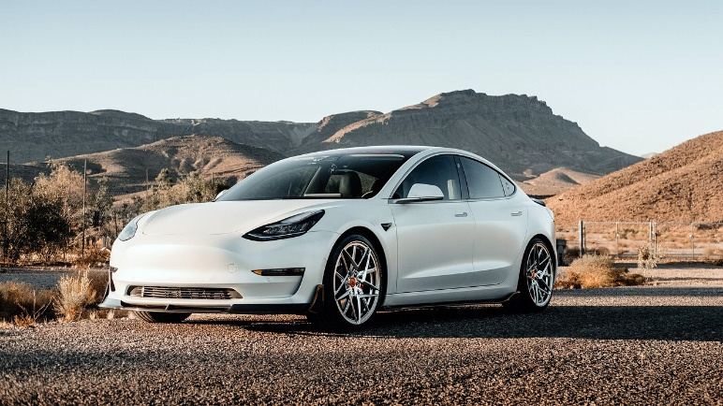
by Franca Harzl

SIMPLY THE BEST QUESTIONS
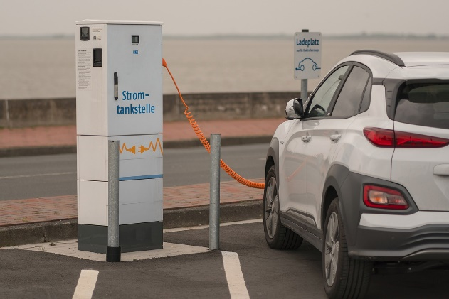
Q: Which company is the best known and richest?
A: It is Tesla. It’s a California-based company, which makes electric cars. The name comes from the inventor Nicola Tesla, because he worked with electricity and electric cars. It was started in 2003 by Martin Eberhard, Dylan Stott and Elon Musk. Today Elon Musk is the boss. He’s on the third place of the richest men in the world.
Their first car was only sold in 2008, and that's the Roadstar. So far, there are already four different ones. You can see more and more of them on the streets because they are not too expensive. The model 3 costs 46 000€. at the cheapest configuration Of course it’s not so fast, but the most expensive one of the model costs 59 990€. Then you will be able to go 261 km/h.
New generation
Some people, say that in a few years the new generations will almost exclusively drive e-cars, because charging is cheaper, and purchases of them are increasing every year. They think it’s the driving of the future.
E-Scooters
Since 2019, you can use e-scooters in Austria on the road, but they must not drive faster than 25km/h. At the age of 12 it’s allowed to use it, and if you are younger you need a bicycle driving license.
Q: What are the disadvantages of an electric car?
A: It takes longer to charge than to replenish gasoline. On average, it takes about 20 minutes. This means that you need to wait until it is finished. If you run out of battery and there is no charging station nearby, it's also a huge problem, because you have to call the towing service.
https://cdn.pixabay.com/photo/2021/01/21/11/09/tesla-5937063_960_720.jpg
https://cdn.pixabay.com/photo/2020/05/24/08/16/charging-station-5212924_1280.jpg
Q: What is E-Mobility?
A: It’s all cars or means of transport, that are electrically powered.

