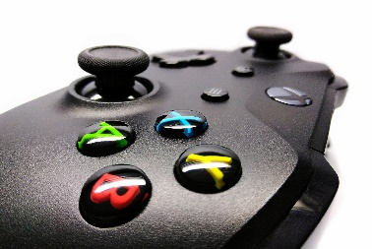
Why videogames aren’t bad at all for children.

First, its normal that parents don’t like it when their child only plays videogames in their free time and don’t do their homework because of the videogames. Many people say that videogames are bad for your mental health, but many studies say the opposite.

There are many different types of games (Shooter, Adventure-games, Strategy-games) and many people say that shooters are bad, butthat doesn’t mean that all games are bad,because there are many different types of games and every different type is about something different. For example, Minecraft is different to “Call of Duty”.
A famous brain scientist called Daphne Bavelier said in a lecture videogame are like drinking wine: There are bad uses for wine, but when you don’t drink too much of it can be very healthy.
Some studies from her:

Are computer games bad for attention?
In this study Daphne Bavelier found out that gamers can switch better from one task to another one and the brain region for attention is better developed than in people who don’t play videogames.
Are Video games bad for your eyes?
No, people who play videogames have better eyes. The people who play videogames can see details better.
Another study said that videogames are positive is from National Literacy Trusts and said that videogames are good for creativity, empathy and reading skills.
Of course, it’s important what the game is about for example are many people who say that shooters make you aggressive. The verdict on this is still out: there are studies that say that that’s not true but there are also studies who say that it is true. In the end everyone has to decide for themselves what he/she wants to do in their free time.

Dear Clemens,
You did not write a lead for your article - make sure to include a good lead. Remember, your audience are classmates, so I'm sure they would like to read your article to find some arguments to convince their parents that videogames are not bad at all - use that in your lead!
Have a look at my corrections - I'm sure you would have spotted these mistakes if you had had another look at your article!

