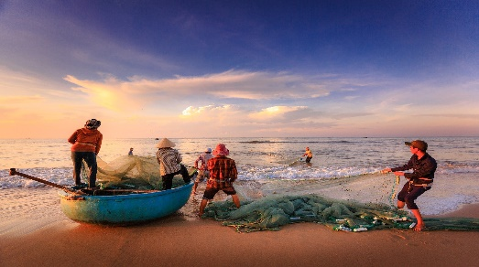
How the the seas become extinct

Fid out how our seas get destroyed and animals are killed brutally, why animal death is also a big problem for the climate change and how the plastic problem in the sea related to fishing.

by Clemens

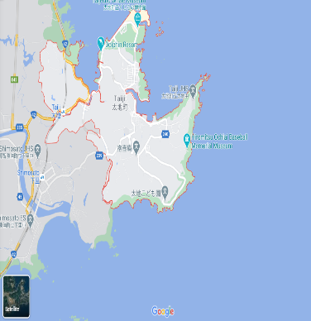
Whales’ and dolphins’ deaths in Japan:
most countries in the word forbid whale and dolphin hunting. But some countries do not abide to it, for example Japan more accuratly, Taiji. On the picture you can see that Taiji is a city on the sea. A lot of fishermen live there, and they help to kill whales and dolphins because they eat their fish, which they want to sell, but that is not the most disgusting thing. 700 whales and dolphins are killed yearly and then sold. Sharks get killed for their fins. The fins are sliced off and the halfdead sharks are thrown back into the sea, but the government does nothing about it.
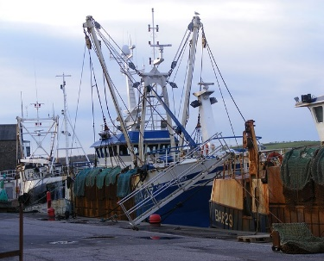
Illegal fishing:
Illegal fishing is also a big problem because the fisherman with big fishing boats fish in places where there are many fish, for example, in Africa. Some villages there live from fishing, but the big fishing boats catch most of the fish before they can come near the beach where it is easier to catch them. So the poor fishermen and their families starve because they only have small boats for fishing and cannot go out that far. So they cannot catch any fish. The FAO estimates that 30% or more from the fish all over the world are caught illegally.

Plastic in the sea:
We all know that plastic in the sea is a problem. But did you know that every minute 1 truckload of plastic is thrown into the sea? Or that 500 times more microplastic particles are in the sea than stars in the Milky Way? And that’s not science fiction that is the truth. Many animals die in the sea because they swallow plastic. They do not swallow only the normal plastic bottles or other small pieces of plastic. They swallow fishing nets, planes, or other fishing equipment. Most of plastic in the sea is old or broken fishing equipment and turtles or whales impose into these nets.

But there are many organizations who fight against these things. For example, OcenCare, Sea Shepherd and some more. It is very important that the sea gets saved, because when the sea dies, we all die.

