Destructive Korean Beauty Standards!

Why is it impossible to fit the Korean Beauty Standards naturally?


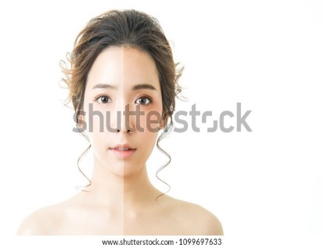
The Korean Beauty Standards are actually very beautiful, but not when it gets toxic, depressing, and unhealthy. A slim body, pale skin, a V-shaped jaw, straight eyebrows, flawless skin, larger eyes, double eyelids, and heart shaped lips are a most in the Korean Industry! Ridicules, right? The fact that musicians, models, actors must follow those Standards and get judged, not because of their talents but because of their appearance is not fair.

Surprisingly and sadly the discrimination and the beauty standards, have a very long history. Back in the days, people that were brown or dark skinned were identified as Farmers or very workers, because they must have been in the sun very long working. That meant that they were less privileged hard to work a lot to earn their money. People with paler skin were identified as privileged rich and successful. That meant that they came from a wealthy family and didn’t have work a lot. This continued, and that was the start of the Beauty Standards.
Shockingly it is way worse today. Musicians start as trainee’s first before they debut. They are thought everything about the Industry. The saddest thing is that they have to abide to the beauty standards and have a very strict and unhealthy died. Like they are just aloud to consume 300 Calories a day, which is crazy. A lot of K-pop Idols have suffered from anorexia or weakness attacks, because of this madness. Social media has a very big influence on this since, they like whitening pictures to make them look “good”, and if they don’t follow the instructions, they mostly get bullied really hard, that it has led to a of suicide’s in the past.
Even though there are a lot of people that support this there are also people who don’t, and totally “brake the Standards”. Like Jessi, Hwa Sa (MAMAMOO), Jennie (Blackpink), Lee Felix (Stray Kids), Joy, and Fatou (Black Swan).
Survey Link: https://surveyhero.com/c/a8b418ba

A lot of people think that these Standards are unnecessary and unhealthy, and are definitely not a good Example for their young Fans. Than to spread hate towards people that don’t follow these Standards, it is way better to spread awareness and love!

