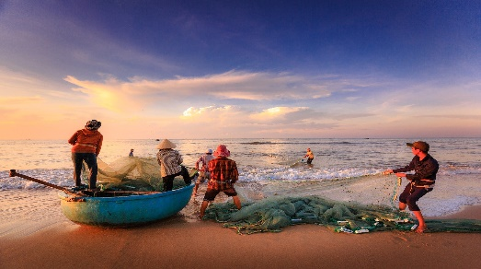
How the the seas become extinct

The article is about how our sea gets destroyed and animals get killed brutally. The animal death is also a big problem for the climate change and how the plastic problem in the sea related to fishing.
By, Clemens

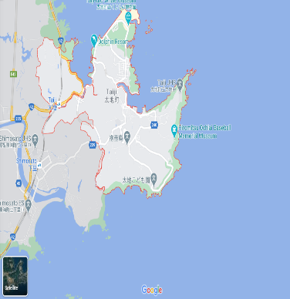
Whale and dolphin death in Japan:
The most countries in the word forbid whale and dolphin hunting. But some countries do not adhere to it, for example Japan more accurate, Taiji. On the picture you can see that Taiji is a city on the sea. In Taiji live many fishermen and they help to kill the whale and dolphins because they eat their fish, which they want to sell, but that is not the most disgusting thing. There where yearly killed over 700 whales and dolphins to sell them. There also sharks get killed only for their fins. The fins get sliced of and the halfdead sharks get throw back into the sea, but the government does nothing about it.
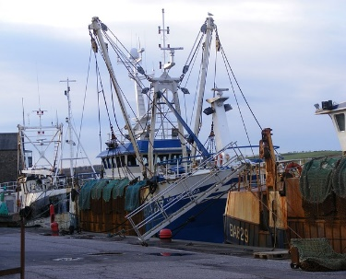
Illegal fishing:
Illegal fishing is also a big problem because the fisherman fish there where there are many fish. For example, in Africa. Some villages there live from fishing, but the big fishing boats catch the fish before the could come near the beach where it is easier to catch them, because the people there have only small boats for fishing. The FAO estimates that 30% or more from the fish all over the world got cached illegally.

Plastic in the sea:
We all know that plastic in the sea is a problem. But have you known that every minute 1 truckload of plastic get thrown in the sea? Or that 500 times more microplastic particles are in the sea than stars in the Milky Way? And that’s not science fiction that is the truth. Many animals die in the sea because they swallow plastic. They do not swallow only the normal plastic bottles or other small pieces of plastic. They swallow fishing nets, planes, or other fishing equipment. Many % of plastic in the sea is old or broken fishing equipment and turtles or whales impose into these nets.

But there are many organizations who fight against these things. For example, OcenCare, Sea Shepherd and some more. It is very important that the sea gets saved, because when the sea dies, we all die.

