Madeira
The island of your dreams
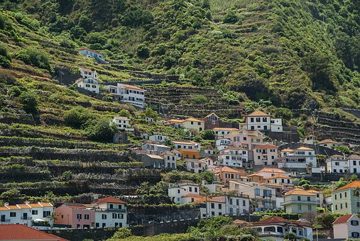
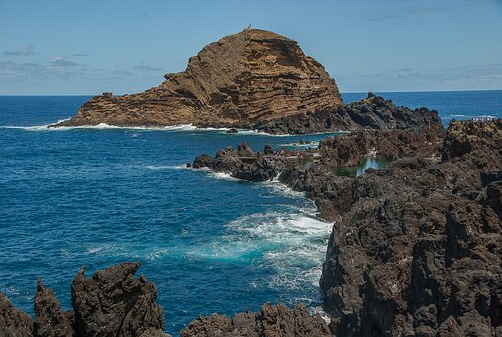
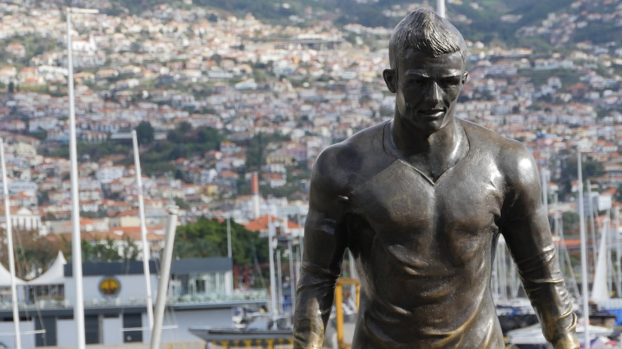
by Franca Harzl
https://cdn.pixabay.com/photo/2018/07/23/00/27/portugal-3555841__340.jpg
https://cdn.pixabay.com/photo/2018/01/05/17/32/travel-3063482_1280.jpg
https://cdn.pixabay.com/photo/2018/07/26/22/53/madeira-3564818__340.jpg
Different life than in our country
Living there is very different, because everyone knows everyone around them. The weather there is also completely different. It is not cold in winter. Only the sea is cold, and the air smells of fresh sea.
There are also a few disadvantages, and it’s that you can’t drive there for so long, because in an hour and a half you are already at the end of the island. It’s very quiet there, so the neighbours complain when you’re noisy.
Influencers
Many famous Youtubers from Germany live in Madeira, because they pay less rent or the price of a house is cheaper.
Home of a football pro
Cristiano Ronaldo grew up there.
He started playing football there at a young age, and didn’t have much money. Now there is a museum of him and a hotel. The island’s airport is named after him.
Information about Madeira
The Portuguese word madeira means wood. It’s an island in Portugal, and has a population of 250 000. The island is located 951 kilometers southwest of Lisbon. The capital is Funchal.

