Diet
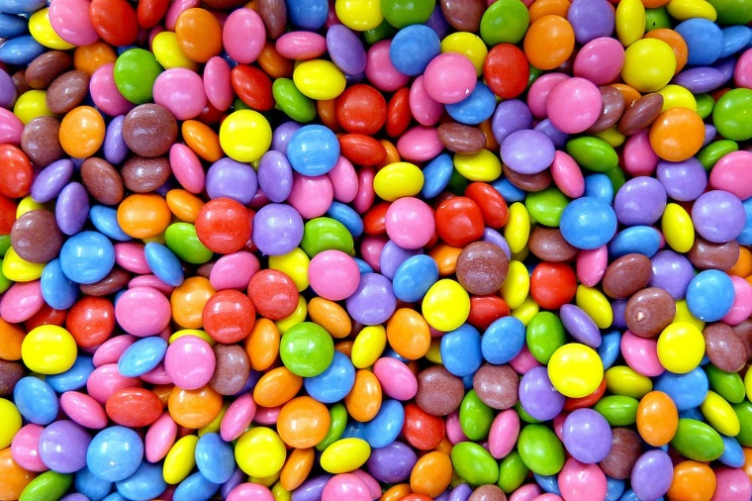

I know many of you want to have perfect bodies by summer. Will diets help? Is it healthy to eat very little? Does this diet work at all? you must Give up chocolate? Are you doing everything right? Do you even have to weigh less?
https://pixabay.com/de/photos/s%C3%BC%C3%9Figkeiten-konditorei-s%C3%BC%C3%9F-smarties-50838/

In All Places on the Internet, there are only perfect people. I think it is important for many to have a good body. This summer it is supposed to be different, everyone must be perfect. Many are already trying to take off for the summer. I was going to go on a diet myself. It is a bad idea to just do what other people want. We are at a stage where we need a lot of food because we need to grow. Why do you want to lose weight if you do not weigh much? be yourself and do not listen to others. You can make sure you eat lots of healthy things and fewer sweets. You should do a little exercise, drink a lot of water, because our body needs fluid. Be yourself and get healthy, if you do, you do not need a diet. our health is much more important than our appearance. Even though most people only pay attention to the appearance, you should not try to be perfect. Nobody is perfect. Sport is important, that is why you will find here on this page a workout that is good for your body. And that is not for you to take off, that is for you to stay fit.

