Caprese Sandwich
Summer is coming, which means picnic season. Your blankets are ready, your drinks are ready, but not your sandwich? Yes? I'm going to show you how to do sandwich. Don’t worry! it's simple and tasty. Good picnic food does not have to be difficult. This sandwich is here to prove it.
Caprese Sandwich Recipe Ingredients
Here is what you will need to make this sandwich recipe:
- Mozzarella cheese
- Tomatoes –choose the best ones you can find!
- Fresh basil leaves –If your leaves are large, tear them into bite-sized pieces before adding them to your sandwich.
- Extra-virgin olive oil, salt, and pepper

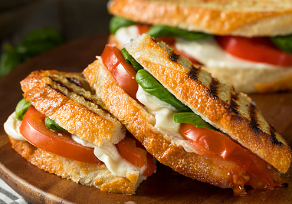
https://media.istockphoto.com/photos/healthy-grilled-basil-mozzarella-caprese-panini-picture-id930271208?b=1&k=6&m=930271208&s=170667a&w=0&h=l20WIucho4A8oq5MqSzMM7Wt3d-S9uGePdHmVFF9RPw=

Caprese Sandwich Recipe Tips
Don't forget to season it. The pepper, salt, and olive oil in this recipe don't seem important, but they're just as important as the other ingredients. The salt improves the sweetness and smell of the tomatoes, and the olive oil combines all of the flavors.
This caprese sandwich is perfect for a picnic because the tomatoes contain so much water that it's best if you make it just a few hours in advance. If you get too far ahead, it will get wet.

By Azra Kisa

Instructions
1. First wash the tomatoes and cut them into slices. Wash the basil too. Then cut the mozzarella into even slices.
2. Cover two slices of sandwich with tomatoes and basil and drizzle with a little olive oil. Then layer the mozzarella on top, season with salt and pepper and finish each with another sandwich slice.

