High-Higher-Buildings
The tallest buildings in the world get higher and higher
by Elias Kitzberger
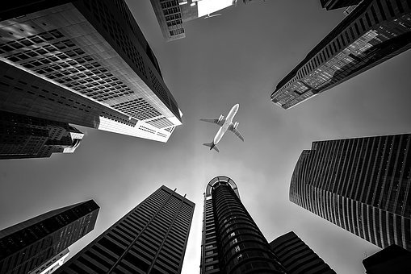
Wide in the past people began to create buildings. In the beginning the buildings were very small, because the workers didn’t have any machines that could help to build these buildings. But now we build a lot buildings every year, like houses, schools and much more. The highest building right now is the Burj Khalifa. This building is in Dubai and 828 metres high, but there are two new buildings in production which should be much bigger than this tower. The Jeddah Tower in Saudi Arabian will be about 1000 metres high and the Dubai Creek Tower could be even higher. But the exact hight isn’t sure.
Flugzeug Gebäude Perspektive - Kostenloses Foto auf Pixabay
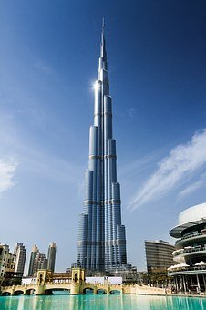
Burj Khalifa: The Burj Khalifa is the highest building in the world since 2009. They began to build this skyscraper in 2004. First the building was called Burj Dubai, but they renamed it in honour to the president of the United Arab Emirates, Khalifa bin Zayed Al Nahyan, Burj Khalifa. The building was designed by the architect Adrian Smith, an international architect. Of course, such a high building costs a lot. The Burj Khalifa cost about 1.5 billion US$.
Dubai Turm Arabische - Kostenloses Foto auf Pixabay

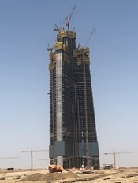
Jeddah Tower: The Jeddah Tower is a skyscraper construction in Jeddah, that’s in Saudi Arabian. It should be the first one kilometre high building in the world, but in January 2018 they stopped building. They wanted to start building again in 2020, but because of the Covid-19 Pandemic they couldn’t start. After the pandemic they want to start building again. The tower was only 256 metres high when they stopped building. To build the Jeddah Tower they needed a total amount of 1.23 billion US$ till now.
Jeddah Tower August 2019 S.Nitzold - Jeddah Tower – Wikipedia
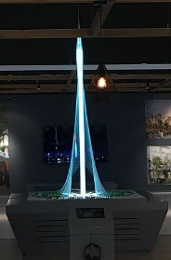
Dubai Creek Tower: It was expected that the Dubai Creek Tower is finished in the year 2022, but because of the Covid-19 pandemic it is not clear when the building is finished. On the fourth April 2020 they stopped building the tower, because of the pandemic. The goal for the height of this tower is clear, it should be the highest building in the world. So, the tower will be at least 828 metres high (height of the Burj Khalifa), but the height could be about 1300 to 1400 metres too, that isn’t fixed yet.
The Tower at Dubai Creek Harbour1 (cropped) - Dubai Creek Tower - Wikipedia

If you want to find out more about the highest buildings, watch this video: (3600) EVOLUTION of WORLD'S TALLEST BUILDING: Size Comparison (1901-2022) - YouTube

