Nice Movies you should wait for


Are you bored during the lockdown? Do you want to have nice experiences? Then this Article can really help you. Today I will show you the three best Movies that will probably come out soon.

By: Tim K.

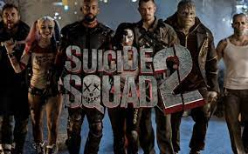
- The Suicide Squad 2
The release of this movie is planned for the 6th of August 2021. The film is about the anti- hero team “Suicide Squad” from the comic publisher DC. It’s the 11th movie of the DC Extended Universe. I would recommend it for people who like the first part and are interested in more. In general, for all DC fans.

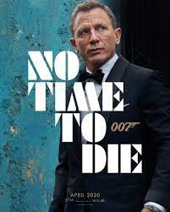
- James Bond “No time to die”
Do you like action and spectacular stunts? And you like the character 007 than “No time to die” is the right movie for you. James bond has retired and enjoys his free time in Jamaica, but a friend asks him for help, that means a new mission for 007. That’s what we know about the content and we can also already watch the trailer since more than a year. Initially the movie should have been released in April 2020. Now you can mark October 8th in your calendar.
Fun Fact: It will be the last James Bond in which Daniel Craig acts 007.

- Mission Impossible 7 and 8
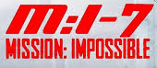
In these parts of Mission impossible, which will probably be released in the middle of the year 2022 and 2023, Tom Cruise will get back in his role as the IMF-Agent Ethan Hunt. Part 7 and 8 will be released shortly after one another because they were filmed together. What is very fascinating with the mission impossible series is that Tome Cruise does most of the stunts himself, that’s very special because normally a stuntman does that. If you are a fan of agent movies and you can’t watch a movie without stunts than is Mission Impossible a must see for you.

