MINECRAFT
The Woodword Chronicles
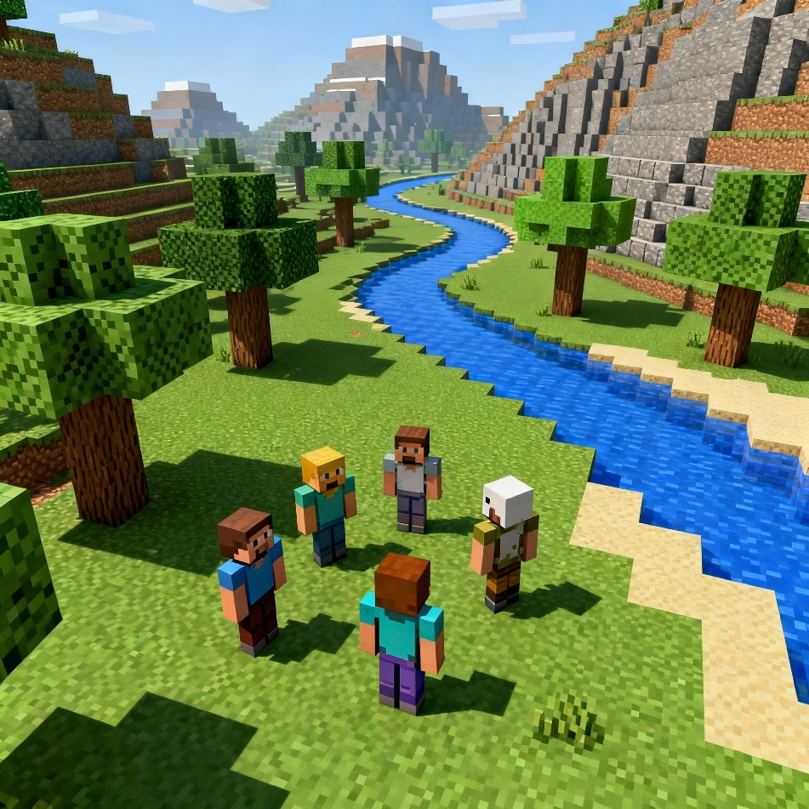

My Top Secret Diary

Name: ……………………..

The Woodsworth chronicles

1. Getting started: Just a game?
Imagine you and your friends had special virtual reality goggles that can transport you into the world of Minecraft. Sure it makes the game much more fun, but what if you get lost? …. or hurt? …. or die in the game?
If the game is real …. so is the danger!
Would you dive into the game or would you rather not?
Let’s discuss this in class.
2. Read the prologue of book 1 and find what is happening
Would you dive into the game or would you rather not?

Read the whole prologue and answer the question:
WHAT IS THE PROBLEM?
__________________________________________

http://tiny.cc/vgat001

3. The players
Find the students who have received the same book and start to read. (30min)
Who are the main characters that you meet in your book?
While you are reading, take notes about them. What are they like? What do you learn about them?
Morgan | Ash | Po | Harper | Jodi

5. The Gamer’s Diary

Slip into the mind of ONE OF THE PLAYERS and write 2 detailed diary entries of “your” adventures. Choose the most interesting places and events that they have encountered.
In your diary
  - explain why you went there and what you were trying to find
  - describe the places you have visited
  - say what happened there
  - make sure you include “your” thoughts and feelings, worries, hopes …
Diaries are usually full of such personal reflections. People do not write diary entries on boring days. 
Look at the next page to learn more about “How to write a diary entry”.

How to write a diary entry
Start with a main impression of the day or situation. Was it a wonderful day, a stressful/ scary/sad/happy situation?

Dear Diary,
Today was one of the most exciting and scary days of my life. No place is safe anymore. There are monsters everywhere and now that the game is real, it’s a lot more scary. I am so afraid that one of us is going to get hurt. What happens if someone dies?
Write in the first person: “I”
This morning Ash, Jodi and I went deep into the dark forest near the lake. I had only my sword and some bread in my bag. The trees were really tall, and there were some chicken running around, looking for food. At first, everything looked quiet but the shadows made me feel like someone was watching me. I was afraid but when
I said so, Jodi just laughed. That made me a bit angry.
She never takes me seriously.
Describe the events (what happened) in the past tense
Write honestly about what you think about people and situations.
Suddenly, I heard a strange sound behind me. When I turned around, three skeletons were pointing their bows at me! My heart jumped, but I knew I had to fight. We ran behind a tree and quickly built a small wall with dirt blocks. The arrows hit the blocks, and I managed to attack one skeleton with my sword. After a hard battle, we finally killed them. I was shaking, but also proud that I survived.
After the fight we saw that there was a chest hidden in the ground. It was visible now, because we had used the earth to build a wall. Ash was faster than me. She opened the chest. Inside, there was a map. It showed a some hidden place beyond the river. I don’t know what is there, but I feel it could be something very important. But it could also be a trap.
Write about hopes / worries / expectations
What do you think is going to happen next?
How do you feel about it?

I wonder what will happen tomorrow. Will we find treasure? Or maybe we will meet something dangerous, like a creeper or an Enderman? I am nervous, but also excited for the adventure.
Wish me luck!

6. Talk to a friend


Imagine this: After a dramatic day, you (Morgan, Ash, Harper, Po or Jodi) are calling a friend on Whatsapp.
Tell your friend about the dramatic events of the day.
Your friend will listen carefully and ask several questions to find out more details about your dramatic day.
Step 1: Letˋs do 1-2 such conversations in the plenary.

Step 2: Work in pairs and tell each other about "your" dramatic days. Listen carefully to your partner’s story and ask at least 5 questions to find out more details.

Step 3: In the plenary, you will have to report what you have found out about your friend's dramatic experiences. Be prepared to tell us lots of details.

7. The Gamer’s Diary 2
Keep reading your book and write a second diary entry as one of the characters.
Hand in your diary.

8. Grammar Challenge 1
Why has the writer used these tense forms?
I In this scene, Ash, Morgan, and their friends are suddenly attacked inside the Minecraft world.
Work with a partner. Read the text and explain why the writer has used these tenses, rather than other ones.
Why past simple, why past progressive (-ing form)?
Tip: Use your grammar book p.58/59 and check if you find a helpful explanation for these tense forms there.

Everybody was doing their best to keep the monsters at bay. Morgan was trying to rebuild the wall. She was placing blocks as quickly as she could, while Maddie and Jodi were swinging their swords at a wave of skeletons charging the ruined entrance. For every enemy they defeated, two more appeared.
Suddenly Ash saw something. She spun around. A creeper was right behind her. She shouted a warning, but it was too late. The monster hissed, its body swelling. BOOM! The blast sent blocks flying through the air. Dust and pieces of stone rained down.
“Keep fighting!” Jodi yelled. Arrows were raining down on the. Ash was stumbling through the smoke, her ears ringing. She couldn’t see where she was going. Suddenly she came across a building. She went intside and spotted a chest in the corner, half-buried under rubble. He reached it and pulled it open. Inside was an enchanted bow, glowing faintly with blue light. “We might survive this attack after all”, she thought.

9. Grammar challenge 2 (for pros)
Look at the underlined phrases. Why has the writer used the past perfect tense here?
had finished… had found…had met…had stayed…
Ash was new to Woodsword Middle school. She had moved to town only a few weeks ago. She liked doing her best in all things. That was how she had obtained so many Wilding Scout Badges. Ash smiled at Jodi.
Jodi was the first friend she had made here. She was creative, fearless and a bit weird. Because Jodi had skipped a grade, she was younger and smaller than her classmates.
The air-conditioning vent above Ash’s head burst open. Dozens of dark shapes flew into the classroom, squeaking and chirping, flapping and fluttering.
“Are those….?”, said Jodi
“Bats!” Ash shouted.
The classroom erupted into chaos. The kids screamed. Some ducked low while others tried to wave the bats away.
Ash hid beneath her desk. She saw that Jodi had done the same.
[Excerpts adapted from: Minecraft chronicles; Mind of the bats by Nick Elopulos]
Tip: In what order did these things happen? Draw the events on the timelines:
Example:
Ash was new to Woodsword Middle school. She had moved to town only a few weeks ago.

Because Jodi had skipped a grade, she was younger and smaller than her classmates.

Ash hid beneath her desk. She saw that Jodi had done the same.

Ash was at Woodsworth Middle school
Ash moved to town

Now find 5 examples of the past perfect tense in your book.
Write the sentences on this page, and draw similar timelines.

