Datum | 09/02/22 | Klasse | 4F
Name | Lea Prettenhofer 4F
Part 1
Read the text below. Imagine what happened that day. Choose 3 or 4 pictures and write a DIARY ENTRY. Amy, Dan and you are chased again – and this time you are helping them to get to the next clue. Write about
- the day’s events and
- your feelings.
You were sitting on the train and reading the 39 Clues books when you realized that a boy and a girl were looking at you very curiously. You tried to look away, but you felt uncomfortable. Suddenly the girl started talking, “I’m sorry, we don’t want to bother you… But we are surprised someone is ACTUALLY reading our books!” You couldn’t believe your ears- they were Dan and Amy from the 39 clues and they were on their way to their next adventure! You were really engaged in a conversation when suddenly…..

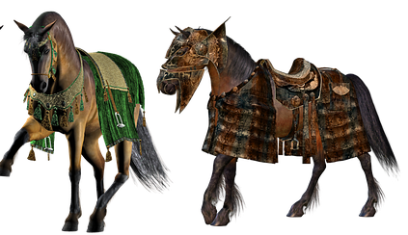




Focus on Form
- It’s not true! A is lying!
A: “Lena played in the park.”
B:”That’s not true! Lena ____________________________________ in the park.
A: Really? Where _____________________________________(she / play)?
B: She played in her garden.
A: “Lena did her homework in the afternoon.”
B: That’s not true. She________________________________________in the afternoon.
A: Really? When _______________________________________(she / do) her homework.
B: She did it right after school.
A: Lena rode her bicycle to school.
B: That’s not true. She ___________________________________ her bicycle to school.
A: Really? How ______________________________________(she / get) to school?
B: She took the bus.
A: She went home at 8 o’clock.
B: That’s not true. She __________________________________at 8 o’clock.
A: Really? When ___________________________________(she / go) home?
B: She went home at six o’clock.
Focus on Form |  | Writing
FoF | / 16P | Writing | %
Grade FoF | % | Grade Writing | %  according to assessment scale – see online (eduvidual)

