1 |  | Listening: Watching TV

5 |  | a) | Listen to different people talking about watching TV. Match the pictures to the correct speaker.  There is one extra picture.

  A |  | 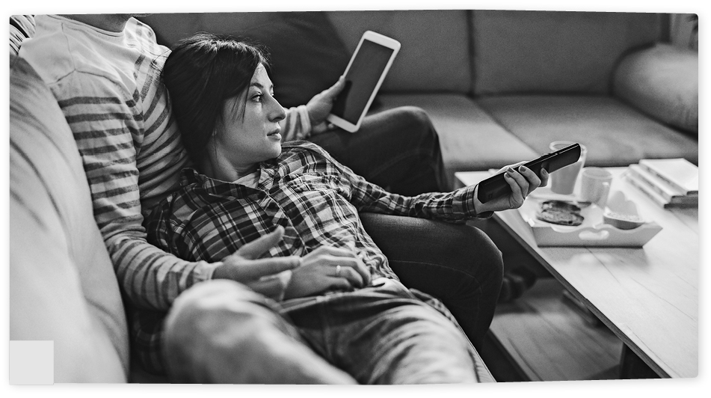  B
Speaker: 5 |  | Speaker:
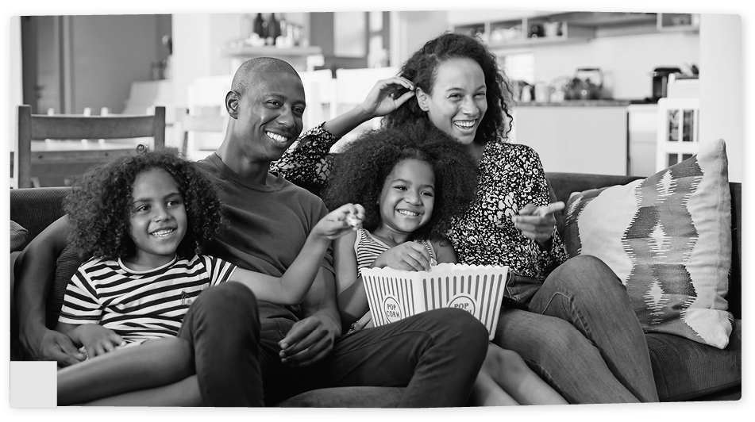  C |  | 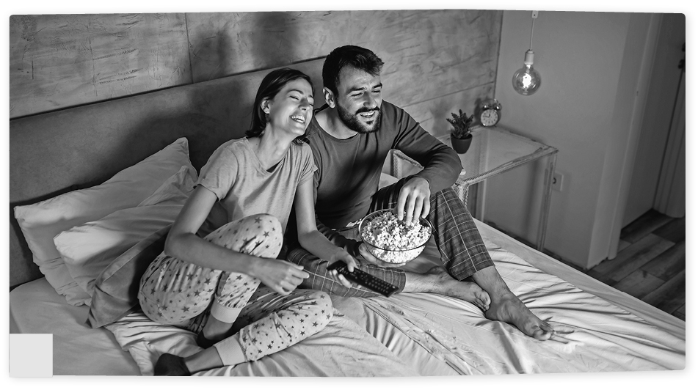  D
Speaker: |  | Speaker:
  E |  | 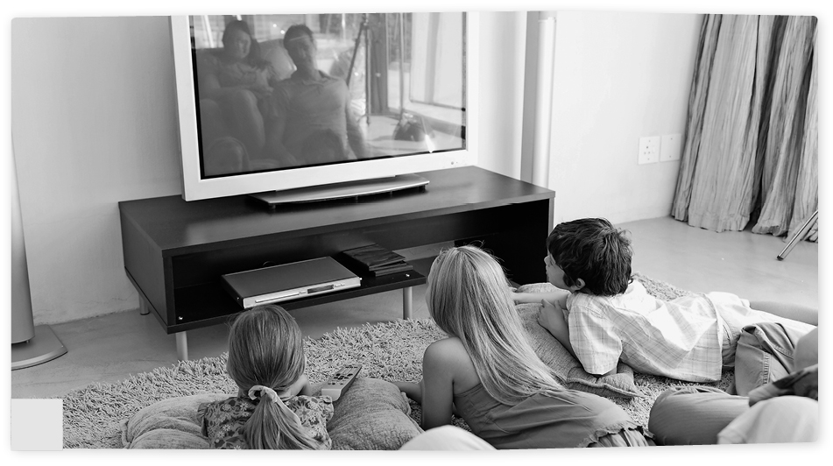  F
Speaker: |  | Speaker:

5 |  | b) | Listen to the speakers. Tick T (= true) or F (= false).

 |  | T | F
1. | Speaker 1 is talking about picture A.
2. | Speaker 2 is talking about picture C.
3. | Speaker 3 is talking about picture D.
4. | Speaker 4 is talking about picture E.
5. | Speaker 5 is talking about picture F.

2 |  | Reading: Watching habits

Anthony  I am a sporty kind of person. I don’t spend too much time watching TV. I never miss the sports programmes on Tuesday, Friday and Saturday. I love watching sports on TV, there’s so much on that you could watch for hours, but I do a lot of training, so I only manage to watch about one hour on average.  One thing I try not to miss is the news. You’ve always got something to talk about if you’ve seen it. Occasionally, I might watch a film if I can’t do any training for some reason, and there’s nothing else I can do. That’s some- thing I do on my own. My parents are out a lot. And to be honest, I don’t think they would be interested in the films I watch.  With the amount of TV watching that I do, there’s no danger whatsoever of feeling guilty about it. | Ben  I guess you could say I am addicted to TV. There is never a day that goes by that I don’t turn it on to watch something. But having said that, my parents are really strict, and they don’t like me to watch more than two hours a day, so I’m pretty picky with what I choose to watch.  Sometime ago, I started watch- ing one of the reality shows. It didn’t take me very long to discover that’s not my kind of entertainment.  What I like is to be up to date with what is going on in the world to be able to form my own opinion on the issues of the day.  From time to time I’ll watch a good film together with my Dad because we have the same taste. As I’ve admitted to being addicted to watching TV, you might think I feel bad about it, but as I don’t watch too much, I don’t. | Charles  I am totally unlike my sister who watches TV every day. You’ll only catch me in front of the TV three times a week. But then, I binge watch for more than four hours at a time at the weekend. On average, I guess it’s about three hours a day.  My sister is totally into these reality shows. I can’t see what she sees in them.  But there again, she can’t understand how I can sit and watch five episodes from one series in one afternoon, and I can’t think of anything better to do. Because we have such different tastes, we never watch anything together.  Sometimes my Mum will join me when I’m watching something.  When I’m glued to the TV and can’t seem to stop watching, I do have a bad conscience about it, but not that often.

 |  | a) | Use the information in the texts to decide if the statements are true or false and tick T (= true)  or F (= false).

 |  | T | F
1. | Anthony and Ben watch TV a few times a week.
2. | On average, Charles watches TV 3–4 hours a day.
3. | On average, Anthony watches TV more hours a day than Ben.
4. | Charles likes to watch TV series and reality shows.
5. | Apart from sport, Anthony and Ben like to watch the same programmes.
6. | Charles only watches TV with friends or family.
7. | Anthony does not feel guilty about watching too much TV.

3 |  | Writing: Viewing, sleeping and exercise habits of teenagers

24-hour movement guidelines for teenagers from the Canadian Government  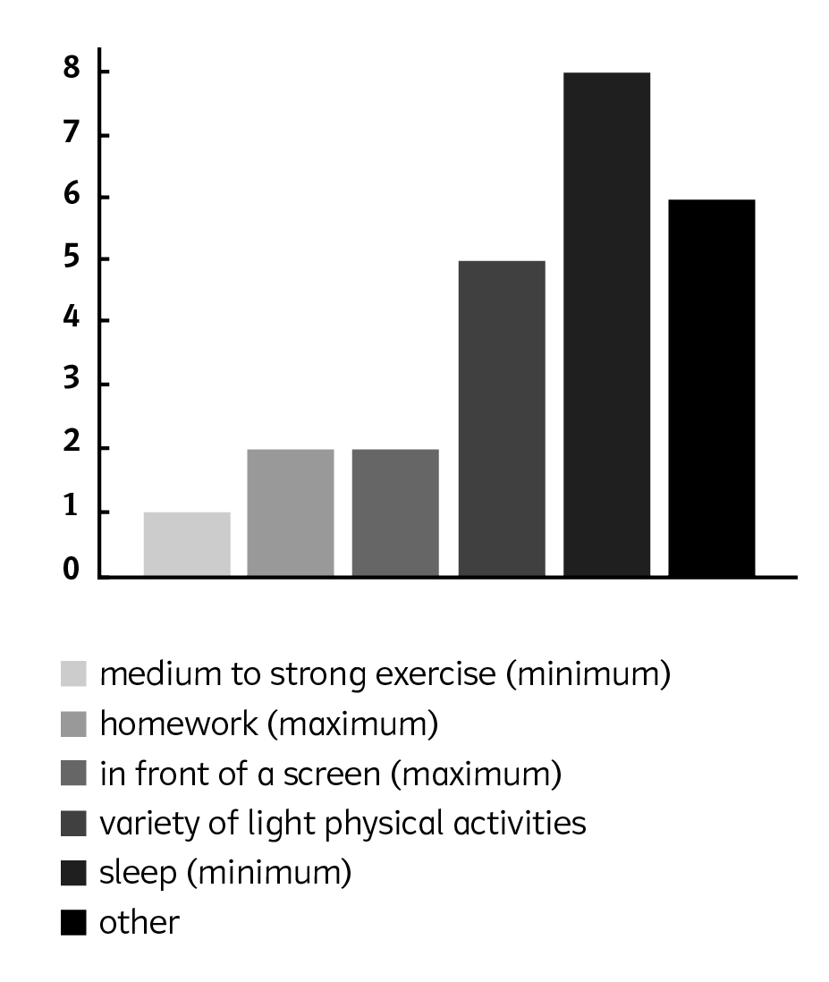  1 | Results of a new study in the UK in which teenagers were asked about their habits  2 Teens sleeping for more than eight hours  on a school night  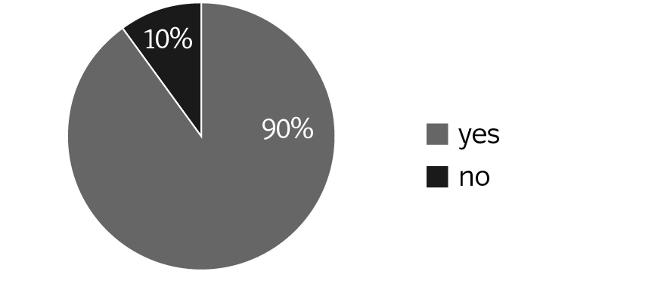  3 Teens doing recommended level of medium  to strong exercise  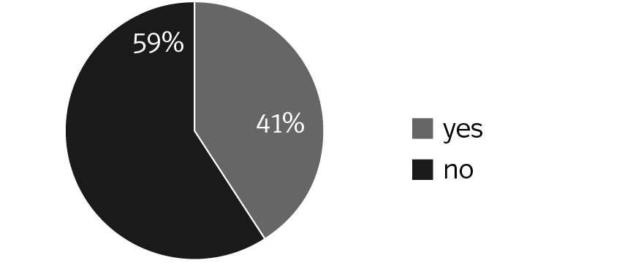  4 Teens meeting all three guidelines for exercise, screen time and sleep  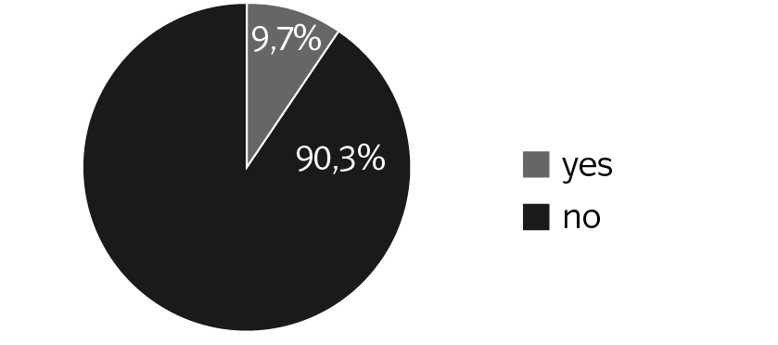

 |  | a) | Look at the charts about teenage habits and write a report (100–150 words) about them. Use the phrases in the box to help you. Do not forget to use paragraphs.

The first/second/third chart is about … The … pie/bar chart shows …
… % of teenagers should/not… More/Less … than … young people …
Most teens said that … The majority/minority of the teenagers …
I normally/usually … Compared to the teens in the study I …
In future, teenagers should/not …

 |  | b) | Look at the charts about teenage habits. Write a report (120–150 words) in which you:

- describe the charts,
- compare the results with your habits and the guidelines for teenagers,
- give advice to future teenagers.

4 |  | Language in use: Television and streaming

 |  | a) | Write the correct phrase from the unit next to each definition.

1. something that has never been made before invention
2. an object or a machine that has been invented for a particular reason
3. a failure in communication between two or more people
4. a statement about what you think will happen in the future
5. a synonym for ‘often’ beginning with f
6. on a few occasions/almost never

 |  | b) | Use the words in the box to fill in the gaps. There is one extra word.

set available longer with fashioned item streaming

Nowadays, television and streaming has become such a normal part of our daily lives that it is hard to imagine a house without a television set 1 . Since its invention in the 1900s it has now become an everyday household 2 . Over the decades, people have sat down at specific
times to watch their favourite programmes together. For many young people today, this way of viewing seems to be old 3 . Thanks to the never-ending developments in technology,
youngsters today no 4 have to do this. More and more people are turning away
from the traditional broadcasting companies for their entertainment and are relying on a
5 service. This change in viewing habits is taking place globally as services are becoming widely 6 to viewers of all ages all over the world.

 |  | c) | Put the words in the correct order and write them down.

1. used to sweets she eating love child was a she when
She used to love eating sweets when she was a child.
2. young I England I used when to live in was

3. winter go used we to every skiing

4. to the not cinema they often very did to go use

5. he bicycle did to not ride use his lot a

6. not use you were you to like mushrooms when little did

 |  | d) | Convert the sentences into questions and write them down.

1. She used to watch TV in a neighbour’s living room.
Did she use to watch TV in a neighbour’s living room?
2. The children and adults used to watch TV together.

3. He used to watch TV on Sundays.

4. There used to be four TV channels in total.

5. There didn’t use to be any programmes on in the morning.

6. We didn’t use to watch TV after lunch.

