1 |  | Listening: Jess’ vlog

6 |  | a) | Listen to Jess’ vlog and cross out the wrong words.

1. Today Jess is suggesting blogs for teens tweens.
2. “Whatever Bright Things” is a great blog for teens who like to
organise their own blogs keep a note of their ideas.
3. Jess writes posts for Whatever Bright Things Inspiration Indulgence.
4. Tyler Oakley Marcus Butler is on YouTube.
5. Tyler Oakley PewDiePie is best for teens who want some help and advice.
6. Younger teens who like some safe silliness should go to Marcus Butler’s PewDiePie’s vlog.
7. “Teenage Wonderland” is best for teens who like a mix of ideas art and design.

6 |  | b) | Listen to Jess’ vlog and tick the correct blog/vlog for each statement. More than one blog/vlog can be correct.

 | Which is best for teens who like … | Whatever Bright Things | Inspiration Indulgence | Tyler Oakley | PewDiePie | Marcus Butler | Teenage Wonderland
1. | writing down their ideas? | ✓
2. | guest bloggers/ vloggers?
3. | fashion and accessories?
4. | getting advice every week?
5. | realistic computer games?
6. | safe silliness?
7. | design and furniture ideas?

2 |  | Reading: Time management

 |  | a) | Read the text and tick T (= true) or F (= false).

Welcome to this week’s blog. Today, we are looking at time management which is really important when you have homework and tests, but you still want time to have fun.
So, what exactly is time management? There are lots of different approaches to time management. Making a
to-do list, keeping a planner, setting reminders on your phone, and marking events on a calendar can all help you with your time management. However, in general, when we talk about time management, we mean a skill that involves thinking about your use of time, planning ahead, and checking your activities.
Good time management is linked to a number of personality traits. People with better time management skills usually have higher self-control, which means that they think before they do something. People who are better at managing their time also often believe they can manage challenges and complete tasks successfully. And they want to finish tasks and do them well. Interestingly, these people are often happier too.
There is advice that may help you. Scientists have shown that if you are bad at time management and then get help with using planners and checking how you use time, you can improve. Other experiments didn’t get the same results. So, it is hard to know what you should actually do.

 |  | T | F
1. | Time management is important for working and having time for fun.
2. | There is one best method recommended for time management.
3. | You can use your phone to help you with time management.
4. | According to the text, self-control is thinking before you act.
5. | This blog explains that good time managers find difficult challenges easy.
6. | Scientists are clear about how to help people be better time managers.

 |  | b) | Read the information about time management and find the missing titles below. There are two titles you do not need.

Welcome to this week’s blog. Today, we are looking at time management which is really important when you have homework and tests, but you still want time to have fun.
Growing up 1
When you are young, your parents might help you with time management. They might wake you up on time, check you have done your homework, and do lots of other things to help you. At school, teachers can help you too. But as you get older, you have to organise yourself.
And to do this you have to think about time management.
2
So, what exactly is time management? There are lots of different approaches to time management. Making a to-do list, keeping a planner, setting reminders on your phone, and marking events on a calendar can all be part of time management. However, in general, when we talk about time management, we mean a skill that involves thinking about your use of time, planning ahead, and checking your activities.
3
Good time management is linked to a number of personality traits. People with better time management skills usually have higher self-control, which means that they think before they do something. People who are better at managing their time also often believe they can manage challenges and complete tasks successfully. And they want to finish tasks and do them well.
Interestingly, these people are often happier too.
4
Scientists want to know if you can get better at time management. Some research shows that if you are bad at time management and then get help with using planners and checking how you use time, you can improve. But that doesn’t always work.
5
Better time management is linked to more success at school and feeling happier and less stressed. There are lots of ideas out there about how to avoid wasting time and improve your time management skills.
Next week, we will look at study skills and how to ace that test!
Can I improve?
Who’s the best?
A definition of time management
Self-control

Extra suggestions
Growing up
Use your phone

3 |  | Writing: Blogs

 |  | a) | What have you learnt about blogs? Write an information text (about 100 words) giving 5–10 suggestions for someone who wants to write their own blog. Use the sentence starters below.  Don’t forget to use paragraphs.

First, you need a good idea such as …
One thing to remember is …

The thing most blogs do is …
The reason why people like blogs is because …

Another important thing is …
I think it is a good idea to …

 |  | b) | Write your own blog (about 150 words) about a topic that is important to you (such as travel, health, sport, school, friends). Remember to include:

- a catchy title for your blog,
- general information about the topic,
- reasons why the topic is important for you,
- fun, useful advice about the topic,
- links and suggestions for more information,
- information about the next blog coming up soon.

4 |  | Language in use: Blogs

 |  | a) | Reasons why teachers and students should blog. Fill in the gaps:

 |  | 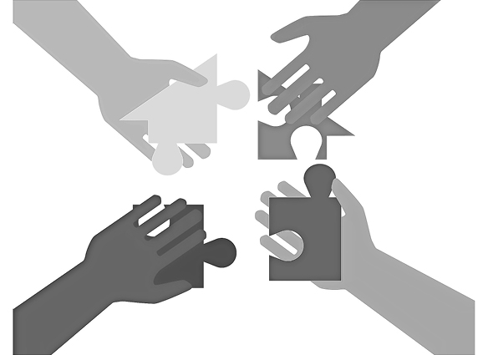
Social skills and confidence | Digital f | Classroom c
 | 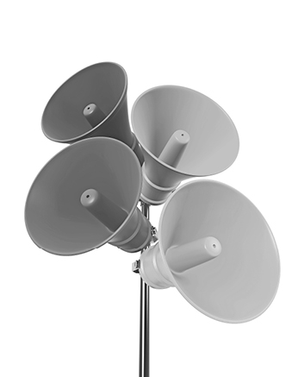 | 
Purposeful and p | Having a v | Developing t

 |  | b) | Cross out the wrong words in the sentences below.

1. Many blogs have advertisements so that the blogger can focus make money.
2. Many bloggers are very successful celebrity and make money from their blog.
3. Blogging is a great way for some teenagers to become publish self-made superstars.
4. It is important for blogs to have a good aspect layout so that people want to read them.
5. Some blogs feature focus video content or guest spots by other bloggers.
6. If you want to be well-known, you will need your own brand aspect that people can recognise.
7. The content publish of your blog is important. It must be interesting for people.
8. The people who read your blog are known as blog hosts consumers or subscribers.

