1 |  | Listening: Tiny houses

8 |  | a) | Listen to the audio and match the person to the right house. There is one extra picture you do not need.

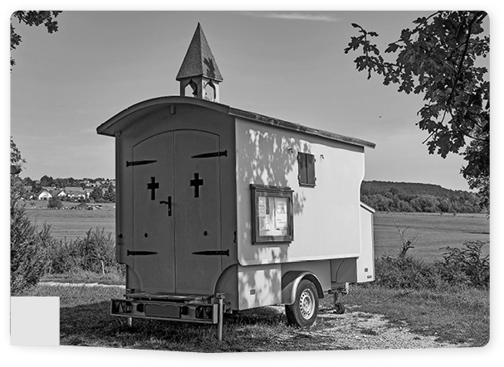  A | 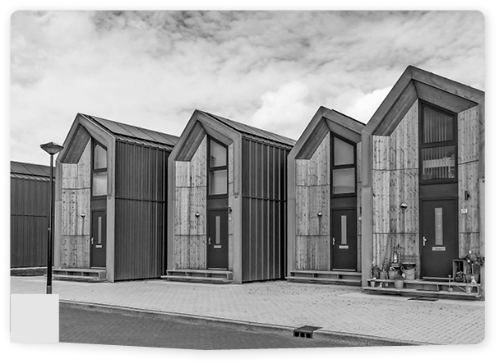  B | 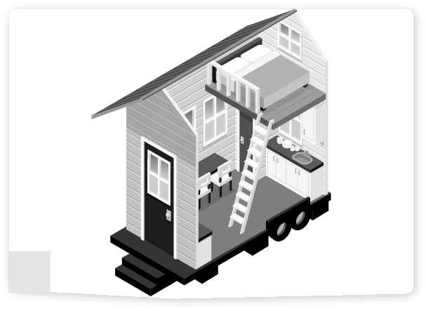  C
Abigail
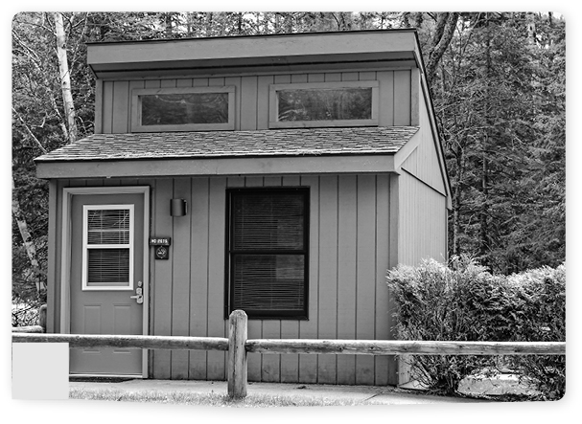  D | 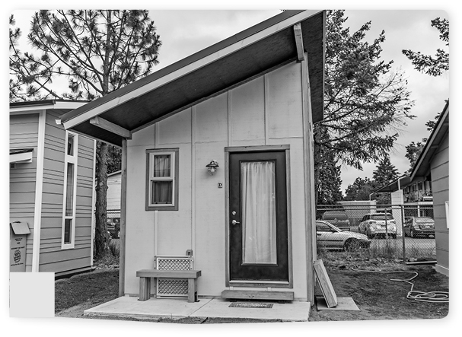  E | 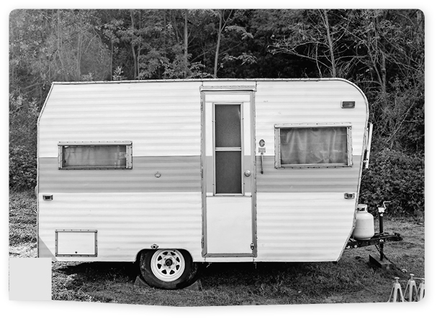  F

8 |  | b) | Listen to the audio and tick the correct person for each house. More than one person can be correct.

 |  | Michelle | Tim | Saya | Abigail | Arthur
1. | More than one person lives in this house at the moment. | ✓ |  | ✓ | ✓
2. | The house has not been built yet.
3. | The house is/will be next to other tiny houses.
4. | The house is an unusual shape.
5. | The house has big doors that can be left open.
6. | The house can be driven round the country.

2 |  | Reading: Alicia’s lifestyle

Our art teacher asked us to produce a visual mind-map to show our lifestyle. Here’s mine:

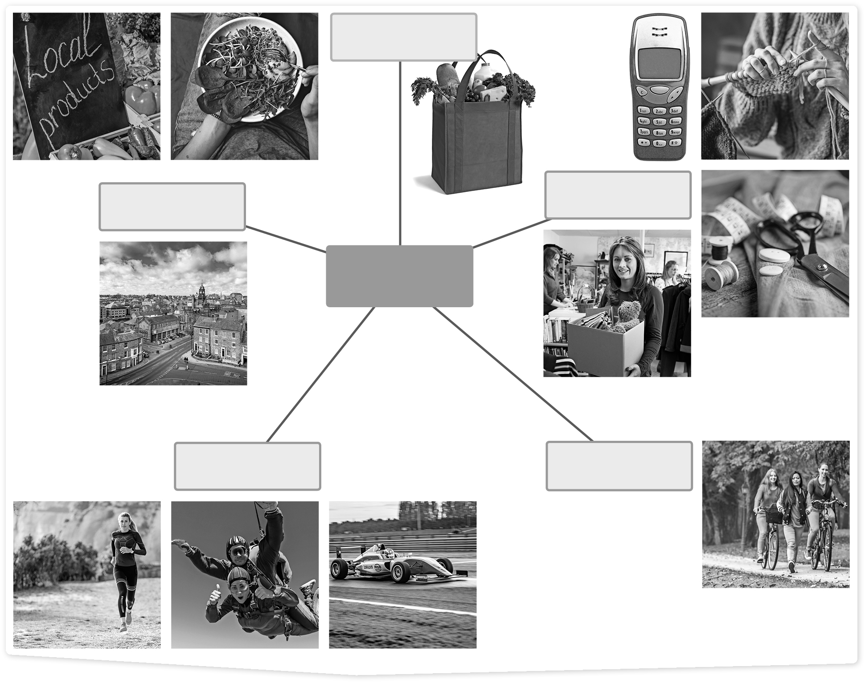
live
food
buy/use
move
fun
ALICIA

move

 |  | a) | Cross out the sentences in the text that do not match the information in Alicia’s mind-map.  You need to cross out 5 sentences. The first is done for you.

I loved making the mind-map for my art lesson. Making things is just so much fun. I even knit my own jumpers. I only buy clothes that I cannot make, and I get those second-hand. But I do buy some clothes online. Living sustainably is important to me. I bike everywhere. My boyfriend thinks I am crazy. Maybe I am a bit!
Some people think I am old-fashioned because I use old things, but I just do not see why we should buy something new when old things work just fine. Although I do have a new smart phone, I couldn’t say no to that.
When I go shopping, I use recyclable bags. Sometimes, I use plastic bags. And I buy all my food from local farmers. Except when we are having a barbecue, then I buy meat from the supermarket.
Generally, I just love nature. I live in a small village which is great. And I love running in the country- side. That is one of my favourite things. It is such an environmentally friendly sport. Not like my brother’s favourites: going sky-diving and watching Formula 1.

3 |  | Writing: Sustainability

 |  | a) | Write a postcard (40–60 words) to your English friend telling him/her about your sustainable travel trip. Use the wordcloud below to help you.

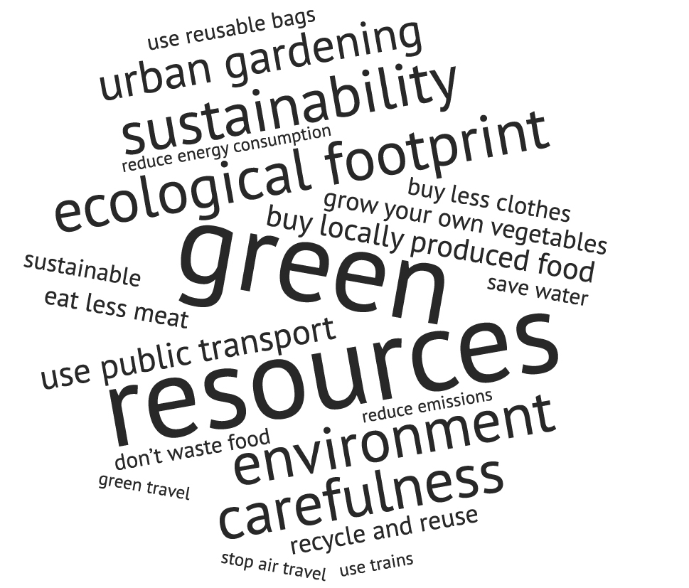

 |  | b) | Your American aunt and uncle love to travel and now that they have retired they go on three or more holidays a year. Write an e-mail (about 150 words) to them persuading them to think more about the environment. Don’t forget to use paragraphs. Make sure you tell them about:

- why tourism can be bad for the environment,
- how they can travel in a more sustainable way,
- holidays that are better for the environment,
- what else they can do to live in a more sustainable way,
- what you do to live sustainably.

4 |  | Language in use: Sustainability

 |  | a) | Match the sentence halves below. There is one extra half.

1. | My family try to |  | into the atmosphere damage the environment.
2. | Emissions released |  | promote sustainable shopping habits.
3. | Today, many fashion blogs |  | as more people become vegetarian.
4. | The food industry is adapting |  | problem for children in many countries.
5. | Some world leaders believe | 1 | buy most of our groceries locally.
6. | Learning about sustainability can be |  | negative impact on nature.
7. | Food poverty is a growing |  | that equality is very important.
8. | Tourism can have a |  | the inspiration for changing your life.
 |  |  | in small shops.

 |  | b) | Use the words in the box to complete the sentences below. There is one extra word/phrase you do not need.

global challenges environmental footprint inequalities food waste second-hand
recycle consumption reusable bag

1. Buying second-hand clothing is a good way to shop sustainably.
2. Tiny houses help lower the of resources such as electricity.
3. Many supermarkets give away unwanted food to try to prevent
.
4. It is a good idea to take a with you when you go shopping.
5. One of the biggest is climate change.
6. Many scientists think that global warming will cause further
in the world.
7. Tiny houses have a small .

 |  | c) | Change the sentences from active to passive.

1. They buy a lot of second-hand items.
A lot of second-hand items are bought by them.
2. People speak English in Britain and America.

3. Shakespeare wrote many plays for the theatre.

4. The school’s football team won the match.

5. The children catch many fish in this lake.

6. We should buy more products locally.

 |  | d) | Put the words in the correct order and write them down.

1. passports are being their before the board can they plane checked
Their passports are being checked before they can board the plane.
2. race been of the rain because has stopped the

3. closed the museum would have they but visited it was

4. six hours house in painted only was the

