1 |  | Listening: The Maori

10 |  | a) | Listen to the audio and circle the correct answer.

1. | There are … Maori tribes. | a) 17 | b) 57 | c) 75
2. | Maori tribes share … | a) a language. | b) a language and stories. | c) a language, stories, and haka.
3. | The women usually use … poi for their tribal dance. | a) one | b) two | c) three
4. | Maori use … from the umu to cook food. | a) a large fire | b) hot rocks | c) steam
5. | The most famous food cooked in an umu is … | a) fish. | b) chicken. | c) lamb.

10 |  | b) | Match the words to the correct information. There is one word you do not need.

1. | haka |  | a ball on string
2. | poi |  | a pit oven
3. | umu |  | a person’s importance
4. | h–angi | 1 | a war dance
5. | mana |  | traditional clothes
 |  |  | a way to cook

2 |  | Reading: Adventure holidays in New Zealand

 |  | a) | Read the statements below and tick which holiday would be best for each tourist. More than one answer may be correct.

New Zealand is a land of contrasts: from natural wilderness to towns full of culture. From mountains, to fjords, to beaches, and quiet seas. There’s something for everyone. Here are some of our latest deals for adventures in New Zealand.
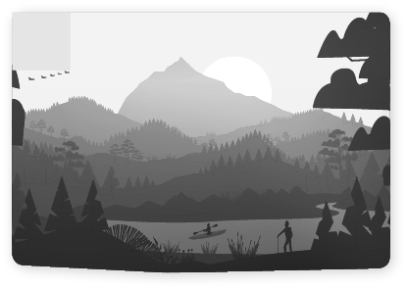  1 |  | 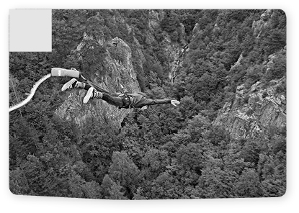  2 |  | 3 |  | 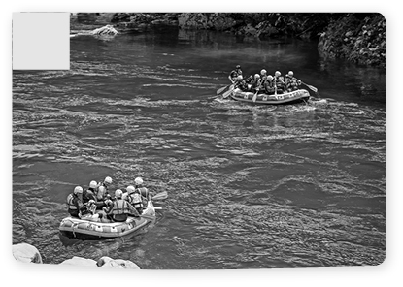  4
Peaceful kayaking  Guaranteed viewing of sealions and seals.  You might even see dolphins and whales.  Book for 2 and save  20 NZD |  | Crazy bungee jumping  30% off from 12th June to 19th July only.  Book now for only  120 NZD |  | Enjoy an easy walk through the -Glowworm Caves  2 free kids for every adult  FREE  offer available from 4th July – 11th -October |  | Wild Water Rafting half price until the end of August  Save up to 50% when you book direct.  50% OFF  only available for the first 50 bookings
More information |  | More information |  | More information |  | More information

 | 1 | 2 | 3 | 4
1. My mum’s looking for a holiday for the whole family. She’s trying to save money as there are six of us with Dad. Poor Mum, there are four of us boys and we all love adventure, we like crazy sports, and we love to get wet. |  |  |  | ✓
2. This will be my first holiday without my parents. I’m planning a trip of a lifetime with my best friend. We love wildlife and don’t mind some activity on the way.
3. I love adventure. I often travel alone and just head off to the most exciting place. This year, I’ve decided to go to New Zealand in August. All I need is some extreme sport!
4. We’ve decided that our children are old enough to take a long flight now so we are thinking about travelling to New Zealand this year, but we are worried that it might be too expensive. We like unusual holidays, but the kids are a bit young for anything too extreme.
5. This is our last year of school, so a few of us decided to book a wild holiday. We are looking for a great deal that will let us fly out as soon as school finishes for the year. We are all adrenalin junkies and need to have fun but no water please. I hate getting wet!
6. We are getting older now. We used to love all the crazy adventures you can do on holiday, but now we want something a little calmer. It has to be outdoors; we love the fresh air. And, not too boring, we are old, but we are still very active and sporty.

 |  | b) | Read the statements below and tick T (= true) or F (= false).

New Zealand is a land of contrasts: from natural wilderness to towns full of culture. From mountains, to fjords, to beaches, and quiet seas. There’s something for everyone. Here are some of our latest deals for adventures in New Zealand.
1 |  | 2 |  | 3 |  | 4
Peaceful kayaking  Guaranteed viewing of sealions and seals.  You might even see dolphins and whales.  Book for 2 and save  20 NZD |  | Crazy bungee jumping  30% off from 12th June to 19th July only.  Book now for only  120 NZD |  | Enjoy an easy walk through the -Glowworm Caves  2 free kids for every adult  FREE  offer available from 4th July – 11th -October |  | Wild Water Rafting half price until the end of August  Save up to 50% when you book direct.  50% OFF  only available for the first 50 bookings
More information |  | More information |  | More information |  | More information

 |  | T | F
1. | You can get 30% off the bungee jumping adventure all summer.
2. | On the guided tours, you will see lots of seals and dolphins.
3. | A visit to the Glowworm Caves is free for kids all year.
4. | The best holiday for wildlife watching is the kayaking holiday.
5. | The rafting holiday is half price until the end of the summer season.
6. | 2 adults can go free with 7 kids in the Glowworm Caves.

3 |  | Writing: New Zealand

 |  | a) | Your friend goes to a different school and he/she has asked you for help with his/her project about New Zealand. Write an information text (about 100 words) to help your friend. Use the words in the box. Don’t forget to use paragraphs.

Maori kiwi island mountains adventure Wellington storytelling sacred

 |  | b) | Your teacher has asked you to prepare a short talk (120–150 words) about New Zealand. Make sure you cover all the topics:

- a short history of New Zealand
- the Maori
- the geography of New Zealand
- what you have found most interesting about New Zealand
- what tourists can do if they visit New Zealand
- why you would like to visit New Zealand
Don’t forget to use paragraphs.

4 |  | Language in use: New Zealand

 |  | a) | Match the place names to the numbers on the map.

1. | New Zealand | 7 | 5. | Indonesia
2. | Australia |  | 6. | Tasmania
3. | North Island |  | 7. | Wellington
4. | South Island |  | 8. | Pacific Ocean
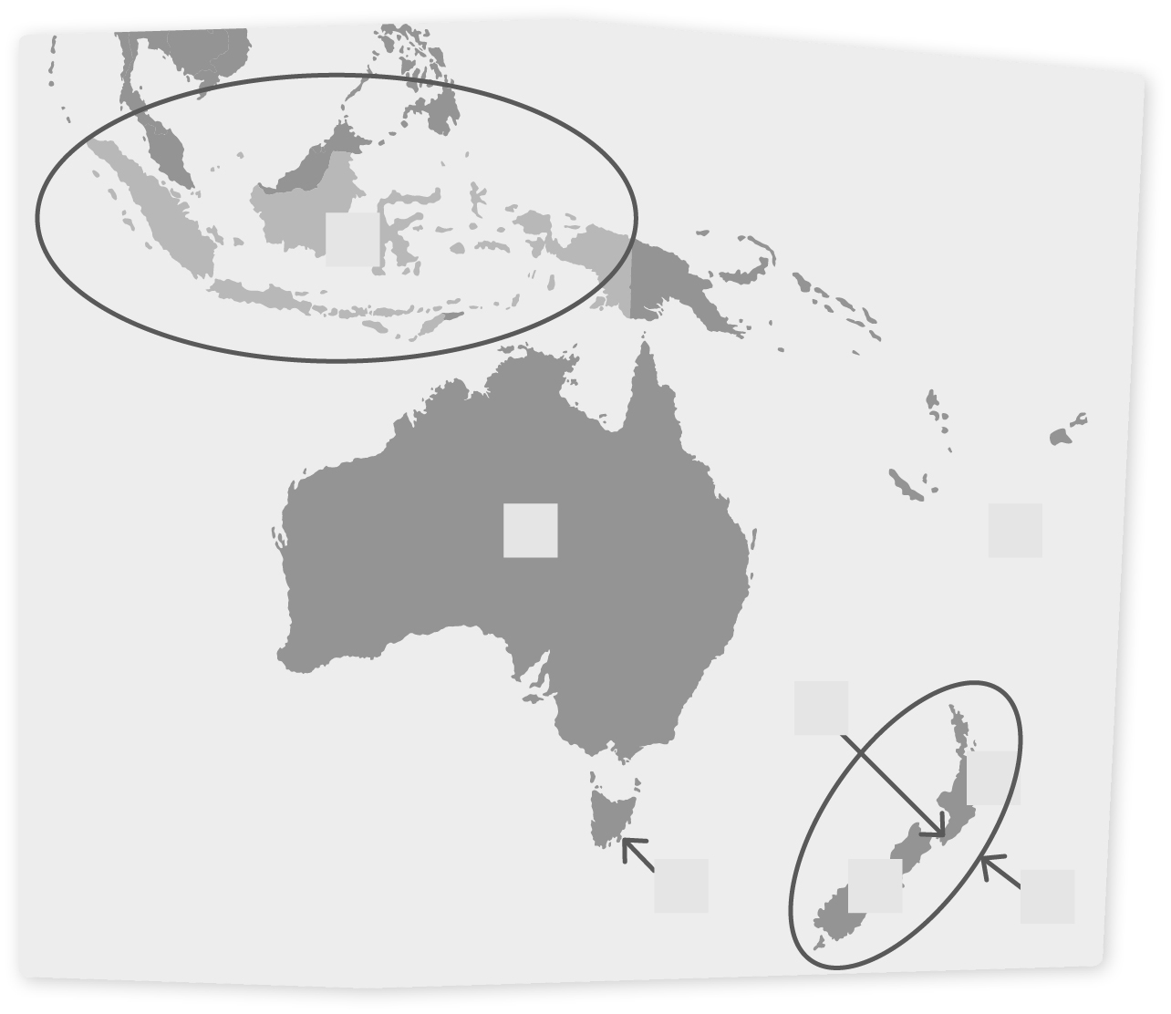
2
1
4
8
3
5
7
6

 |  | b) | Write the words next to their definitions.
1. to record and explain the past by speaking oral history
2. to go up r
3. a long trip or journey v
4. native to a country i
5. a document that is signed to end a war t
6. a serious argument, war, or fight c

 |  | c) | Match the sentence halves.

1. | Travelling |  | makes lots of people nervous.
2. | Flying |  | by car is often the best option.
3. | Going |  | cakes is a popular hobby.
4. | Walking |  | neighbours is a really nice thing to do.
5. | Surfing |  | the internet for good deals is great.
6. | Giving | 1 | alone, can be fun.
7. | Baking |  | your pet a bath can be difficult.
8. | Helping |  | to school is good exercise.

 |  | d) | Cross out the wrong words in the sentences below.

1. Are you nervous about the long flight? Well, a few a little bit. I’m sure it will be okay.
2. The population in the USA is much many bigger than the population in New Zealand.
3. Do you have much a lot of tourists in this town? Yes, we do.
4. There aren’t many much big cities in New Zealand.
5. I like bungee jumping, but I’ve only done a few a little jumps.
6. We don’t have many much money, but we are hoping to visit New Zealand next year.
7. We have much lots of time to spend in Wellington.

