1 |  | Listening: What’s your favourite kind of holiday?

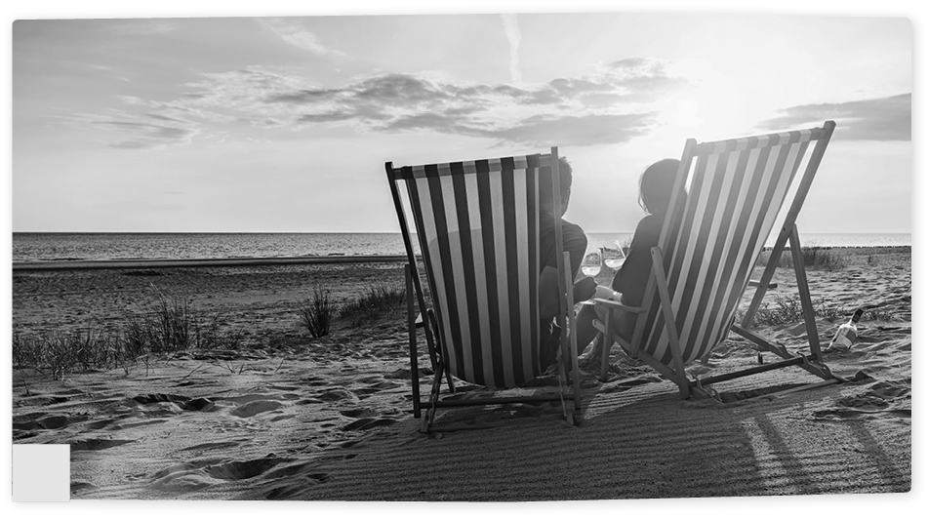  A |  | 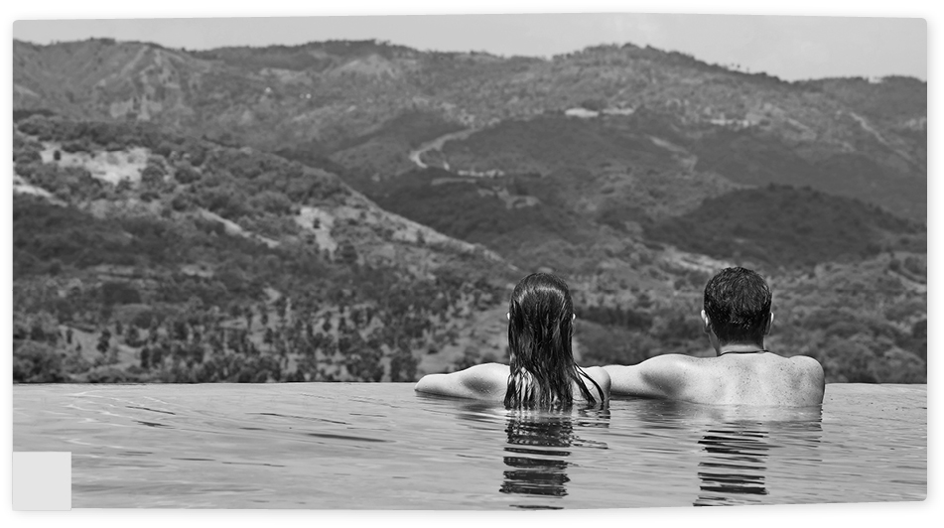  B
Speaker: 3 |  | Speaker:
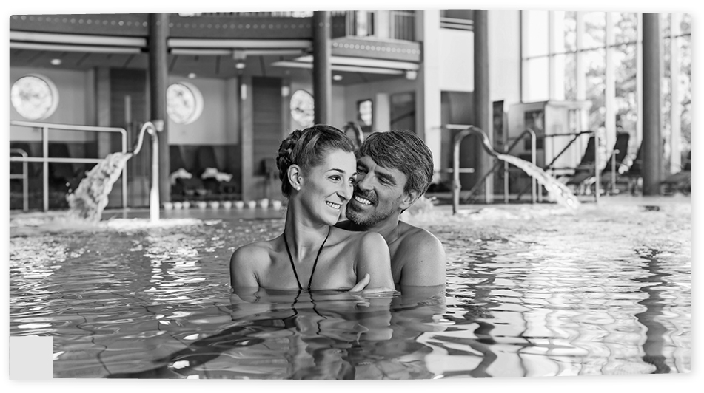  C |  | 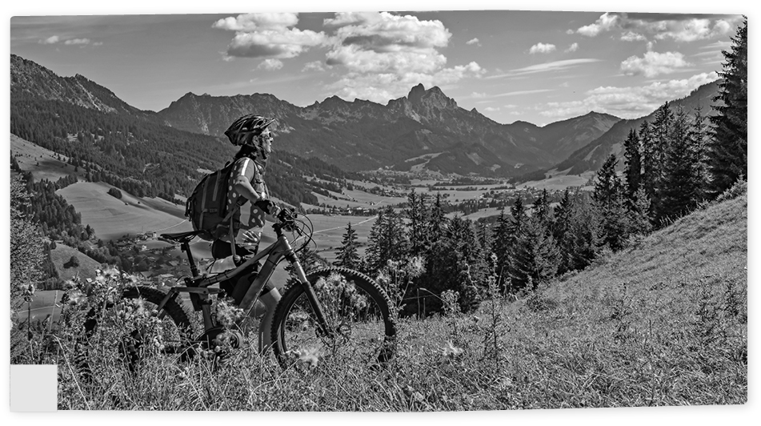  D
Speaker: |  | Speaker:
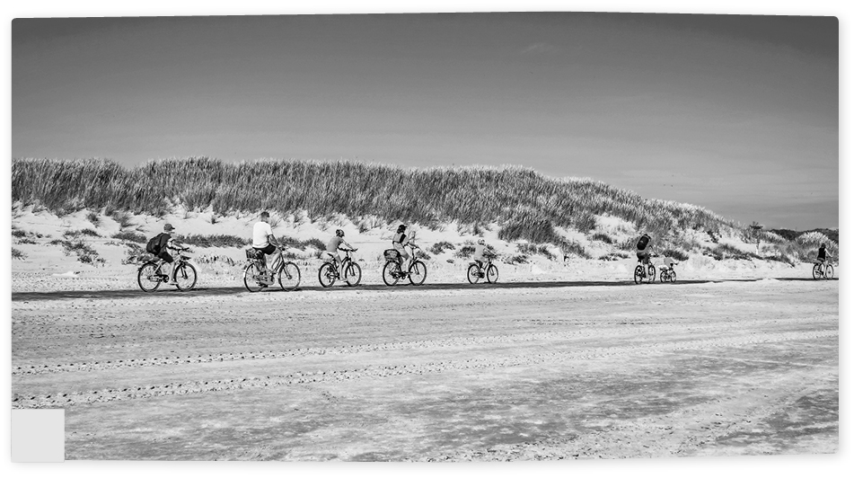  E |  |   F
Speaker: |  | Speaker:

11 |  | a) | Listen to the speakers talking about their favourite kind of holiday and match them to the correct pictures. There is one extra picture.

11 |  | b) | Listen to the speakers talking about their favourite kind of holiday and tick T (= true) or F (= false).

 |  | T | F
1. | Speaker 1 is talking about picture E.
2. | Speaker 2 is talking about picture D.
3. | Speaker 3 is talking about picture A.
4. | Speaker 4 is talking about picture C.
5. | Speaker 5 is talking about picture B.

2 |  | Reading: Guesthouses

 |  | a) | Read the statements below. For which of the guesthouses are they true? Tick the correct guesthouse. The statements can be true for more than one guesthouse.

 | Guest- house 1 | Guest- house 2 | Guest- house 3
1. The guesthouse can be reached easily by car. | ✓ | ✓ | ✓
2. The guesthouse sells home-made produce.
3. The guesthouse has more than four bedrooms
4. You have to go outside to wash yourself.
5. There is organised evening entertainment.
6. You can sit outside.
7. You will not have to pay for bedding.
8. You can stay here in October.

1. Dolomite Retreat Guesthouse
Located 36 km from Lienz, of which the last 10 is on good gravel road. The accommodation is on the 1st floor where there are 2 double rooms, one 6-bed room, one 5-bed, one 4-bed and one 3-bed room. Bedding is available on request for a small fee. Other facilities on hand are solar lighting, shower, WC, and electricity. This alpine guesthouse features its own cheese dairy and you can place orders from our own fishpond. Guests are welcome to enjoy our regular barbecue evenings with music and families with children will have fun playing on the natural skittles lane. Rental period from 1 June to end of September.
2. Mountain Cross Guesthouse
Located amidst tall trees on a gently sloping meadow 11 km from Bad Sankt Leonhard, at the end of a 200 m level gravel road. As a welcome, there’ll be a Carinthian snack waiting for you in the cosy cabin lounge with an integrated kitchen. The cabin has 5 double rooms, 2 WCs, 2 showers, a bathroom with a bath, central heating, warm water, and a sauna. Bed linen can be hired. The guesthouse also has satellite TV, a radio, a fridge, and a coffee machine. There is a spacious fenced garden with a children’s playground, as well as a barbecue, garden furniture, and sun loungers. Our guesthouse is open all year round. Despite the luxurious renovations and spacious bedrooms and living rooms, the Mountain Cross Guesthouse is still a real alpine cabin. And in winter it’s a skiing cabin, as cosy as you can imagine.
3. Valley View Guesthouse
Located in the Placid valley, Valley View Guesthouse is a cabin for nature lovers who are looking for simple and sound accommodation, in a peaceful, unspoilt mountain landscape, surrounded by alpine pastures. It is a 150-year-old original alpine cabin made out of solid wood, equipped with a combined living room/kitchen and a family bedroom with 4 beds and a WC. We provide all the bedding free of charge. The outdoor shower and solar energy will make your cabin holiday an especially rustic experi- ence. The cabin has been fully adapted for self-catering. It also comprises a nicely furnished terrace with a lovely view over the high-altitude mountain landscape. The cabin is easily accessible via a mountain road in a car that doesn’t have too low a suspension or in a four-wheel drive. Available from early June to the first week of November.

3 |  | Writing: Planning a holiday

 |  | a) | You want to go to a laser-tag game/riding stables with some friends for your birthday.  Write an e-mail (about 100 words) to the owner and ask for more information and place a booking. Use the words and phrases in the box to help you. Use paragraphs.

My friends and I … … hours arrive
available …? recommend …? equipment …?
One last question … confirm further information Kind regards, …

 |  | b) | What would you recommend? Your British/American friend wants to come to Austria for a holiday. Write him/her an e-mail (at least 150 words) with recommendations.  Address the following points:

- Ask about your friend’s wishes.
- Suggest different options.
- Share some personal Austrian holiday experiences.
- Write about your worst Austrian holiday experience.
- Write about your best Austrian holiday experience.
- Say what you would prefer to do on holiday in Austria.
Use paragraphs.

4 |  | Language in use: Coming back

 |  | a) | Unscramble the words.
1. ranrsteaut restaurant
2. lebodu omro
3. lal-sucevnili
4. nlcoyba
5. ilfyma-nur
6. emodheam

 |  | b) | Fill in the gaps with words that mean the opposite of the underlined words in the sentences below. Make sure they are grammatically correct.
1. It is very unlikely that I will book a hotel this year. likely
2. I expect to be bored on holiday. t
3. We decided to walk across the grass with our boots. b
4. I usually stay awake for the whole journey when we travel by car. f
5. The first meal we ate on holiday was awful. d
6. The hotel receptionist has a special way of saying goodbye to the guests. g

 |  | c) | Decide if the sentences below are in the active or passive form. Write A (= active) or P (= passive) after each sentence.
1. Someone has cleaned the room. A
2. The room has been cleaned by someone.
3. Twenty people are employed by the hotel.
4. The ski lift was built three years ago.
5. The town council wants to build another ski lift next year.
6. A meeting to discuss this will be held next week.

 |  | d) | What has changed? Use the underlined words and write present perfect active and passive sentences to explain what has changed.

1. (The village is no longer small.) People build new houses
Active: People have built new houses.
Passive: New houses have been built.
2. (The laundry is no longer dirty.) Simon do the laundry
Active:
Passive:
3. (The grass is no longer tall.) Mum mow
Active:
Passive:
4. (The house is no longer for sale.) The Smiths buy
Active:
Passive:
5. (The milk is no longer in the fridge.) Melanie drink
Active:
Passive:
6. (The sheep are no longer in the alpine pasture.) The farmer take away
Active:
Passive:

