1 |  | Listening: My favourite ads

15 |  | a) | Listen to the audio and tick T (= true) or F (= false).

 |  | T | F
1. | Tom is happy with ads in the middle of videos.
2. | Sue and her sister both like fashion ads.
3. | Adrian does not like pop-up ads.
4. | Adrian’s mum and dad both hate in-app purchases.
5. | Zoe does not like ads.
6. | Ann’s favourite ads are for food.

15 |  | b) | Listen to the audio and tick the correct boxes. More than one answer can be correct.

 |  | Tom | Sue | Adrian | Zoe | Ann
1. | Who does not like ads in the middle of videos? | ✓
2. | Who likes ads for clothes?
3. | Who’s mum hates the ads they like?
4. | Who likes ads in games.
5. | Who does not like ads.
6. | Who likes ads for food?

2 |  | Reading: Advertising

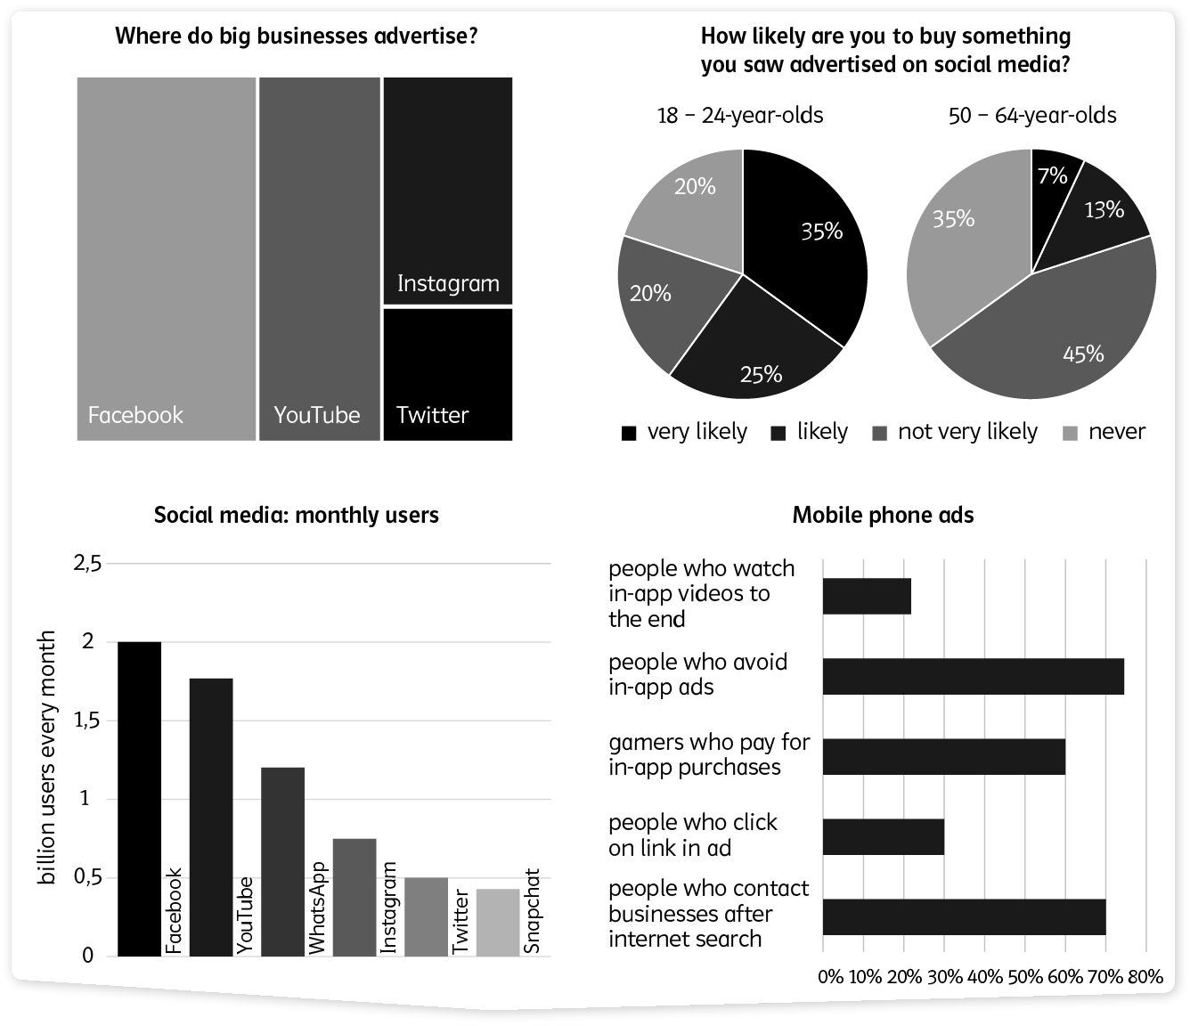

 |  | a) | Read the infographic and tick T (= true) or F (= false).

 |  | T | F
1. | More big businesses advertise on Facebook than they do on Twitter.
2. | More people use WhatsApp each month than Instagram.
3. | More 18-24-year-olds are “very likely” to buy something they saw advertised on social media than “likely” to buy something they saw advertised.
4. | More big businesses advertise on Twitter than they do on Instagram.
5. | WhatsApp has the third highest monthly users of all social media.
6. | Most gamers will pay for in-app purchases.

 |  | b) | Read the infographic and answer the questions.
1. The most popular social media for business ads is Facebook. YouTube. Instagram.

2. Instagram has more monthly users than Snapchat. WhatsApp. YouTube.

3. More 18-24-year-olds are “very likely” “not very likely” to buy something they saw advertised on social media than “likely” to buy something they saw advertised.

4. More big businesses advertise on Instagram than they do on
Facebook. YouTube. Twitter.

5. The social media platform with the most monthly users is
Facebook. YouTube. Instagram.

6. The percentage of gamers who will pay for in-app purchases is 40%. 50%. 60%.

3 |  | Writing: Opinions

 |  | a) | What do you think about the ad below? Express your opinion. Write about 100 words.  Don’t forget to use paragraphs. Use the sentence starters to help you.


CliXity – Where the whole world is only a click away!

Personally, I think …
Obviously, this ad …
Clearly, this is …

Surely companies should …
Frankly, I believe …

 |  | b) | Think about an ad you have seen. Express your opinion. Write about 100–150 words. Make sure you include all the points below. Don’t forget to use paragraphs.

- What is the ad trying to sell?
- Describe the ad.
- Who do you think the ad is for? Why?
- What is good about the ad?
- What could be better about the ad?
- Do you like the ad? Why/Why not?

4 |  | Language in use: Awesome ads

 |  | a) | Match the definitions to the correct words. There is one option that you do not need.

A person/thing that is …
1. | very bad |  | is a grown-up.
2. | not late | 1 | is evil.
3. | organised and puts things away |  | is aggressive.
4. | not a child |  | is punctual.
5. | not heavy |  | is optimistic.
6. | not peaceful |  | is light.
 |  |  | is tidy.

 |  | b) | Use the words in the box to fill in the gaps. There is one extra word.

order hardly unprofessional typically slang
casually social uncomfortable

Although ads typically 1 interrupt a film, or video, sometimes the product is 2 used by characters and 3 noticed by viewers.
Professional ads often use 4 to make people think the product is cool.
Ads on 5 media often include a link so that people can
6 the service or product immediately.
Some people are 7 with the number of ads that surround us, but ads are here to stay!

 |  | b) | Write the correct form (comparative or superlative) of the words in brackets.
1. Some ads are cleverer than (clever) others and get you interested without you knowing.
2. I find ads that pop up on your screen when you are trying to read something
(aggressive).
3. I think video ads are (good) print ads because they can be more exciting.
4. People say that ads with music are (successful) those without.
5. I think (bad) ads are those with a silly song that you just cannot forget even if you hate the product.

 |  | c) | Fill in the gaps with the correct adjective or adverb.
Marlie spent three days at an ad agency for work experience when she was still at school. On the first day she dressed smartly 1 (smart) as she wanted to look 2
(professional). But as most other people were in 3 (casual) clothes she dressed 4 (casual) on the second day. She felt a bit 5
(uncomfortable) at first but soon felt able to speak 6 (natural) to all the other workers even though they were all older than her. Most of them looked 7
(terrible) cool wearing 8 (extreme) trendy clothes. Some of their clothes looked 9 (real) expensive but no one made Marlie feel
10 (different) because of her outfit. Really 11 (quick) she felt like she had been working there for years. She was 12 (definite) sad when her time there was over. And, she was 13 (excited) to think that one day she could work in a very similar business.

