Writing Prompt 1

Hello from our holidays
You are in a holiday destination that you know well. You are writing a letter/an email to a friend who is going to join you there at a later date. Tell him / her
- Where you are staying and what the accommodation / area is like
- What the weather is like
- What your holidays have been like so far
- What you did in the last few days
- What the best thing was that happened
- What you are planning to do once your friend gets there
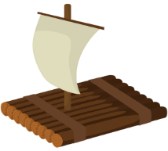
Before you start writing

Role | Audience | Format | Topic
Who are you as the writer? | To whom are you writing? Why? | What form of text are you writing? | What are you writing about? (check bullet points!)

Writing Prompt 2

My family and my home
An exchange student from America is going to stay with you for two weeks. He/She asked you about your family and your home. He/she is a bit worried about what it is going to be like in Austria.
Answer her letter/email and tell him/her about your family and your home. Include information about
- the family members he/she is going to meet
- your flat and his/her room during his/her stay
- the most important family rules

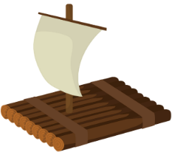
Before you start writing

Role | Audience | Format | Topic
Who are you as the writer? | To whom are you writing? Why? | What form of text are you writing? | What are you writing about? (check bullet points!)

Writing Prompt 3

School Life
An exchange student from America is going to stay with you for two weeks and will also come to school with you. He/she is a bit worried about what school in Austria is going to be like.
Answer her letter/email and tell him/her about your normal school life. Include information about
- your daily routine on school days (including how you get to school)
- your classmates at school
- lessons and breaks
- school rules

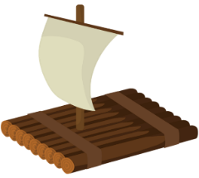
Before you start writing

Role | Audience | Format | Topic
Who are you as the writer? | To whom are you writing? Why? | What form of text are you writing? | What are you writing about? (check bullet points!)

Writing Prompt 4

If I were….
Your best friend and you watched a superhero-movie together. Afterwards you started to talk about the different superheroes and who you would like to be, but your parents picked you up too soon and you did not get to finish your discussion.
In the evening you write an email to your friend and explain
- which superpower you would like to have
- why you would choose this superpower
- describe in detail what you would do if you had this superpower
- ask your friend about his ideas

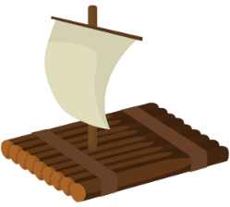
Before you start writing

Role | Audience | Format | Topic
Who are you as the writer? | To whom are you writing? Why? | What form of text are you writing? | What are you writing about? (check bullet points!)

Writing Prompt 5

A person you admire….
Your American pen friend met his/her personal hero – Oprah. He/she told you all about the meeting and why he/she admires Oprah so much in his/her letter.
Write back and tell your friend
- who you admire
- why you admire the person
- what you know about this person’s life
- what you would ask the person, if you met him/her

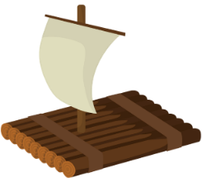
Before you start writing

Role | Audience | Format | Topic
Who are you as the writer? | To whom are you writing? Why? | What form of text are you writing? | What are you writing about? (check bullet points!)

Writing Prompt 6

A note…
You are staying at an English family because you are taking a language course in the summer. One of your classmates calls you and asks you to come to her/his place. Your host family is not at home so you leave them a short note.
Tell them
- where you went
- why you went there
- what you are doing there
- when you will be back
- how they can reach you

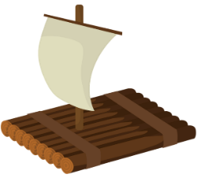
Before you start writing

Role | Audience | Format | Topic
Who are you as the writer? | To whom are you writing? Why? | What form of text are you writing? | What are you writing about? (check bullet points!)

Writing Prompt 7

Directions
You missed class on the last day of school. Your form teacher (Klassenvorstand) offers to bring over your report card (Zeugnis) but he/she does not know how to get to your place. Write a polite email to your teacher.
- Thank him/her for offering to bring over your report card
- Explain in detail how to get from school to your place

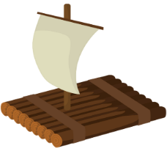
Before you start writing

Role | Audience | Format | Topic
Who are you as the writer? | To whom are you writing? Why? | What form of text are you writing? | What are you writing about? (check bullet points!)

Writing Prompt 9

Dream partners
On a website many teenagers write about the boy/girl of their dreams. You are going to make an entry, too. Describe the person in detail
Write about
- looks (body, hair, eyes….)
- character
- likes and dislikes

Say what is most important for you and why. Explain which things are not important for you and why.

Before you start writing

Role | Audience | Format | Topic
Who are you as the writer? | To whom are you writing? Why? | What form of text are you writing? | What are you writing about? (check bullet points!)

Writing Prompt 10

Thank you letter
It was your birthday yesterday and you got a present from your uncle in America. Write a polite ‘thank you’ letter and thank him for the present.

Write about
- why you like his present
- other presents you got
- your birthday celebrations

Say what is most important for you and why.

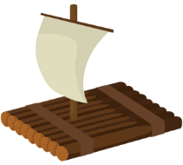
Before you start writing

Role | Audience | Format | Topic
Who are you as the writer? | To whom are you writing? Why? | What form of text are you writing? | What are you writing about? (check bullet points!)

Writing Prompt 11
Agony-Aunt
You are the editor of the school magazine. In this edition you have to write the agony-aunt page. You got the following three letters from pupils of your school. Choose one and write an answer.

Dear agony-aunt,  I have a big problem. I really want to have a dog but my mother absolutely refuses to discuss it. She says I’m not responsible enough and she knows that she will have to do all the work.  It’s not true, though! I would do everything and I would always care for my dog!  Please help me. How can I convince her?  Yours,  Sam | Dear agony-aunt,  I don’t know what to do. I am really bad at English and my parents are angry at me. They say that I will not get any pocket money and will not be allowed to meet my friends if I do not get an A or B on my next test.  What can I do?  Yours,  Ben | Dear agony-aunt,  I’m very sad because my best friend and I had a huge fight. I was jealous because she met some friends at the shopping mall and didn’t invite me. Later I saw that she invited me but I did not see her text.  I said a lot of really mean things and I even wrote some really mean messages.  I don’t want to lose her as a friend. What can I do?  Yours, Alex

Make sure
- you give only good advice
- offer several solutions to the problems
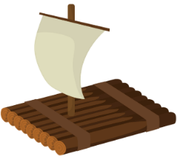
- the person feels better after reading your letter

Before you start writing
Role | Audience | Format | Topic
Who are you as the writer? | To whom are you writing? Why? | What form of text are you writing? | What are you writing about? (check bullet points!)

Writing Prompt 12

Saying you are sorry
A few days ago your English teacher told you to upload your homework on moodle. You did not do this homework. Write an e-mail to your English teacher in which you
- say sorry
- explain why you did not do your homework
- ask if you can do it for the next lesson
- offer to do some extra work for having missed the deadline
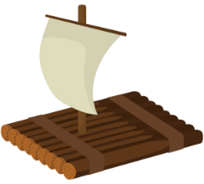
Before you start writing

Role | Audience | Format | Topic
Who are you as the writer? | To whom are you writing? Why? | What form of text are you writing? | What are you writing about? (check bullet points!)

Writing Prompt 13

Have you ever done anything special? Has anything strange or interesting happened in your life?
Tell us about it and win a prize.

The blog “youngsters.com” is looking for cool kids who have experienced some interesting things. You can win a prize if you send in a short blog entry, telling them about the three most interesting things that have happened to you so far.
In your blog entry, tell the readers
- what three interesting things you have done or have happened to you
- give some details about each one: when, where, who, how…
- how did the situation make you feel

Tip: You can invent details to sound more interesting, but your experiences should sound plausible.

Before you start writing

Role | Audience | Format | Topic
Who are you as the writer? | To whom are you writing? Why? | What form of text are you writing? | What are you writing about? (check bullet points!)

