How long have you...?
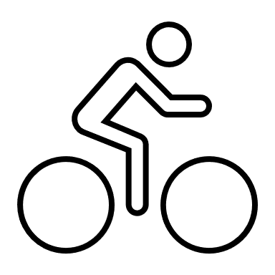



I’ve had my bike for five years.
I have known my friend Sally for 8 years.
I’ve had this T-shirt for ages.
Mrs. Pö has been an English teacher for more than 25 years.

Your turn: How long have you had ....?

We are going to find the oldest items that you have brought to school today. Check your stuff in your schoolbag and in your lockers and choose the oldest item that you have with you today.
Write five true sentences about this item.
Be prepared to present your old item.
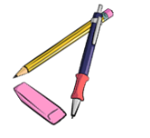
I've had my____________________for
I've had my ____________________since
Any other info about your item:

Old friends and relationships
How long have you all known each other? How long have you known your oldest friends. Think of an old friend and complete the following sentences.
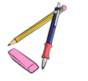
I've known this person for
I've often _____________________________________with___________________
I've never
We've always

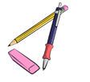
My rule:
Do you remember?
We have used this tense before. Do you remember what we have used it for?
Check your personal grammar book, part 1.
Duration (Dauer)
When we talk about how long we have had something, or how long we have been doing something we use the ……………………………….. tense.

For and Since

Work with a partner. Use the phrases from the box to write true sentences about yourself and the people around.
since 2017… for three years… since September…. for more than xxx years… since Monday… for three days… for many years… since Christmas… for almost an hour… since 7.40

Example: I have been a student at Praxismittelschule since 2017.

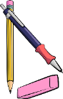
Find a rule: Look at the above sentences again. When do we use for, when do we use since?
My rule:
We use for when …
We use since …

