Writing Spooky Stories
and producing an online storybook

A Horror Scene
Glue the story lines from task 1 on this page in the correct order.

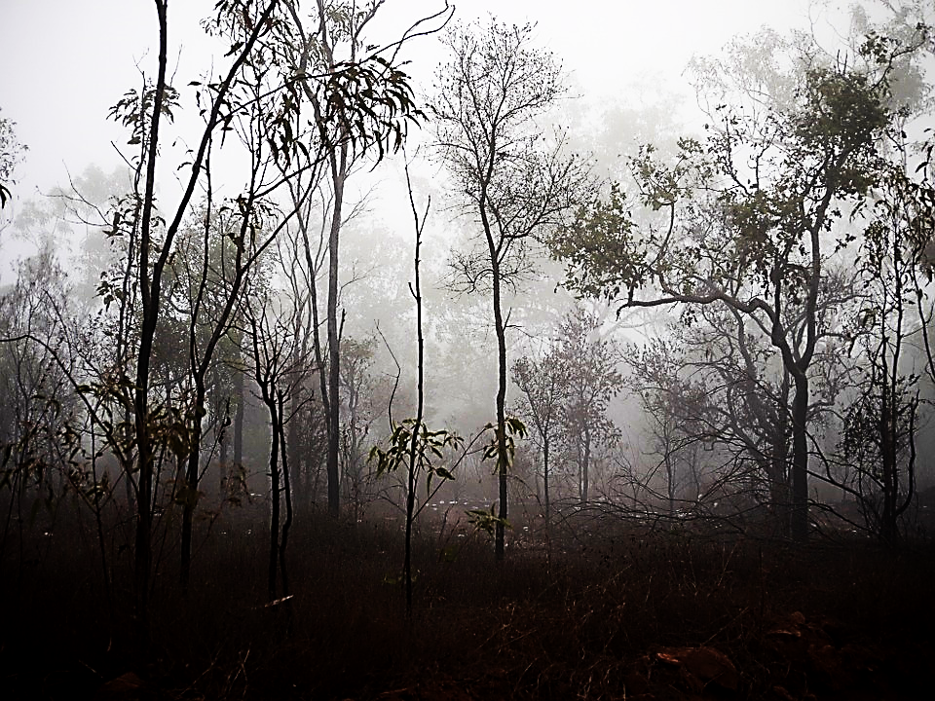

Task 1: A Horror Scene: Cut out the lines and put them in the correct order. Then glue them on page one of this handout. The different writing fonts will help you.
It was a cold night in late October. There was
clouds were moving across the sky quickly, sometimes covering the moon completely.
trees and the last leaves were falling down. Tom and Sarah
The wind was whistling through the
a full moon in the black sky but big
The children were walking quietly but quickly. They were
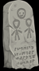
on one side and the cemetery wall
on the other side of the street.
were walking down a dark, narrow street. There was a forest
the wall some strange animal was howling like a
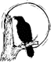
cold and scared. There were strange noises in the air: ravens
were screeching loudly and behind
dog in severe pain. Suddenly there was a
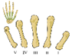
It was a heap of bones.
scream. A dark, skinny figure rushed out of the cemetery and ran
They were clean and white – just like the skeleton they had in the bio-lab at school.
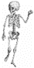
pitch-dark. When the moonlight came back a minute later
across the street. A huge cloud covered the moon and all of a sudden it was
the children could see something white lying in the middle of the street a few meters ahead of them.

The skull even had a small label tied to it.
It said: “property of PraxisNMS : bio-lab Nr: 9999”. (property = Eigentum)
Task 3: A Reading Puzzle
3a: Work with a partner. Cut out the story-blocks on the next page.
Then find the two stories and put them in the correct order into the grid below.

1 The situation (the setting, the atmosphere)
2 What happened first
3 The new situation (the setting, the atmosphere)
4 What happened next
5 What happened in the end

Glue one of the stories into column one and the other one into the column two.

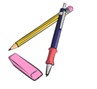
3b: Have a look at the bold words. Underline the past simple (went, was, …) in red and the past progressive (was sitting, was raining….) in green.
- Find the rule:
When we describe the atmosphere and the background in a story,
we use the …………………………………………

When we talk about events and things that happen in the story,
we use the …………………………………………….

Cut out the story blocks. Then find the two stories and glue the pieces on page 2 in the correct order.
The creature jumped at Mike and licked his face. “Stop!” Mike cried. “You nearly gave me a heart attack, Bello. Bad dog! Get off me!” | Mike screamed, but then he saw that it was his friend Tom in scuba gear. “That was really mean!” he shouted. Tom laughed so hard that Mike had to laugh, too.
Now Mike was really frightened. His hands were shaking and his teeth were clattering and it wasn’t because of the rain! | Mike was very nervous. The dark shape was coming closer and closer and Mike’s knees were shaking.
Suddenly there was huge flash of lightening. Mike saw a big shape at the end of the road. Was it a ghost? | Suddenly he saw a dark shape in the water. He sat up on his board and tried to get a better look. Was it a shark?
It was a dark and stormy night. It was raining and lightening was flashing all around. Mike was walking along a road in the countryside. | It was a beautiful sunny day. The wind was singing in the trees. Mike was lying on his surfboard, waiting for the perfect wave.
He took out his mobile phone and turned on the torch. He could still see the creature. It barked and ran toward him. | Mike hugged his knees to stop the board from shaking. He wanted to go home – but how? Suddenly a big, dark thing appeared in front of him.

Step 1: Planning your spooky story
Where is the story set?
Make a list of all the places and add a few keywords to each one.
Setting 1
Setting 2
(Setting 3)
Who are your main characters (A good story only needs 1-3 main characters)
Character 1
Character 2
(Character 3)
Main events: What happens in your story? Only write keywords.

Show your plan to your teacher.
Then go to the next page.

Step 2: Writing your first draft
Name:
Now you are ready to write the first draft of your story. Look at this page to see what your pages should look like.
Write a long and detailed spooky story and think about good illustrations for your storybook. Draw a sketch in the box on the left (or right) side. It should give you an idea of what you want to draw but should not be a perfect drawing. One picture should not take you more than 2 minutes! You will later work on the pictures in your ARTS lessons.
Title:

Write your text into the lines on the right side.
Pic No.


Get free storyboard templates at Boords.com

Write your story in your spiral block. Leave a wide margin (Rand) on one side and draw a simple sketch for each new scene.
Decide how many pages you will need for your book.

Pic No.

Pic No.
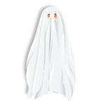
Step 3: Peer Conferencing:
What makes a good, spooky story?
Check if your story (or your partner’s story) meets all the following criteria.
Criteria | You can give up to 3 stars for each category.   If you only give 1-2 stars explain what could be improved and how this can be done best.
Title: The story has a promising, spooky title.

Setting and Vocab:
The setting is described well.
I can hear spooky sounds and I can see the scene in front of my eyes. The writer has used lots of good, spooky vocabulary.
Grammar: The setting/background is described in the past progressive tense (the moon was shining…)
Grammar: The actions /events are told in the past simple tense. (the door flew open, lightning struck…)
Characters: The characters react like normal human beings. We can see that they are scared and they have good reasons for their actions.
Ending and suspense: I am surprised by the ending – it is not predictable. The story is interesting to read – it is full of suspense (Spannung).
Further tips:
How else could this story be improved?

Step 4: Revise your Story
Revise your story carefully. Add more details and correct your little mistakes. Make your story longer and spookier.
Type your story into the book creator and make sure you save it there.
Ask your teacher to check your story when you think you have finished.

Step 5: Illustrate your story
Add pictures and illustrations to your story. Only use pictures that are free (e.g. from pixabay or your own drawings)
Step 6: Record your voice
If your teacher told you, that your story is ok, practice reading your story several times. Use your voice to create the right atmosphere. You can read slowly or quickly. Use your voice to show that the character was scared, happy, relieved… Add simple sound-effects (just use everyday objects: blow into a bottle to create the sound of wind, hit the table to create thunder, stomp on the floor to create the sound of footsteps…)
When you have practiced enough, record your voice for each slide. You can do this for each page separately.

