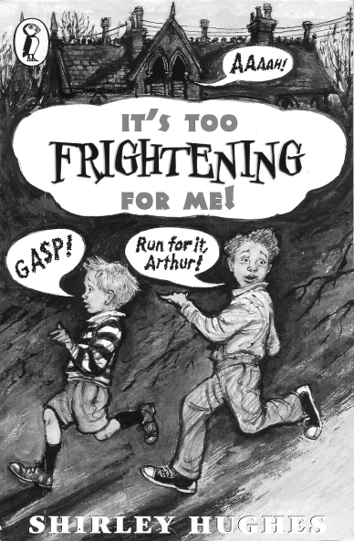
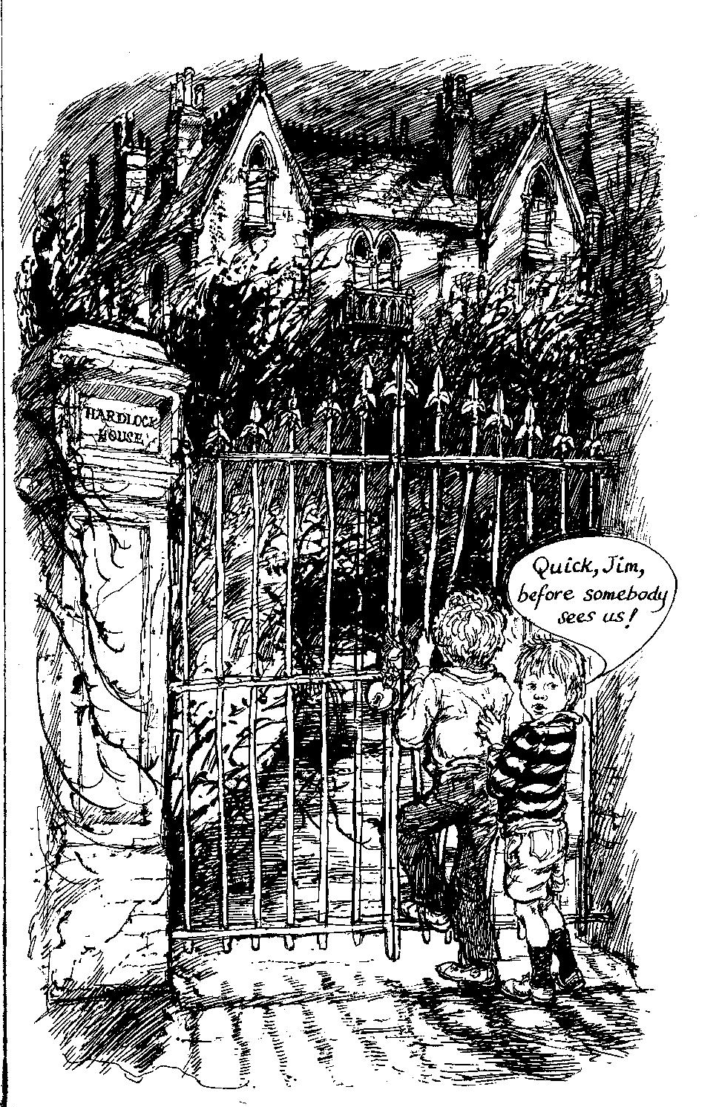
- Look at the picture. Describe the house and the garden. What do you see? What do you hear?
- Imagine what the house looks like inside? Collect lots of ideas and lots of new vocabulary phrases on a sheet.
- After your session with Mrs. Brown, copy the new phrases on vocab cards and practice them (walk and talk, write and check)

