2c First Test November 2012

Write a spooky story:
Listen to the beginning of the story ‘The house on a lake’. Then describe Arthur’s first night in the new house.
Make your story really spooky by describing the eerie atmosphere in the house. What happened during that night?
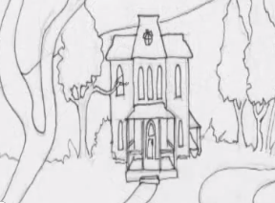 | 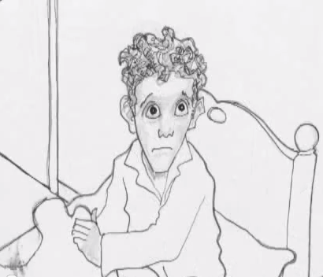
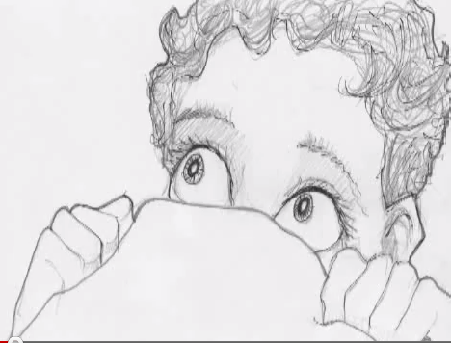 | 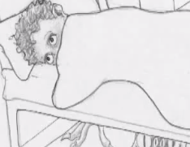

After the test: If you want to know how the story continues, check on Moodle.

