
It was a ………………………………. and ………………….. night in February.
  Outside the moon was shining and the wind _______ _____________ loudly.    An owl was hooting and a big, scary animal ________ ______________up and down in front of the house.  It was growling angrily. |  | Upstairs Tom’s grandparents were getting ready for bed. Grandpa _______ _____________ his teeth   and grandma was sitting in her favourite chair. She ______ __________________ a book. 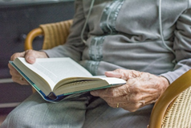 |  | 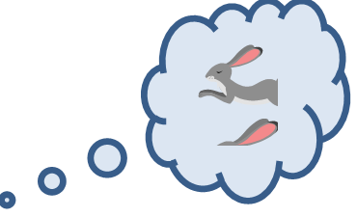  Tom’s dog _______ _________________ on the sofa. It was dreaming of chasing rabbits.  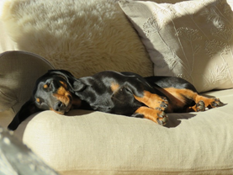
Tom’s sister _______ _______________ on her sofa. She ______ ___________________ to music and chatting with her friend on the computer.     |  | Tom’s parents _______ _______________ a science fiction series on TV. A ghost was trying to destroy the earth. It was very frightening.  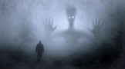   |  | 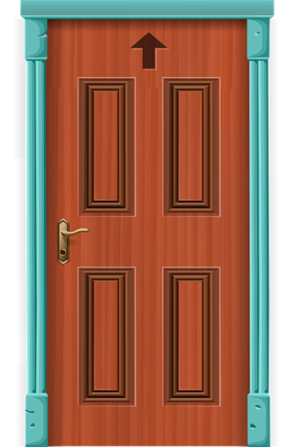
 |  | Tom’s grandpa came downstairs. He still had his toothbrush in his hand. He looked at the vampire and shook his head slowly. He said loudly: ”You should brush your teeth, young man. You can’t come to my house with your mouth all full of blood. Come with me to the bathroom – you can use my toothbrush.”  The vampire looked frightened and started to scream. He turned around and ran away. Tom’s family never saw the vampire again. The End |  | 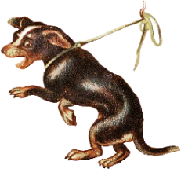  Tom’s dog _____________ up and started to bark. The vampire looked at the dog angrily. “Sit.”, he said quietly. The dog stopped barking and sat down. It looked at the vampire with big eyes.
Tom’s sister came into the living room. When she _______ the vampire she _________ her cellphone and phoned her best friend. She told her friend how good looking the vampire was. Then she took a photo and sent it to her.   |  | Tom’s mother screamed loudly. She jumped up and _________ under the stairs. Tom’s father didn’t notice the vampire – he was watching TV! He said: “Don’t worry dear, there’s going to be a happy ending!”    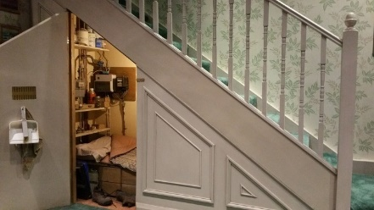 |  | SUDDENLY  the door opened and a vampire came in!  