.
Spooky Story Game  Play this game in pairs or groups of three. Put the picture cards on a pile. Every player takes 7 text cards.  Start with the first picture card. The oldest player starts. Do any of your sentences describe the scene?  If the card fits – put down your sentence card and read it out.  If not – try to add one description or event in the story.  Tip: Description: What was it like. (-ing...)  Event: What happened next?  Then the person on your right adds a sentence to the story.  If you cannot add one of your sentence cards OR think of a good sentence to add, you are out. The person who can add the last sentence wins the round and gets the picture card.  Then start again with the next picture card.  The person with the most picture cards wins the game. | Spooky Story Game  Play this game in pairs or groups of three. Put the picture cards on a pile. Every player takes 7 text cards.  Start with the first picture card. The oldest player starts. Do any of your sentences describe the scene?  If the card fits – put down your sentence card and read it out.  If not – try to add one description or event in the story.  Tip: Description: What was it like. (-ing...)  Event: What happened next?  Then the person on your right adds a sentence to the story.  If you cannot add one of your sentence cards OR think of a good sentence to add, you are out. The person who can add the last sentence wins the round and gets the picture card.  Then start again with the next picture card.  The person with the most picture cards wins the game.

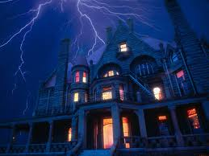  1http://gurneegraded56.sharpschool.com/UserFiles/Servers/Server_2464887/Image/Mr.%20Butler/spooky-house-with-lightening.jpg | 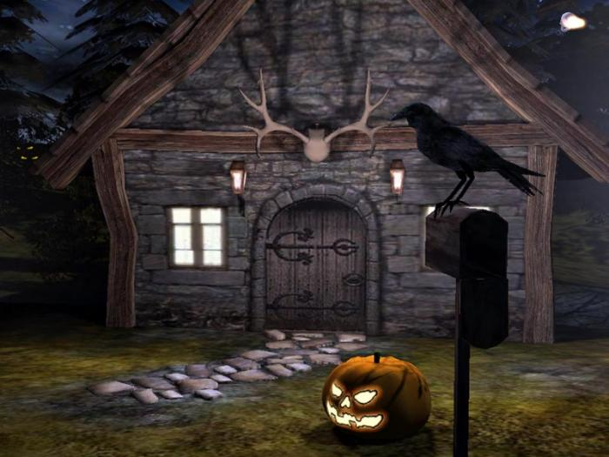  2http://sandbox.yoyogames.com/extras/image/name/san2/212/335212/original/SA0...jpg
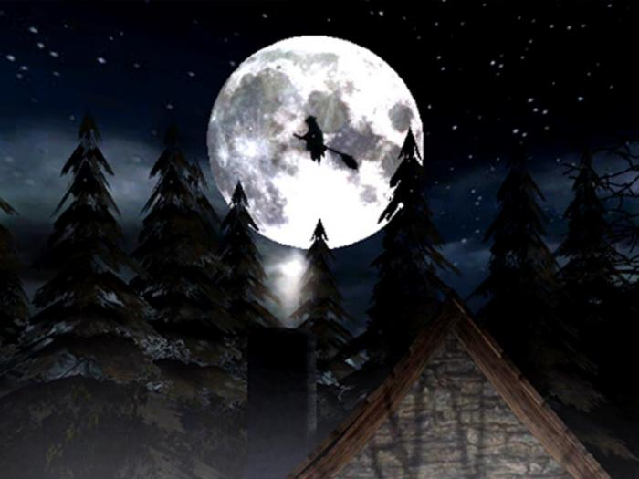  3http://screenshots.de.sftcdn.net/de/scrn/55000/55380/3d-spooky-halloween-screensaver-2.jpg | 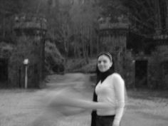  4http://media-cache-ak0.pinimg.com/originals/7e/a2/9e/7ea29e14c98c799e93526dd0192b7f99.jpg
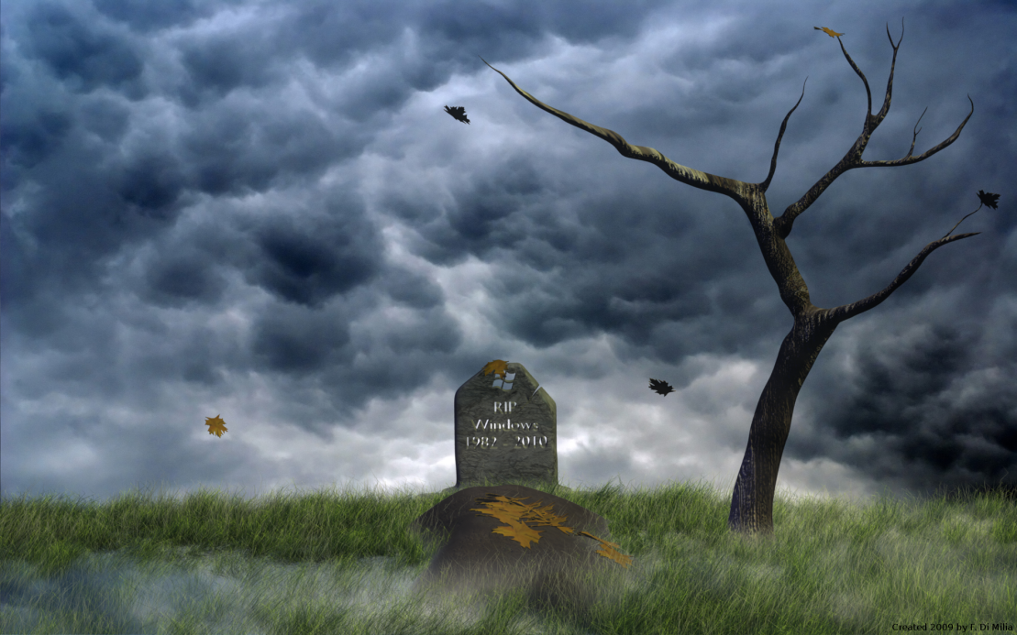  5http://www.desktopas.com/files/2013/10/Spooky-Halloween-2-Wallpaper-1920-x-1200.png | 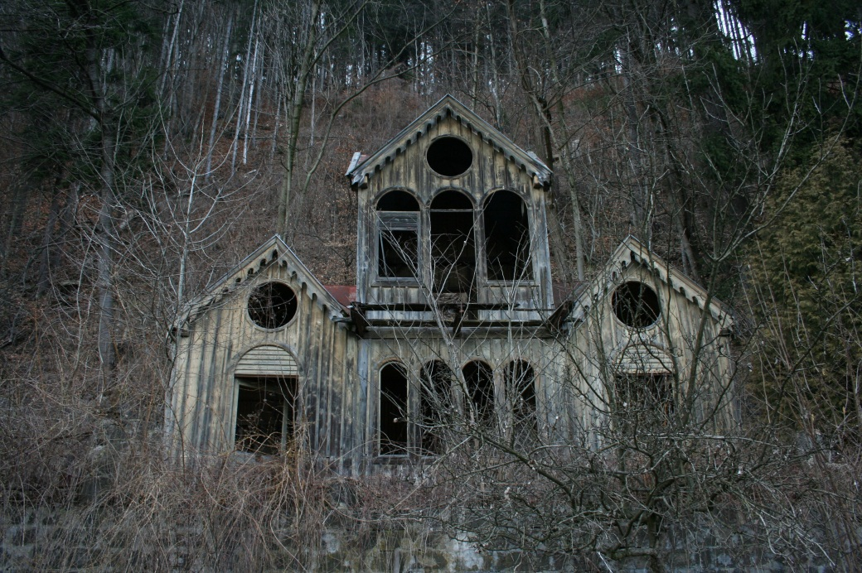  6http://www.hdwallpapersfree1080p.com/wp-content/uploads/2013/10/spooky_house_01_by_chulii_stock.jpg
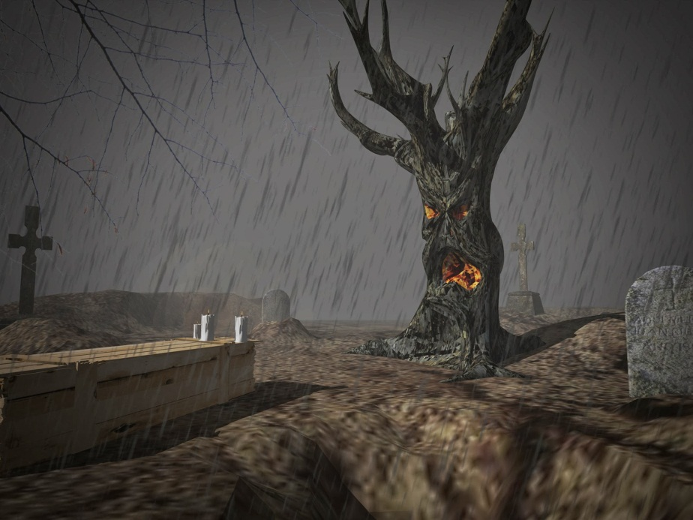  7http://2.bp.blogspot.com/-Ew3HRTMZW1o/UnQpQZXgbaI/AAAAAAAABlo/fVYhy6_LHDk/s1600/190_alsomar.jpg | 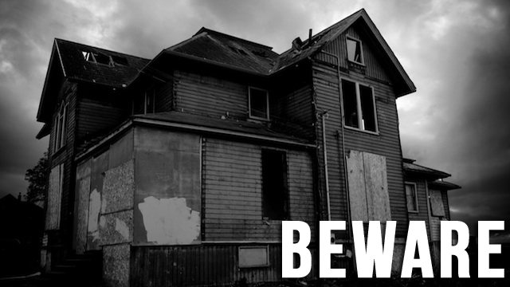  8http://jezebel.com/5854965/ten-super+spooky-ghost-stories-to-keep-you-awake-tonight
9http://imageshack.us/a/img823/4435/ie60.jpg | 10http://img443.imageshack.us/img443/3582/sc32vz0.jpg
11http://3.bp.blogspot.com/-k49tqOzGq5I/Tq08Ks1NsiI/AAAAAAAAAuQ/w-iRtwKfMys/s1600/spooky+path+1939.jpg | 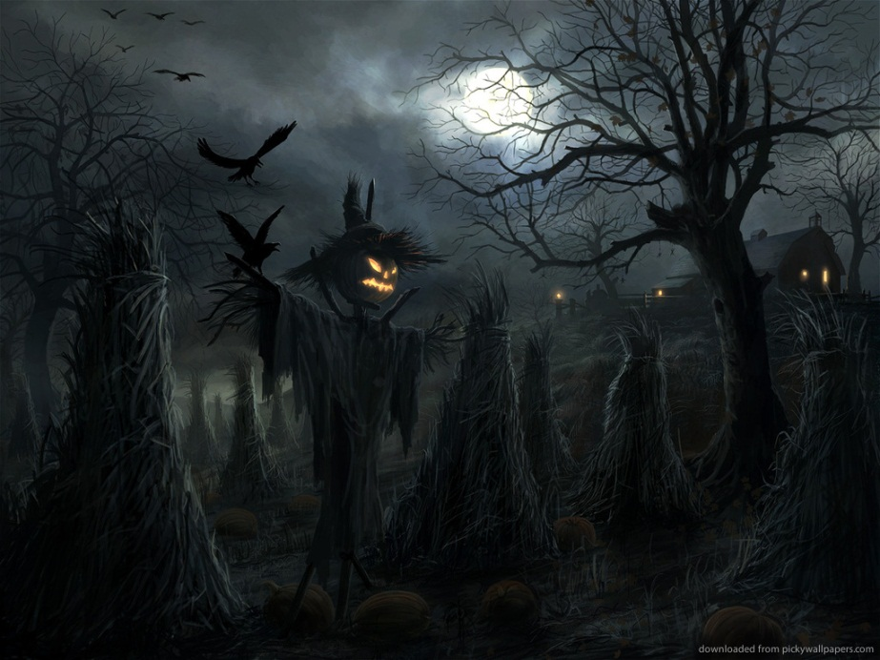  12http://smilingthroughtearz.com/wp-content/uploads/2013/09/spooky-halloween-landscape.jpg

Suddenly….I saw// I heard// I felt… | All of a sudden… | The moon was shining. | There were whispering sounds.
A storm was howling. | Thunder was rumbling in the distance. | Smoke was rising out of the chimney. | The door was ajar.
It sounded like the wind was whispering a secret into my ear. | Far off in the distance a wolf was howling. | The weeds/bushes were rustling in the garden. | Lightning was flashing through the sky.
The wind/rain was lashing against the door. | An owl was hooting somewhere in the darkness. | The shutters on the windows were swinging/banging open and closed. | Shadows were dancing across the garden.
The moon was casting shadows across the garden. | Clouds were blanketing the sky. | The moon was shining and clouds were blowing across the sky. | It was dusk and the sun was setting in the sky.
The children were tiptoeing through the garden. | One boy/girl was looking/peering through the gate. | One boy/girl was whispering into the other one’s ear. | They were shaking with fear…
They were trembling with fear… | His/her voice was trembling. | The gate was creaking in the wind. | The wind was whispering through the trees.
The overgrown grass was blowing in the wind. | The animals were hiding in their holes. | Spiders were spinning their webs. | The crows were shrieking.
A candle was flickering in the window. | The jack-o-lantern was glowing | The windows were boarded up. | The wind was moaning in the distance.
The statues were staring down at them. | The fire was crackling in the fireplace. | The spider webs were swaying in the breeze. | The floorboards were creaking under their feet.
Dark clouds were rolling across the sky. | Frogs were croaking near the pond. | The sound of footsteps was echoing through the house. | Bones were rotting in the front yard.
Her teeth were chattering uncontrollably. | Ravens were flying through the sky. | A rocking chair was creaking in a corner. | The wet grass was glistening in the moonlight

