1 Go to the moodle course Nachprüfung-year1
Do all the exercises (FoF / Listening) online.

2 Writing: Describe the room
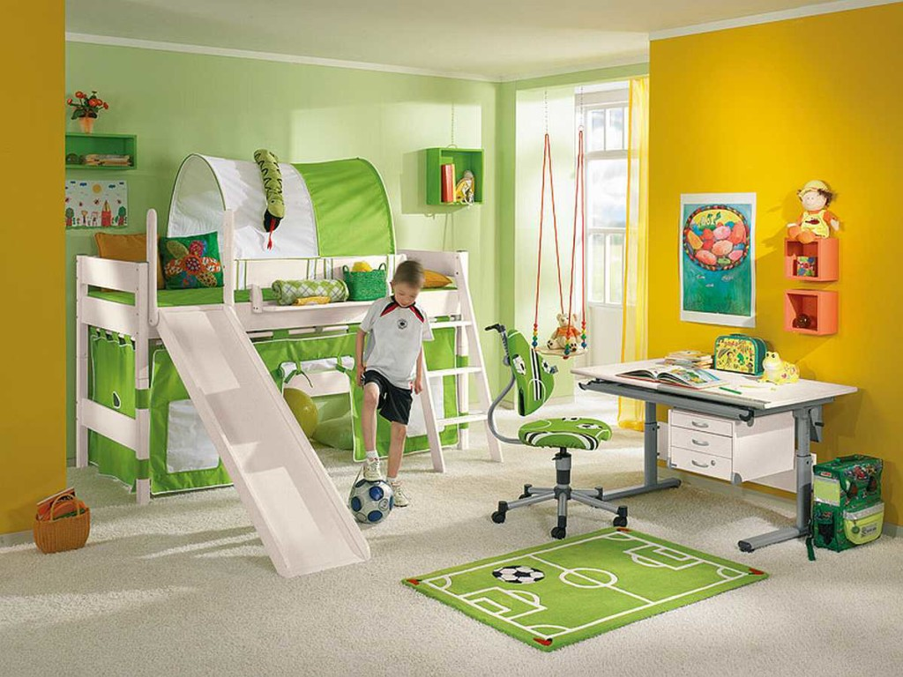
https://mande.brandonrfriedman.com/wp-content/uploads/2017/07/Boys-Loft-Bed-Sport-Theme.jpg

….
- Listening (online) | - Focus on Form (online) | - Writing | - Speaking
- Gesamtnote:

Notenschlüssel gesamt

Sehr gut: 90%
Gut: 80%
Befriedigend: 70%
Genügend: 60%
Standard Befriedigend: 50%
Standard Genügend: 40%
Mindestens drei Teilbereiche müssen positiv sein, ein Teilbereich kann kompensiert werden.

SPEAKING
Elena, Ella, Lukas, Markus
A lot of new students are coming to our school. What can you tell them about a normal school day in Flexi?
- What time do you get up?
- What are the first things you do in the morning?
- Do you have breakfast? Tell us about it.
- How do you get to school? What time do you leave for school?
- When do you arrive at school?
- ......

SPEAKING
Lukas, Leonie

Describe the room we are sitting and our classroom in in detail.
Say where things are and what they look like.
What do you like about the room? What don't you like about the room?

